Lab 7 ALU Report

Ismail Akram

11/14/2021

CSc34200 & 34300

Prof Gertner

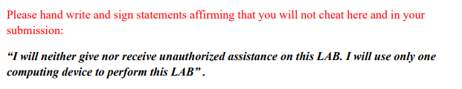

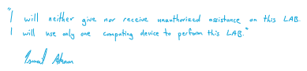

Contents

**Objective** 4

**Screenshots** 5

RS, RD, & RT 5

ADD/SUB unit with flags Overflow, Negative, and Zero 8

Bitwise Operation Unit 9

16-bit IMM Register 10

SignExt 11

MAR and MDR 12

3-port RAM 14

ALU 16

Instruction Register 18

Data Memory 20

**Simulations** 21

add (000) 21

addi (0001) 22

addiu (0010) 23

addu (0011) 24

sub (0100) 25

subu (0101) 26

and (0110) 27

andi (0111) 28

nor (1000) 29

or (1001) 30

ori (1010) 31

SLL (1011) 32

SRL (1011) 33

SRA (1101) 34

SW (1110) 35

LW (1110) 36

**MIPS** 37

add 37

addi 38

addiu 39

addu 40

sub 41

subu 42

and 43

andi 44

nor 45

or 46

ori 47

sll 48

srl 49

sra 50

# **Objective**

1. We are implementing in VHDL, MIPS Instructions show in the table (green pages).
2. We are verifying correctness in ModelSim Simulation using waveforms for several select cases.
3. We are comparing the execution of instructions you have designed with corresponding MIPS instructions in MARS environment.

This ALU lab performs addition and subtraction and stores values into the register, this lab is a portion of the single-cycle CPU. This lab and all the previous labs will lead us to a single-cycle CPU.

# **Screenshots**

## RS, RD, & RT

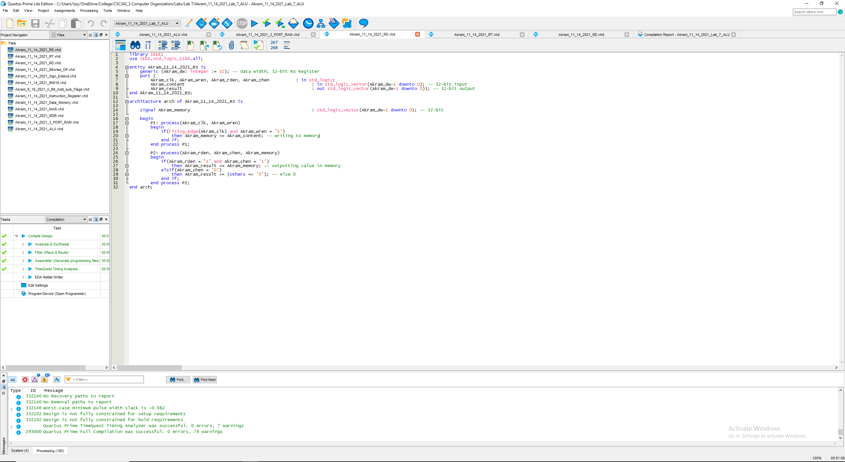

Fig 1. VHDL Code for RS Register (32-bit)

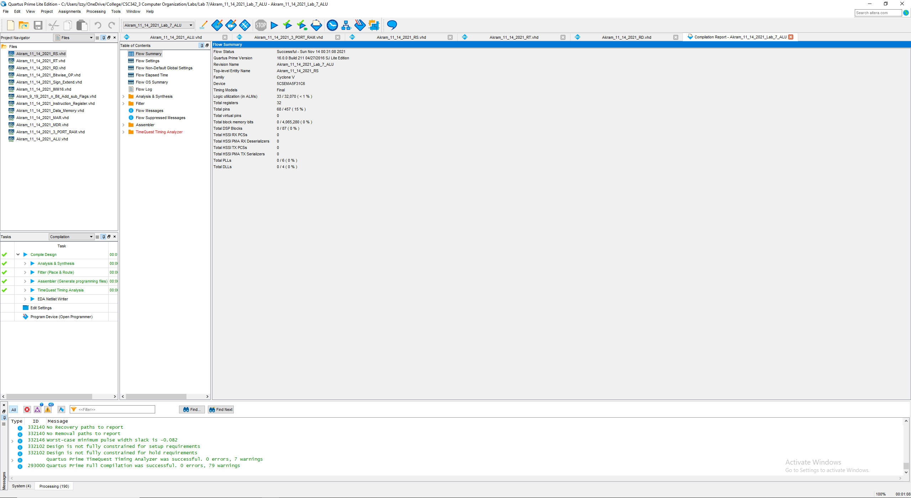

Fig 2. Compilation Report (successful)

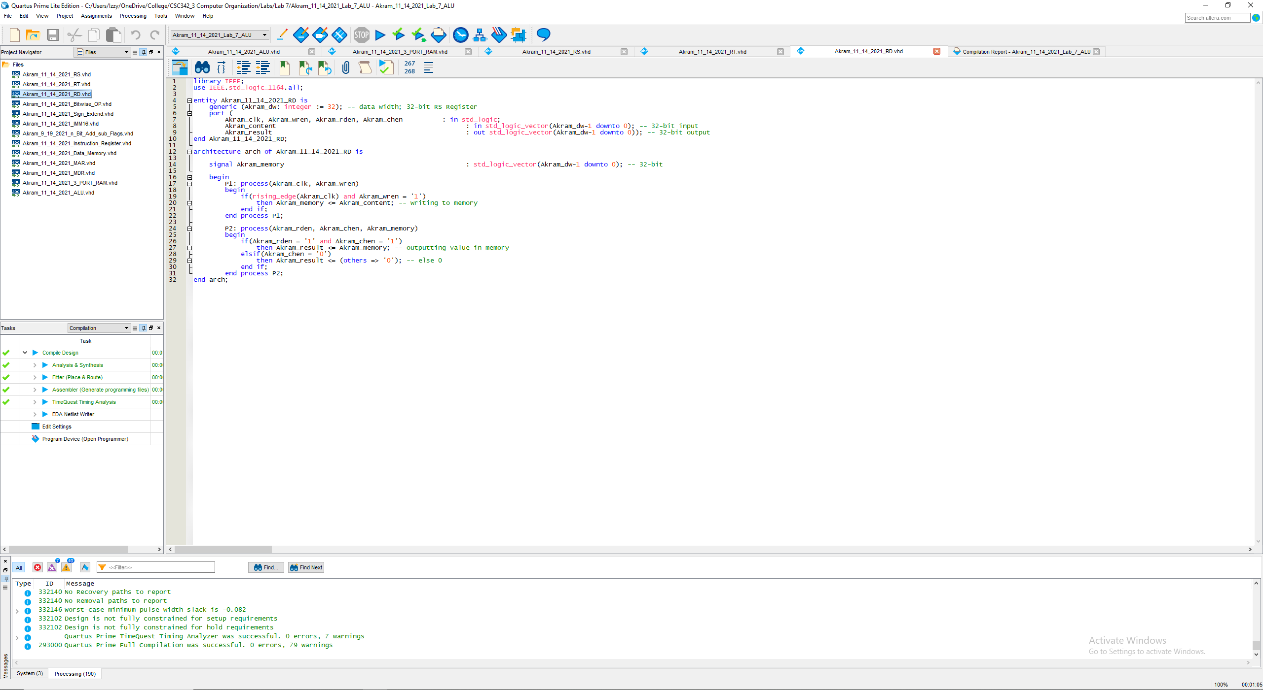

Fig 3. VHDL Code for RD Register (32-bit)

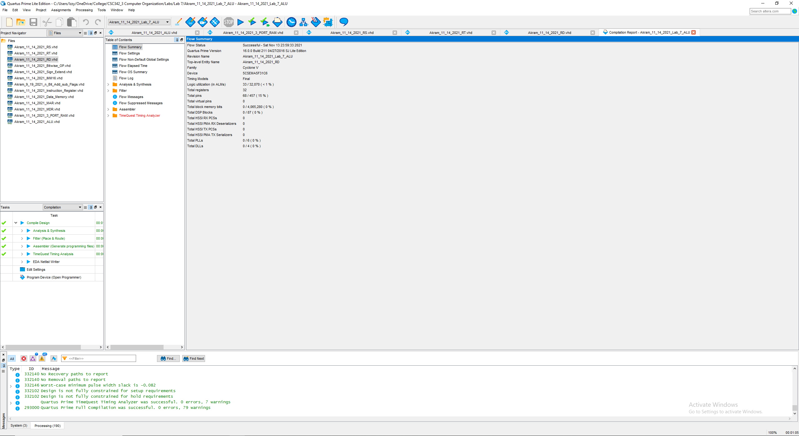

Fig 4. Compilation Report (successful)

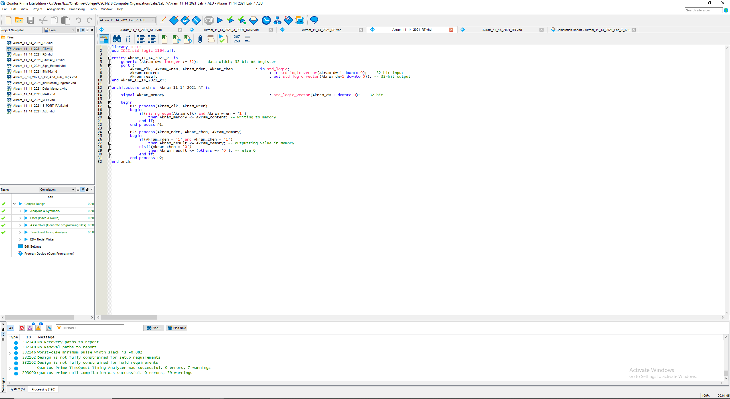

Fig 5. Fig 3. VHDL Code for RT Register (32-bit)

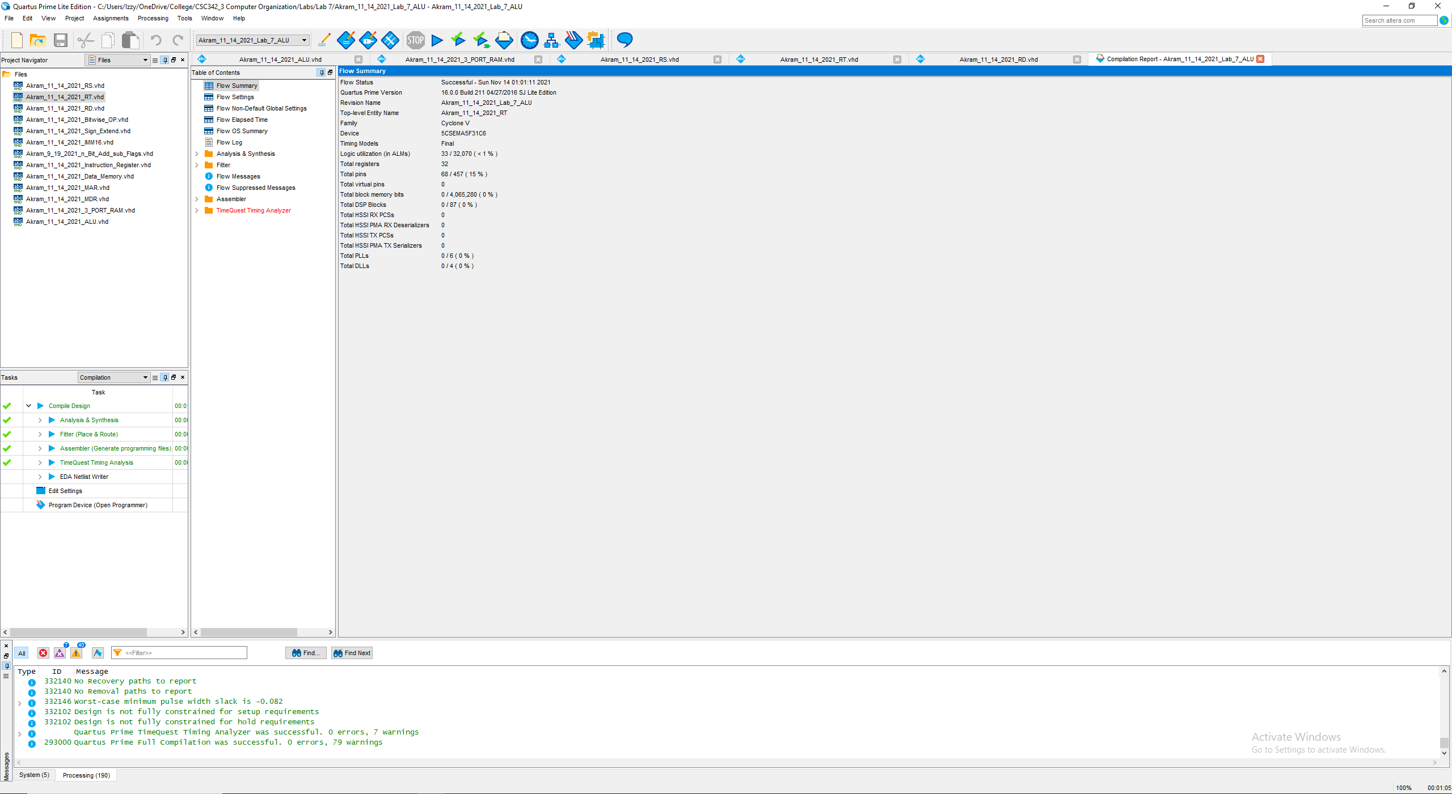

Fig 6. Compilation Report (successful)

## ADD/SUB unit with flags Overflow, Negative, and Zero

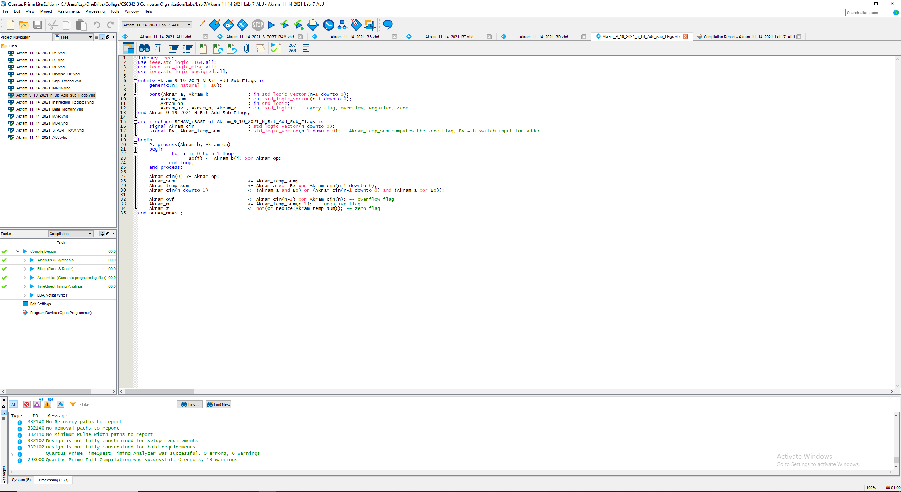

Fig 7. VHDL for Akram_9_19_2021_N_Bit_Add_Sub_Flags (from Lab 3)

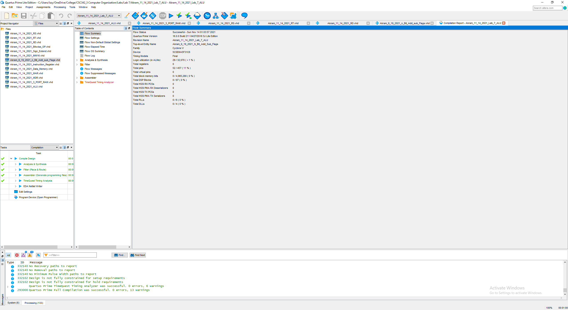

Fig 8. Compilation Report (successful)

## Bitwise Operation Unit

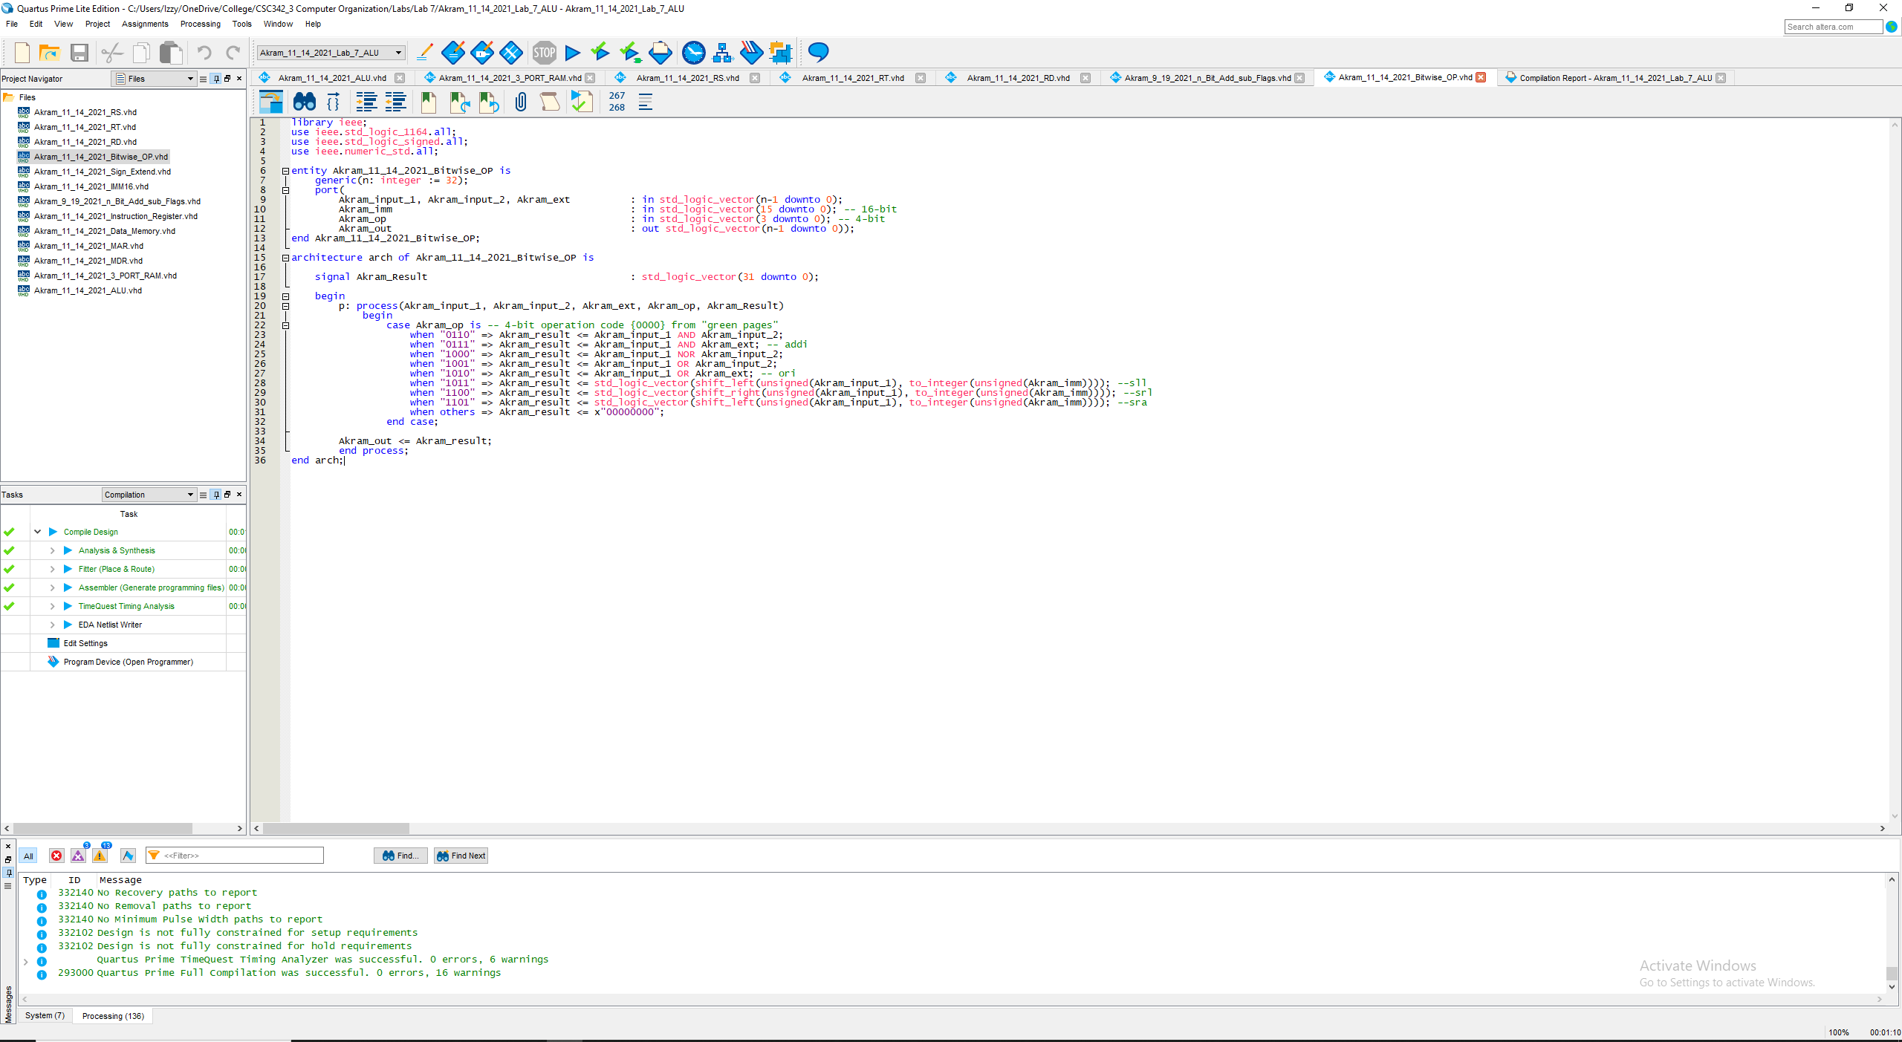

Fig 9. VHDL for Akram_11_14_2021_Bitwise_OP

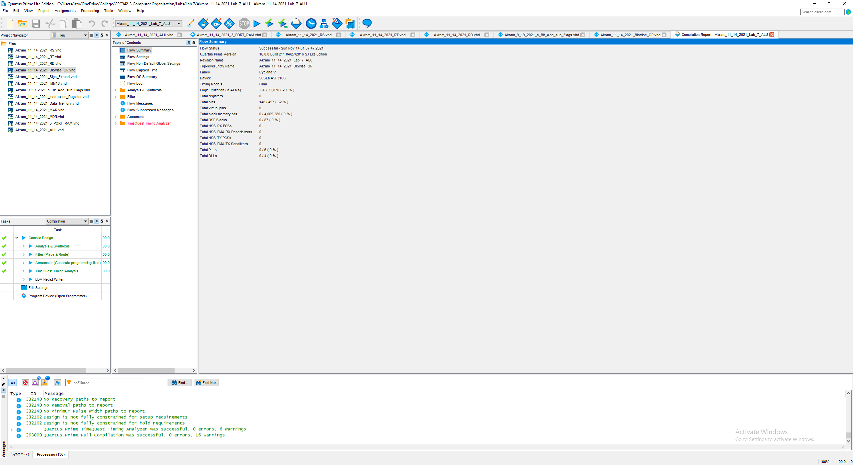

Fig 10. Compilation Report (successful)

## 16-bit IMM Register

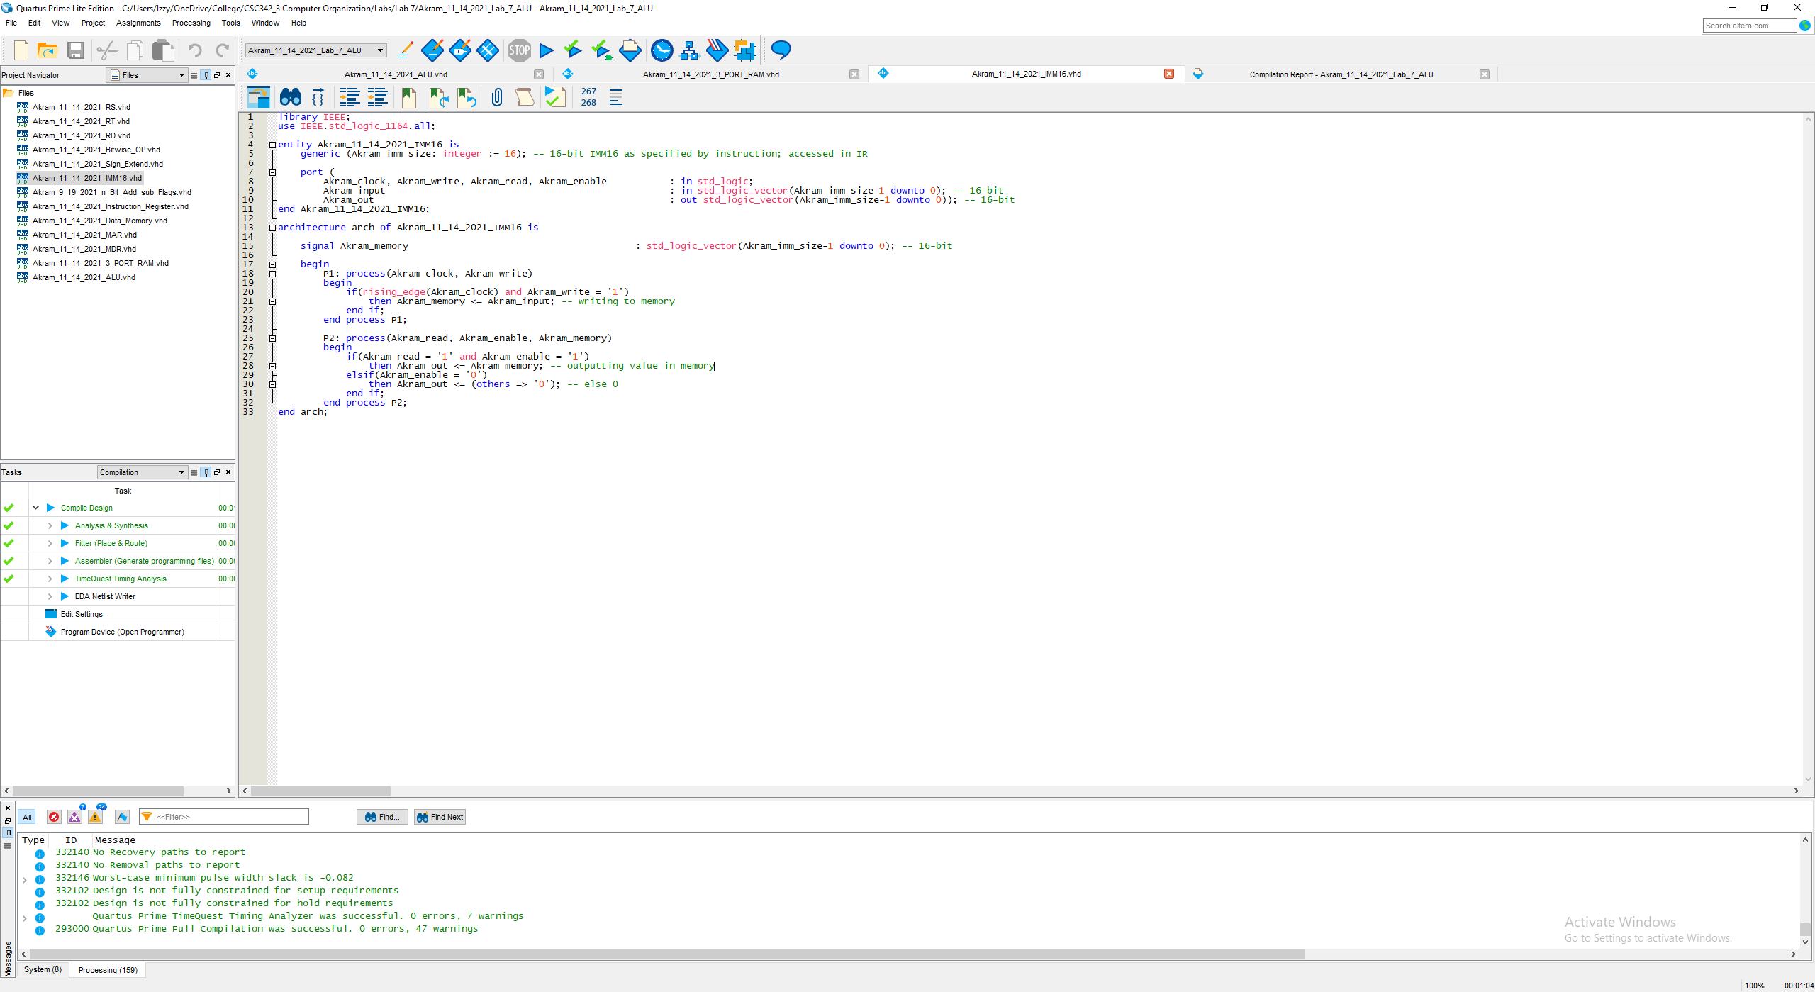

Fig 11. VHDL Code for Akram_11_14_2021_IMM16

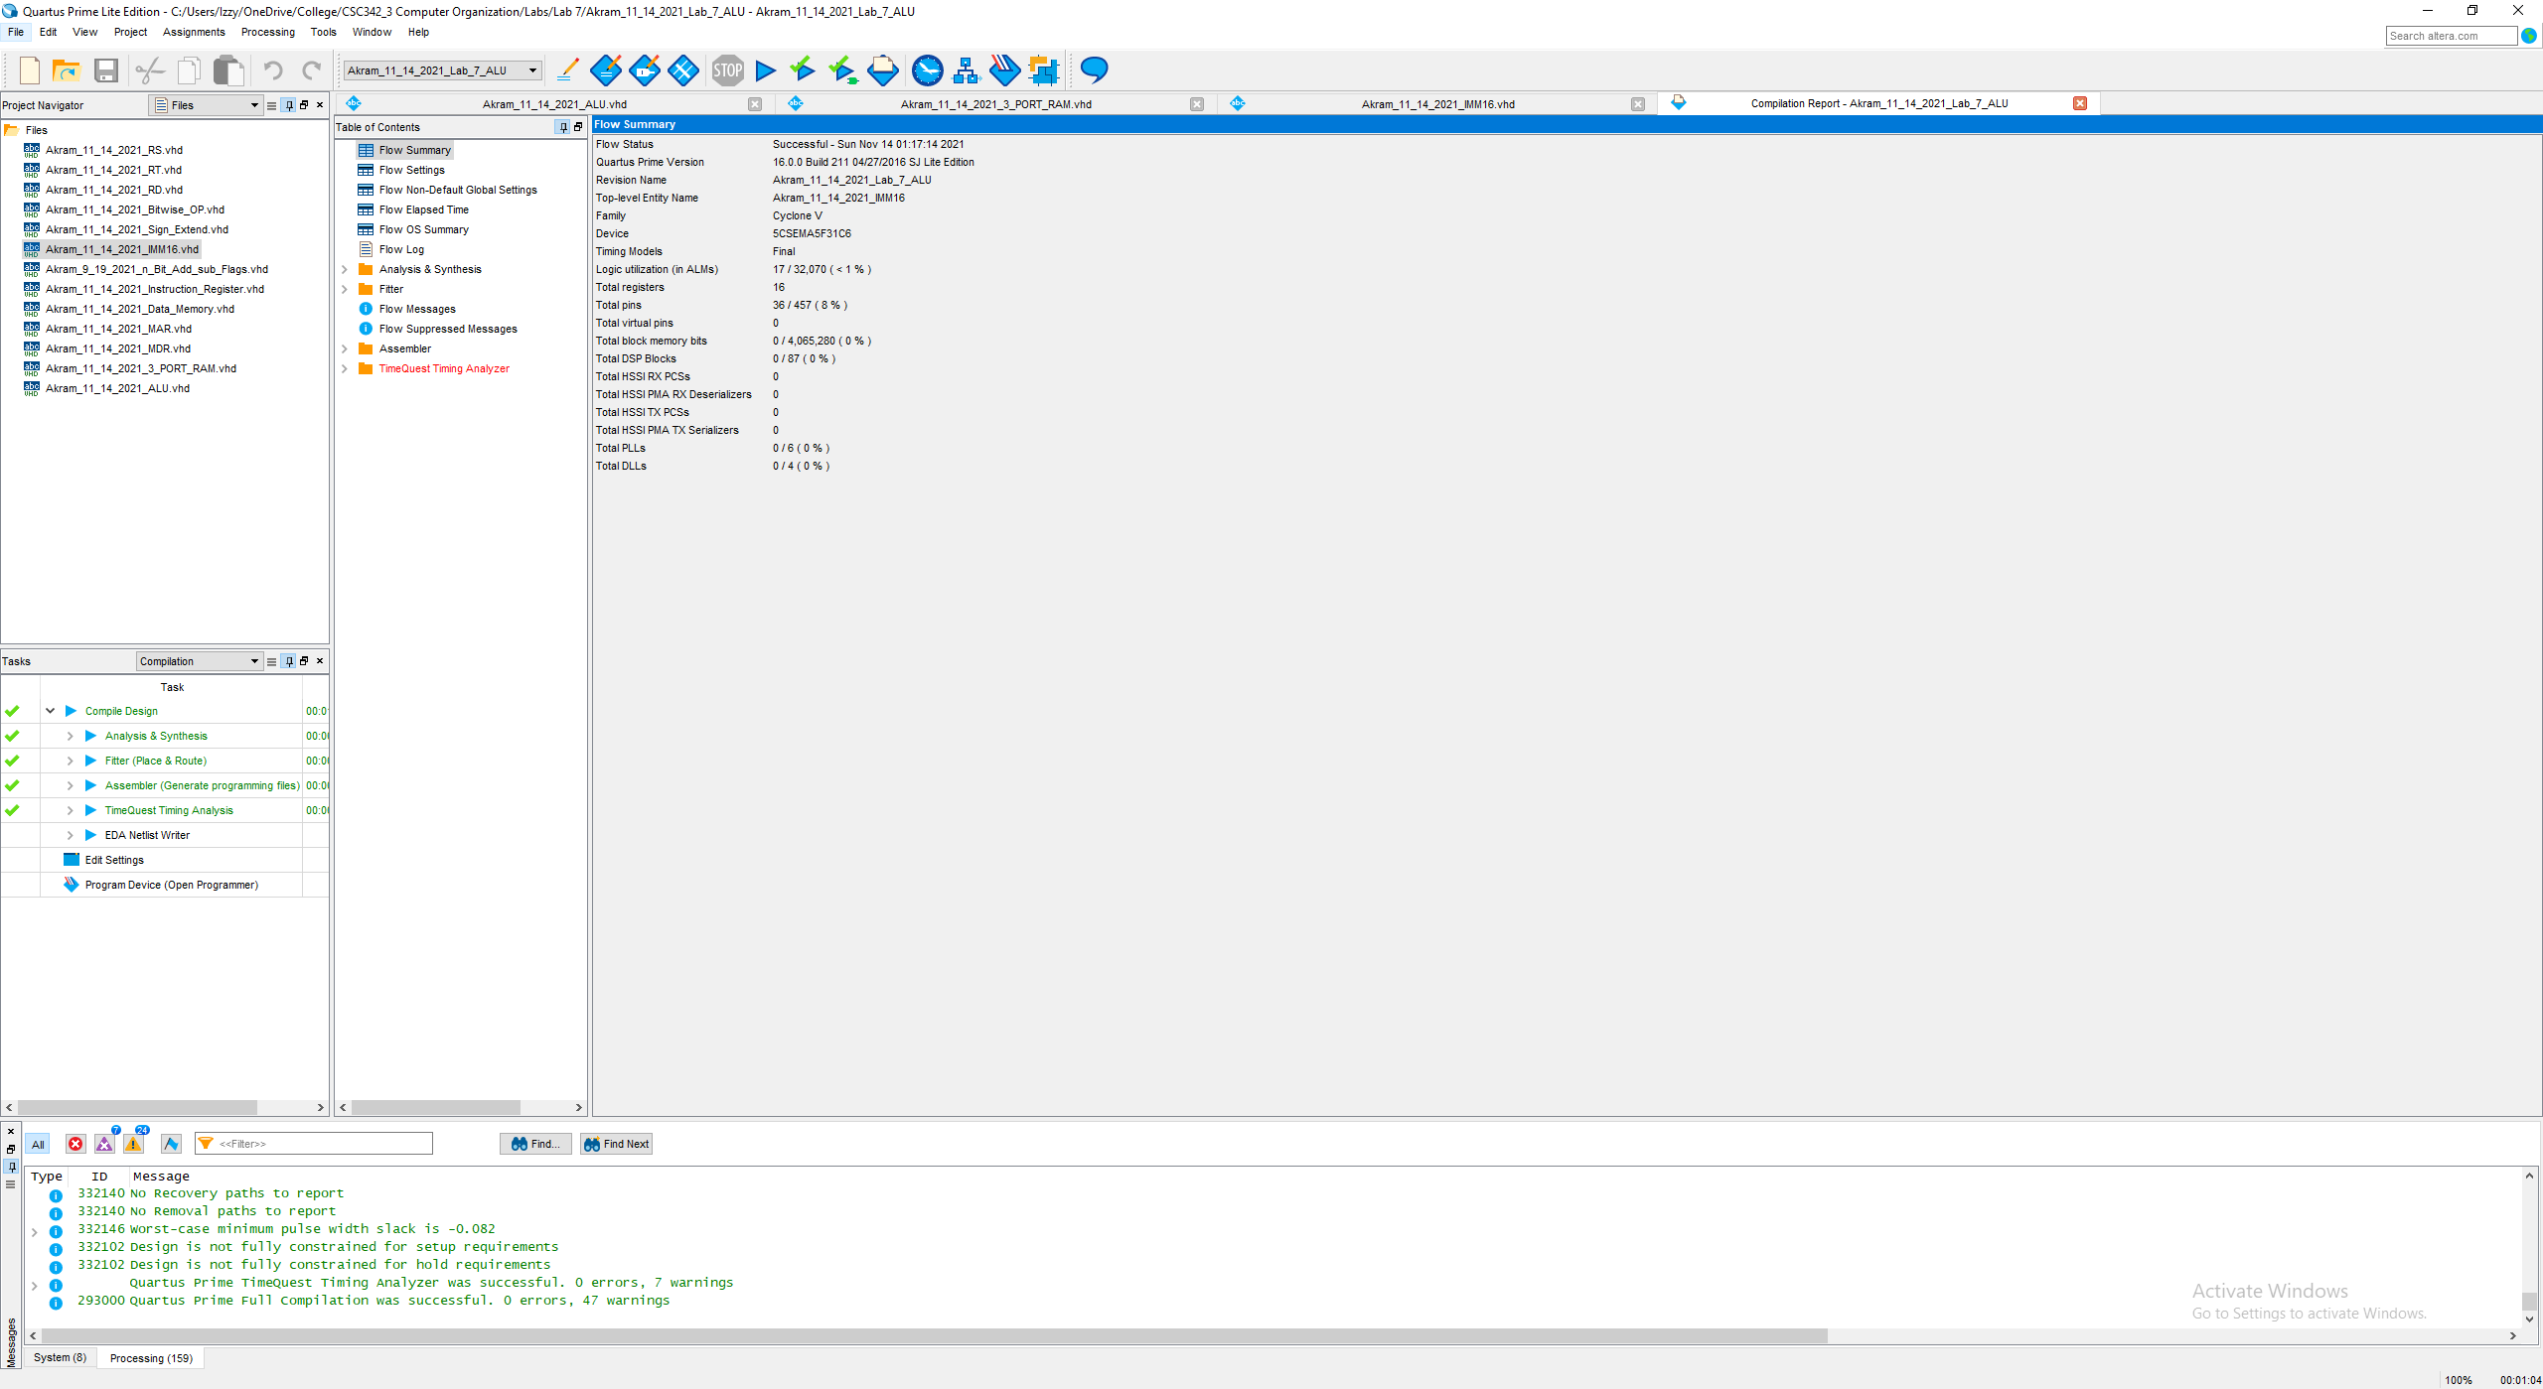

Fig 12. Compilation Report (successful)

## SignExt

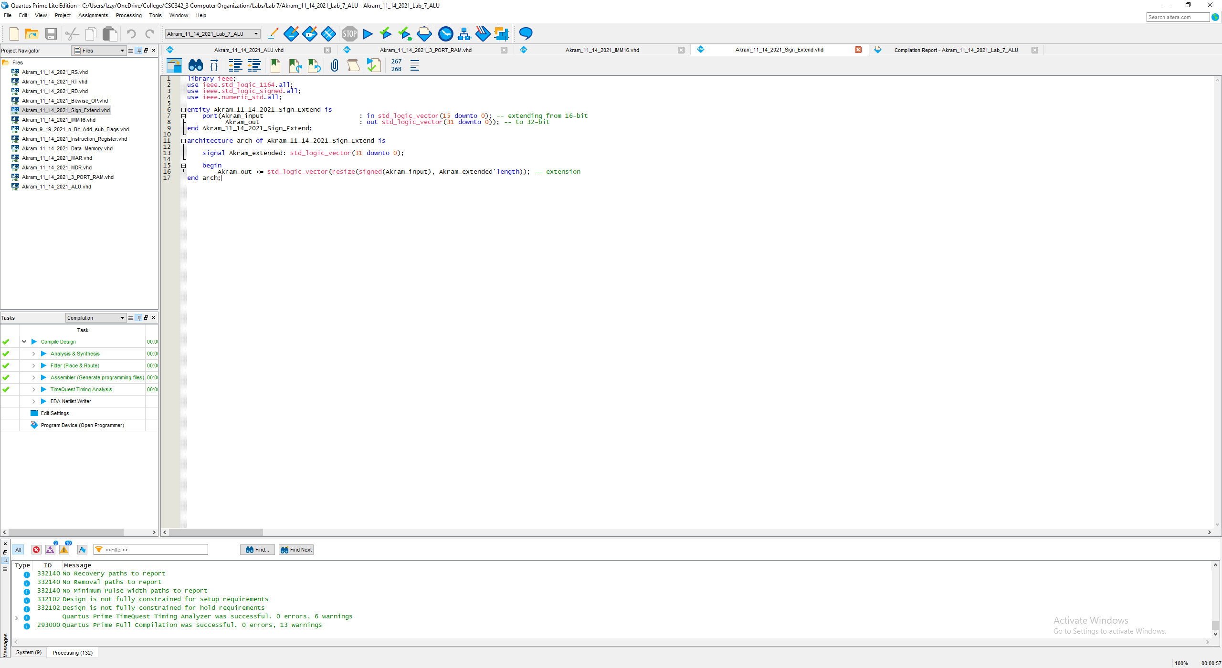

Fig 13. VHDL Code for Akram_11_14_2021_Sign_Extend

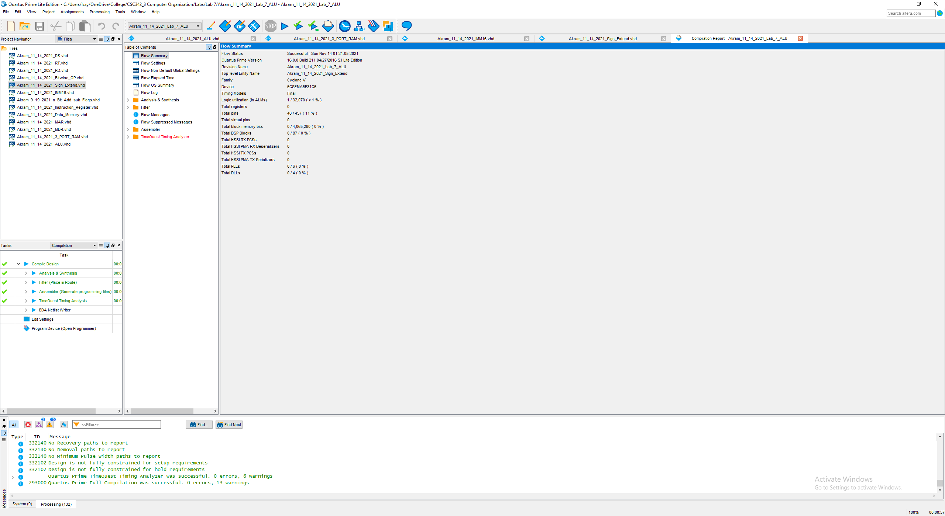

Fig 14. Compilation Report (successful)

## MAR and MDR

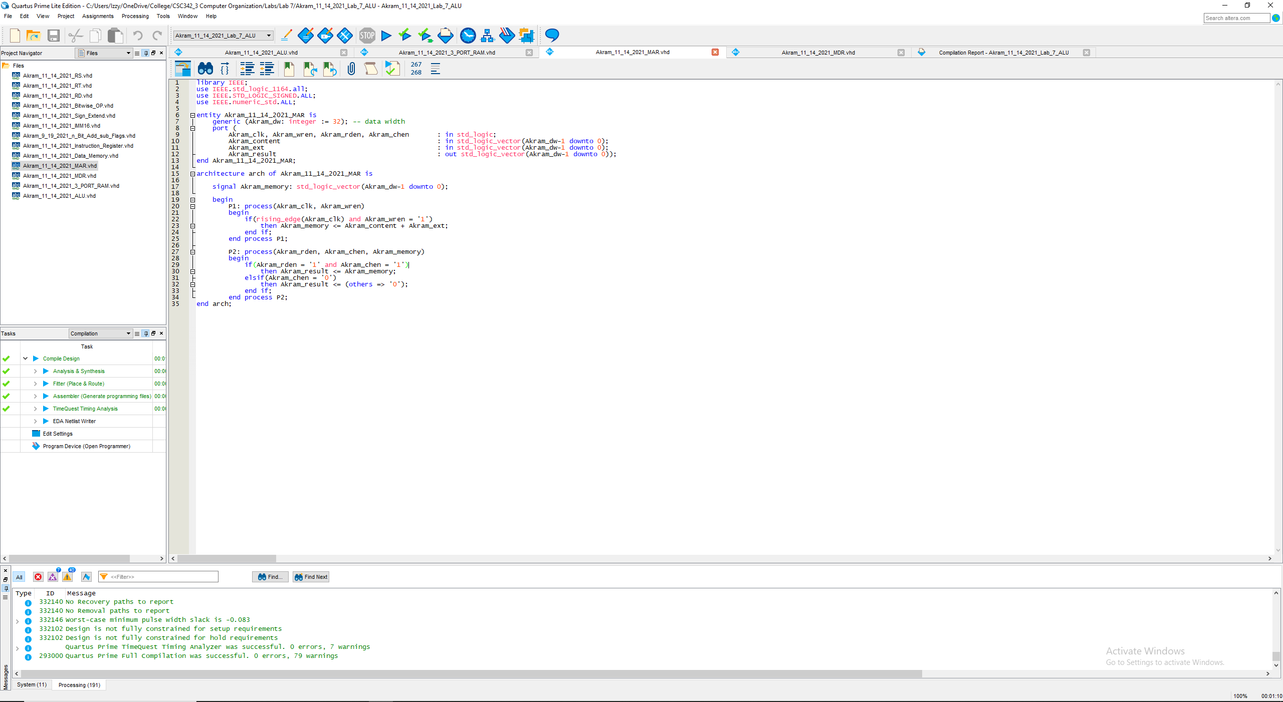

Fig 15. VHDL Code for Akram_11_14_2021_MAR

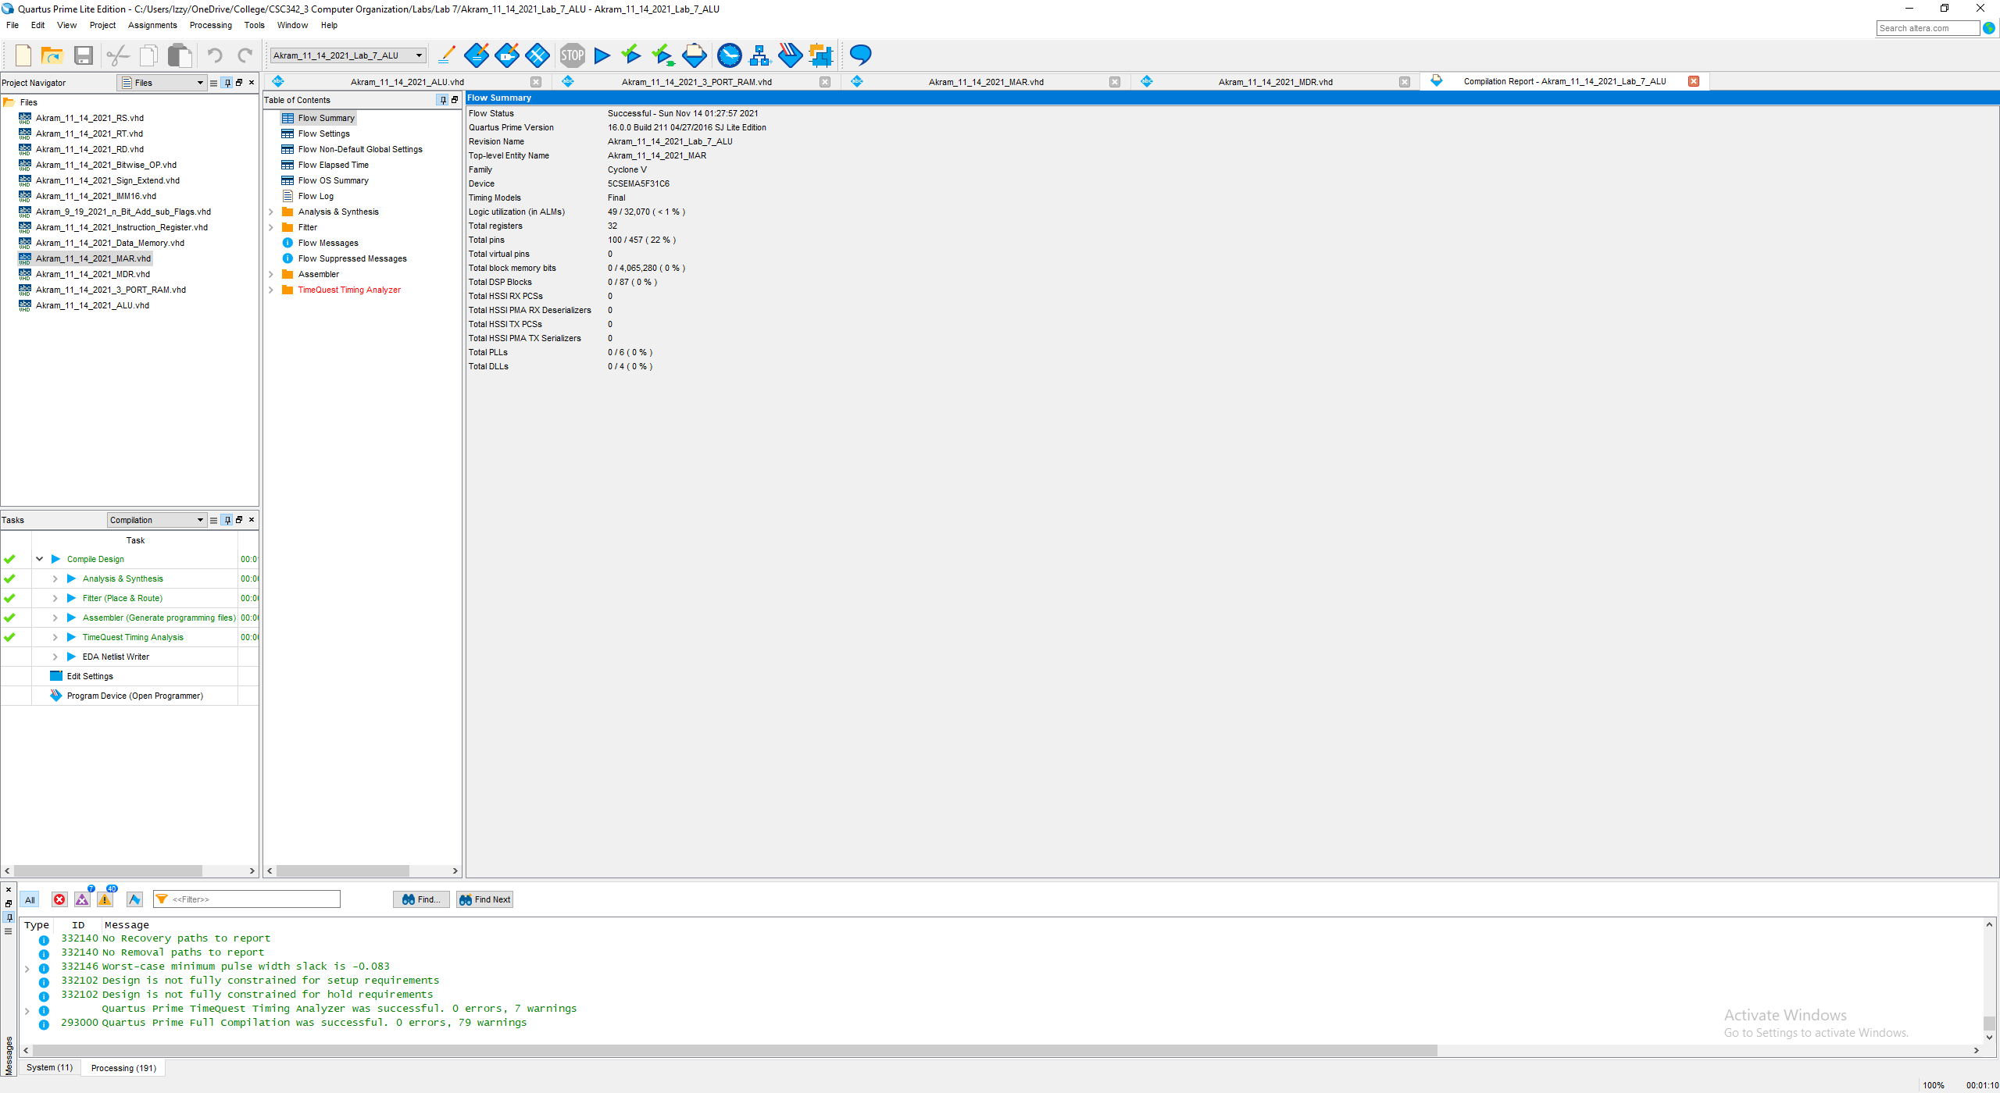

Fig 16. Compilation Report (successful)

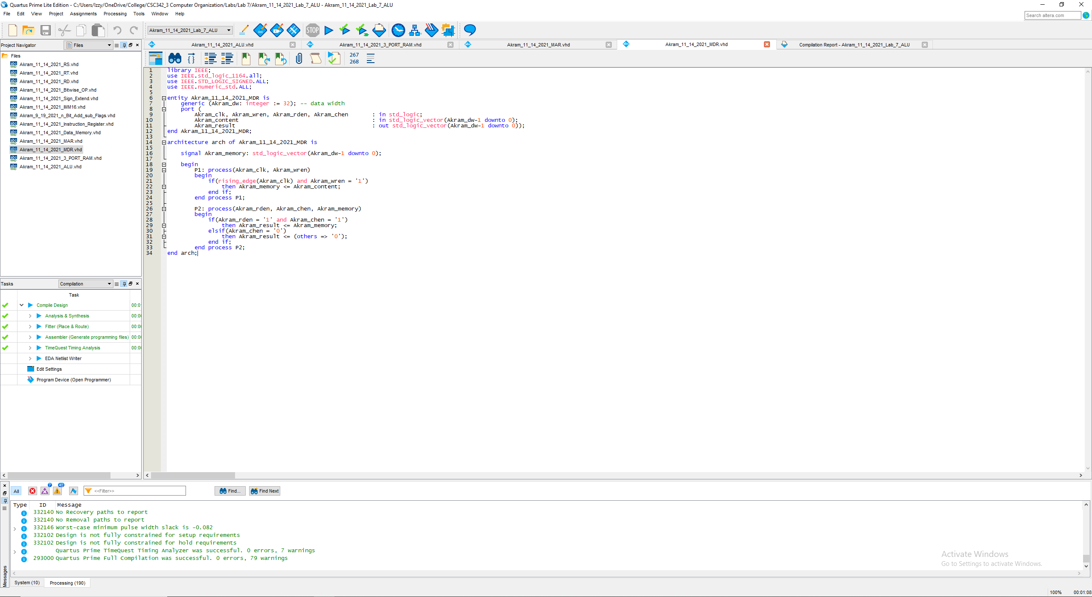

Fig 17. VHDL Code for Akram_11_14_2021_MDR

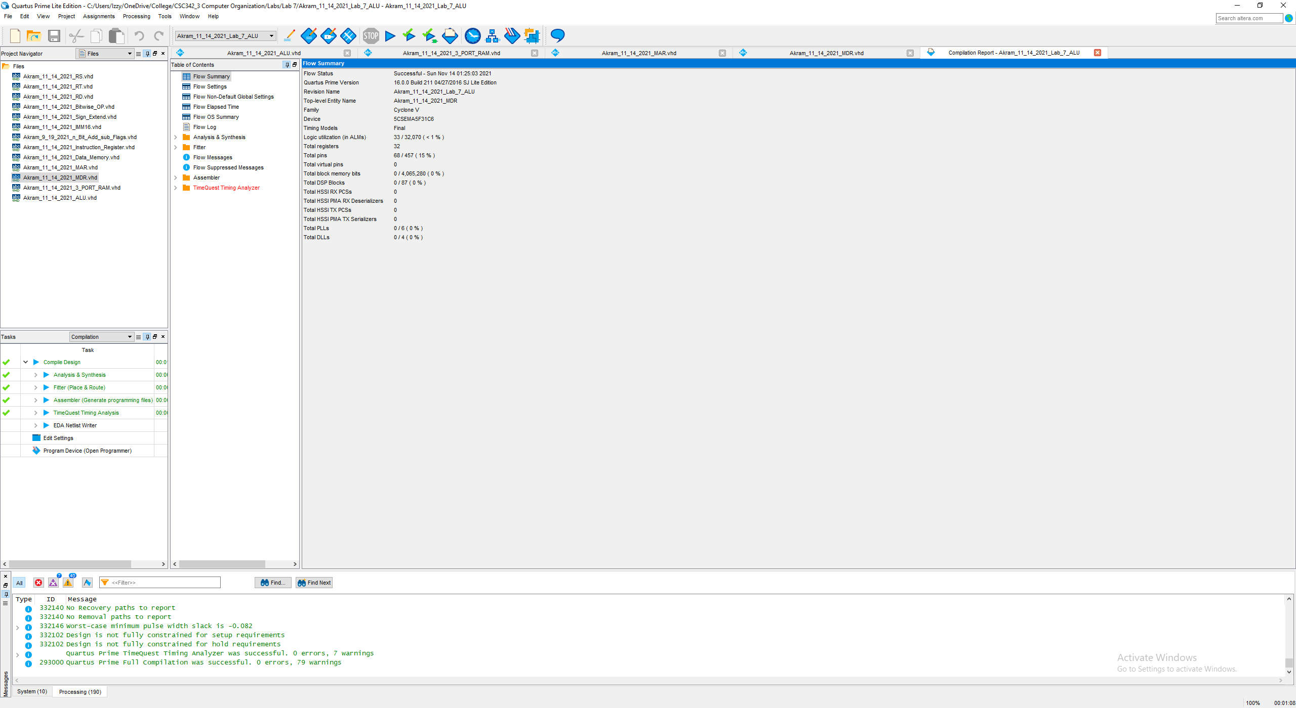

Fig 18. Compilation Report (successful)

## 3-port RAM

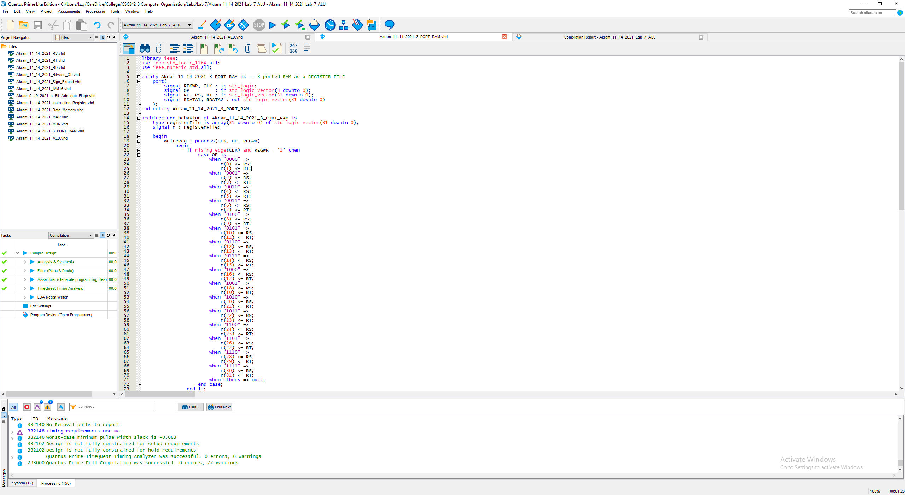

Fig 19. VHDL Code for Akram_11_14_2021_3_PORT_RAM

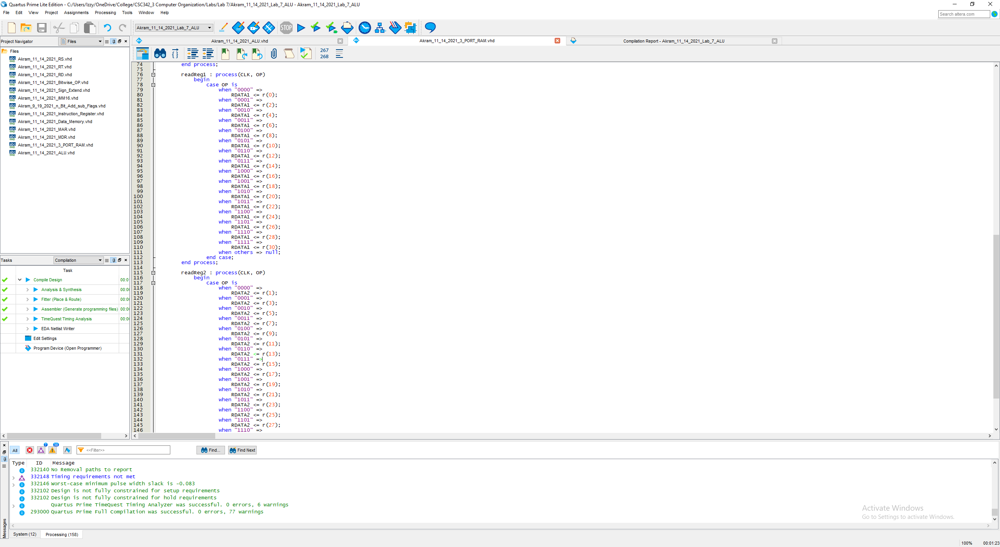

Fig 20. VHDL Code for Akram_11_14_2021_3_PORT_RAM … cont.

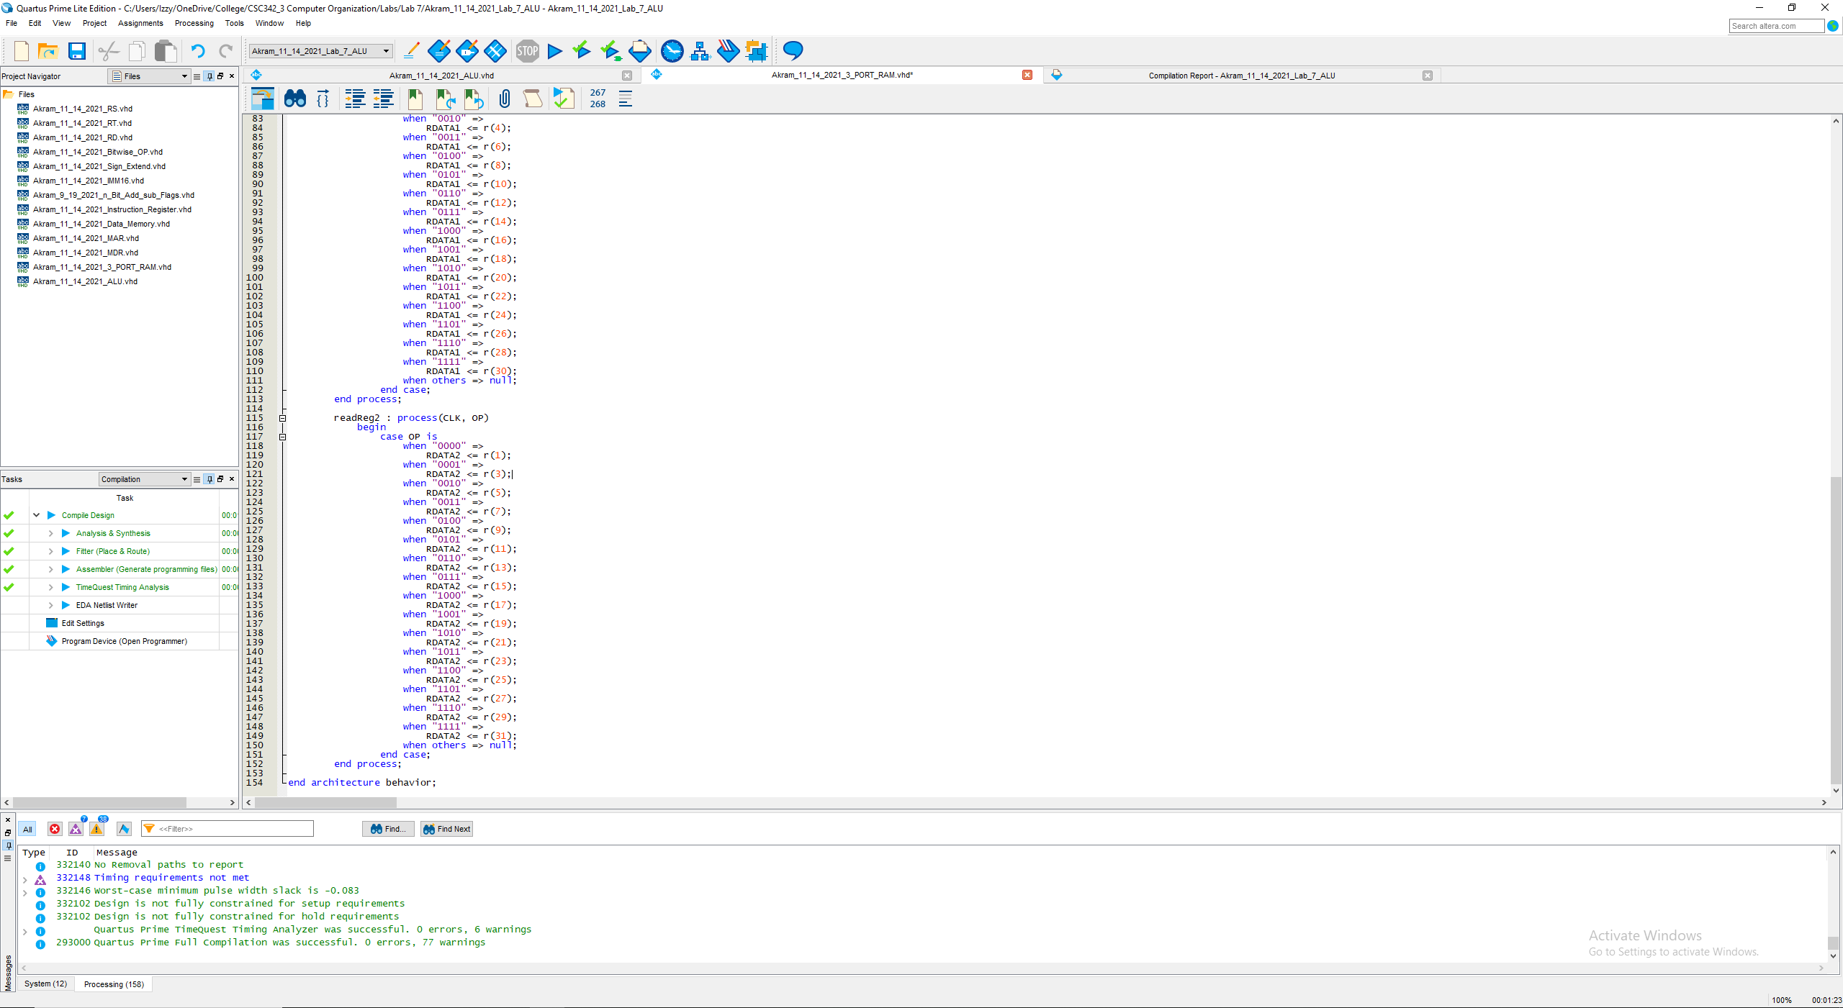

Fig 21. VHDL Code for Akram_11_14_2021_3_PORT_RAM … cont.

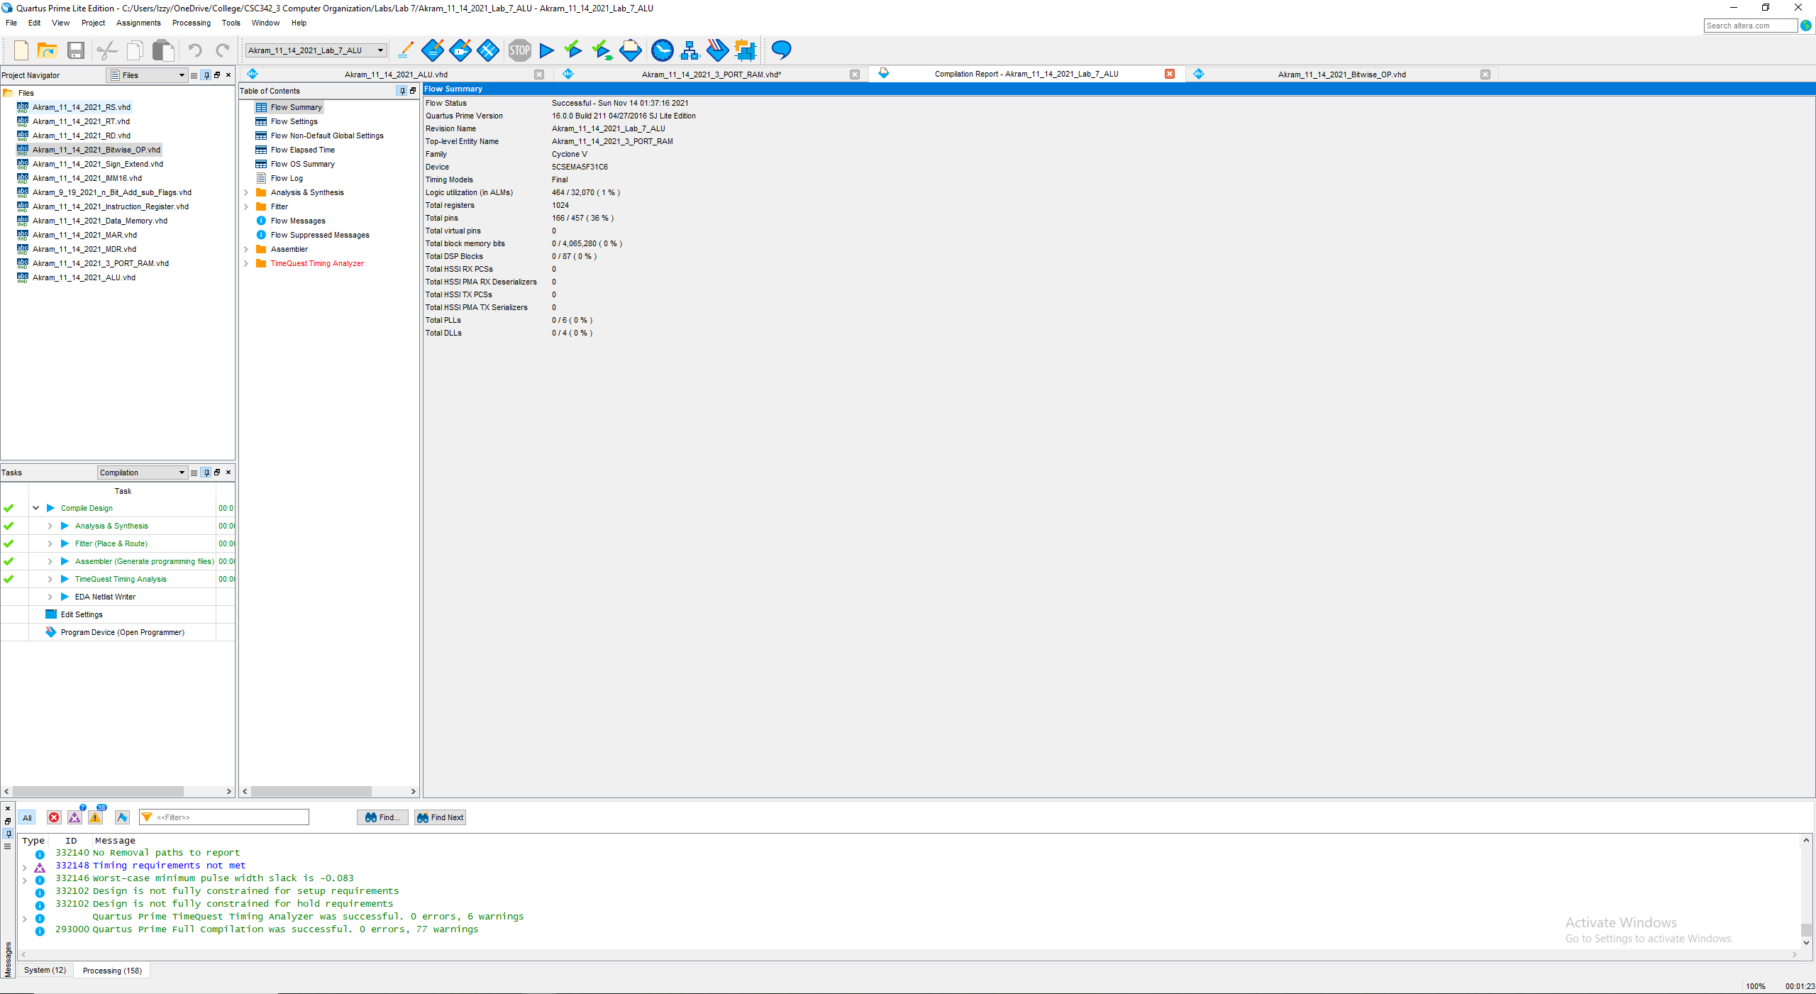

Fig 22. Compilation Report (successful)

## ALU

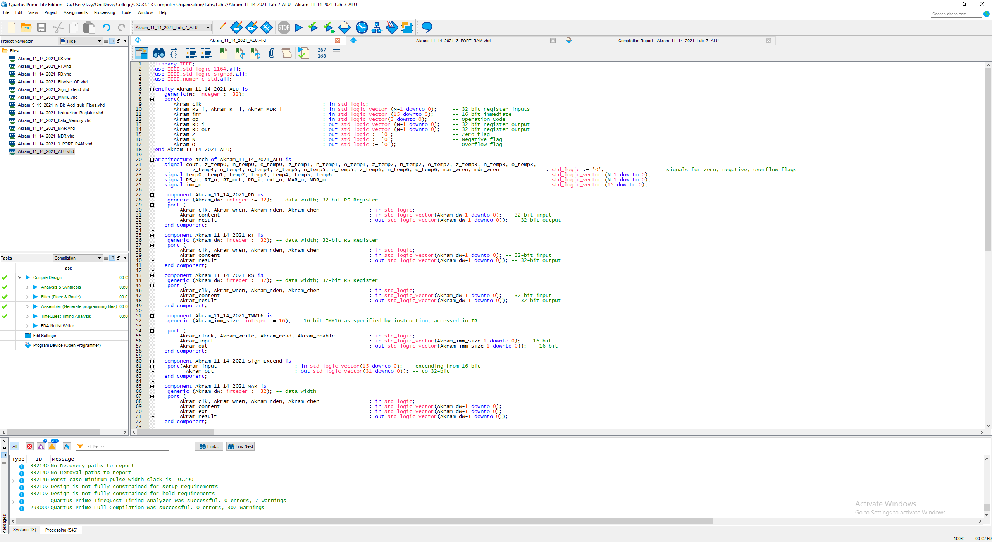

Fig 23. VHDL Code for Akram_11_14_2021_ALU

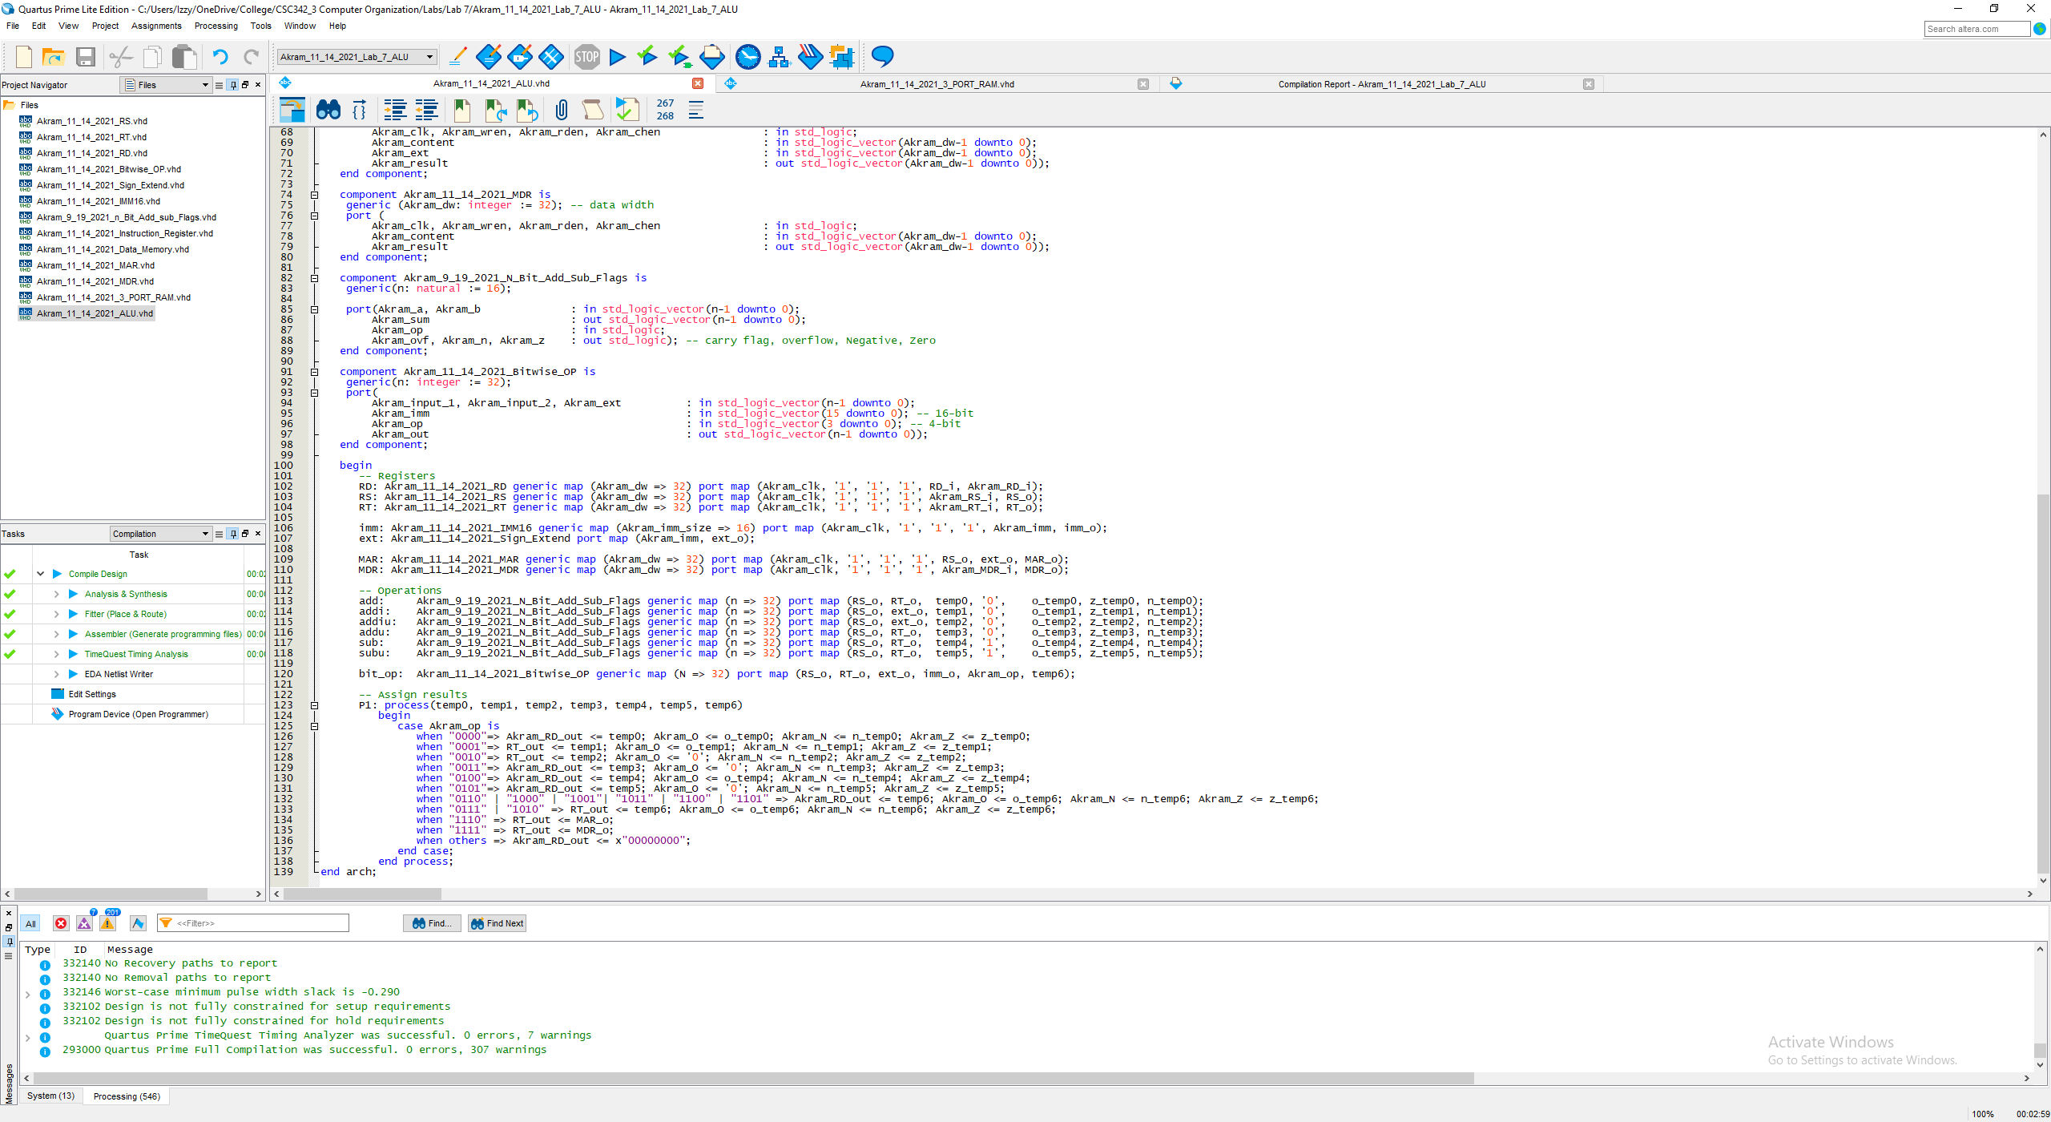

Fig 24. VHDL Code for Akram_11_14_2021_ALU … cont.

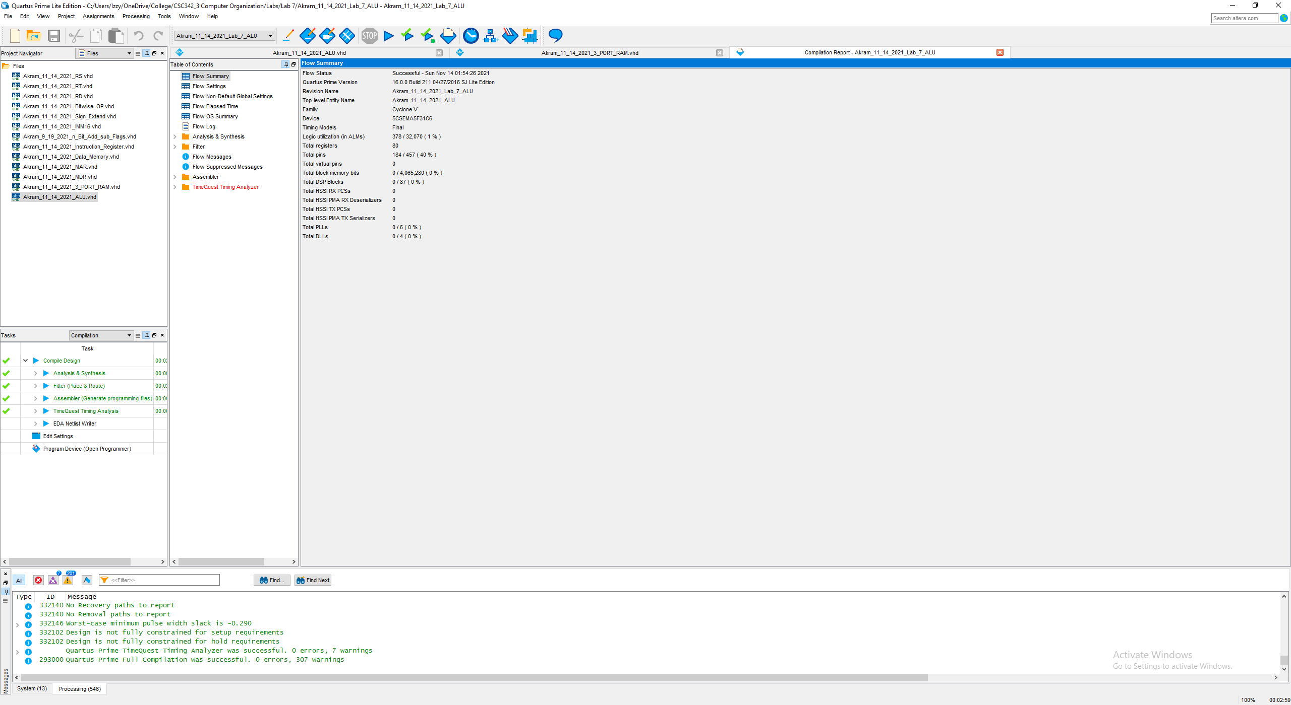

Fig 25. Compilation Report (successful)

## Instruction Register

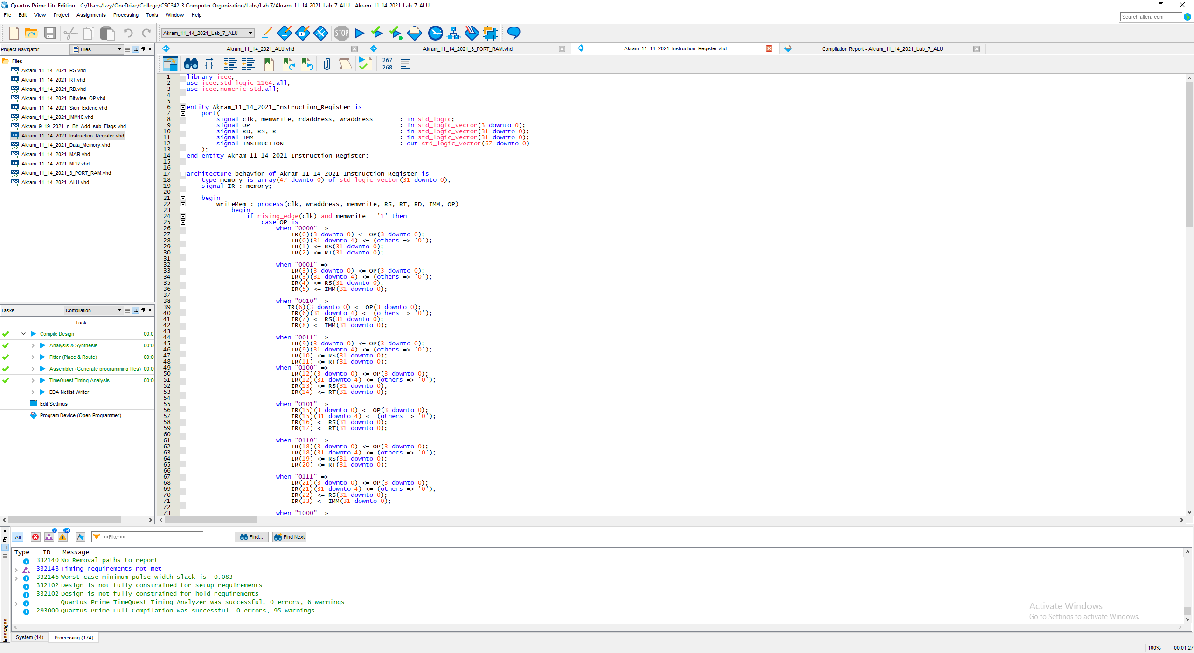

Fig 26. VHDL Code for Akram_11_14_2021_Instruction_Register

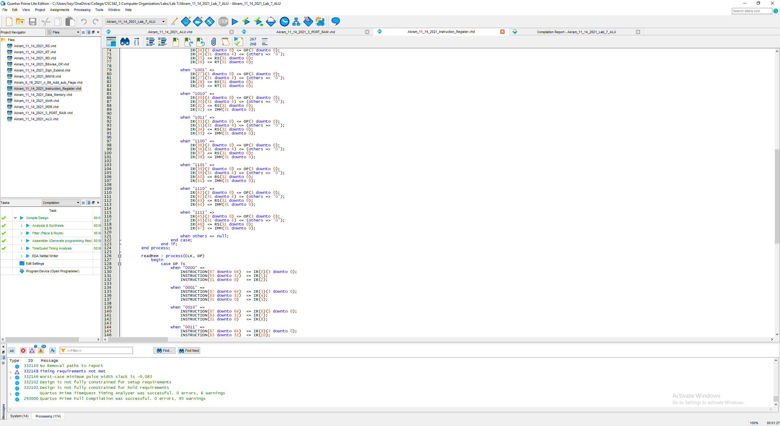

Fig 27. VHDL Code for Akram_11_14_2021_Instruction_Register … cont.

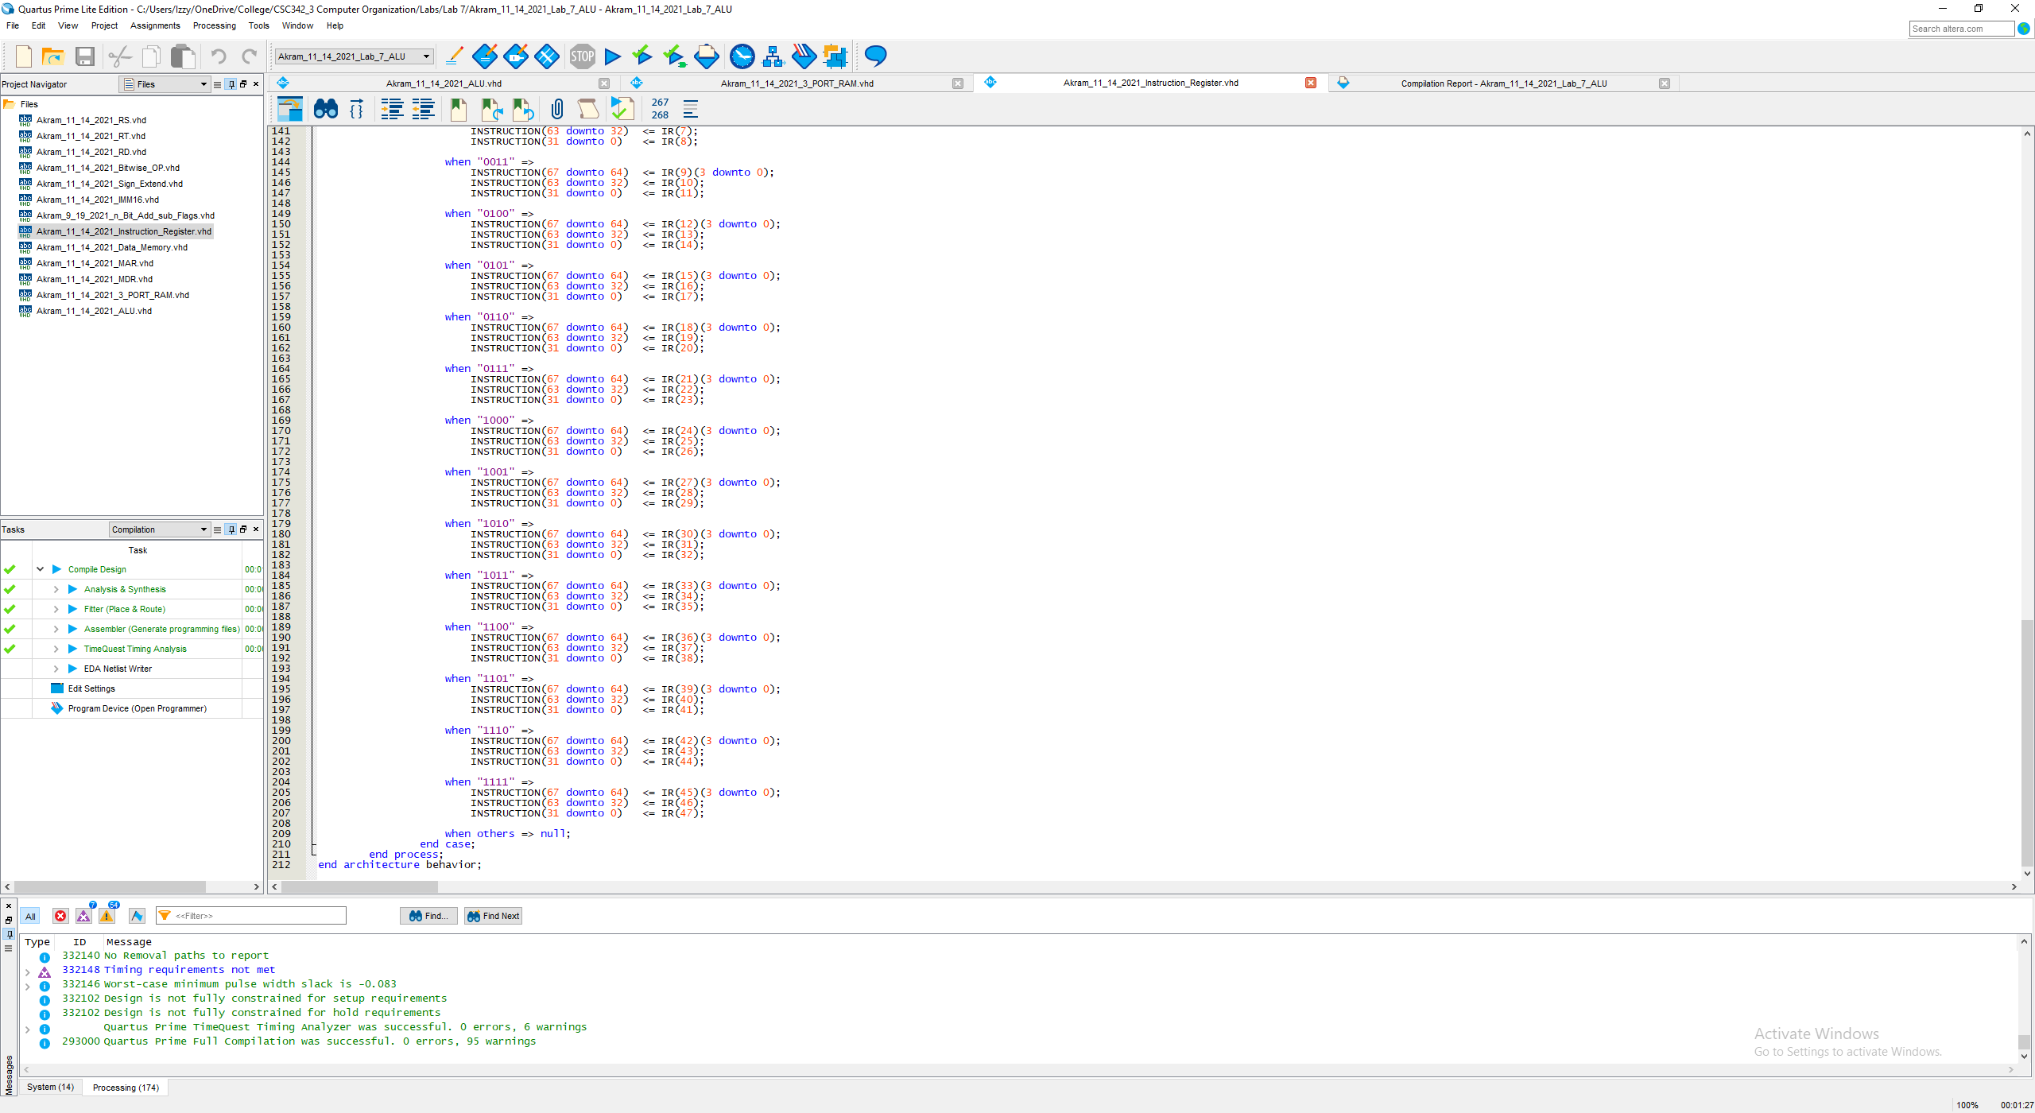

Fig 28. VHDL Code for Akram_11_14_2021_Instruction_Register … cont.

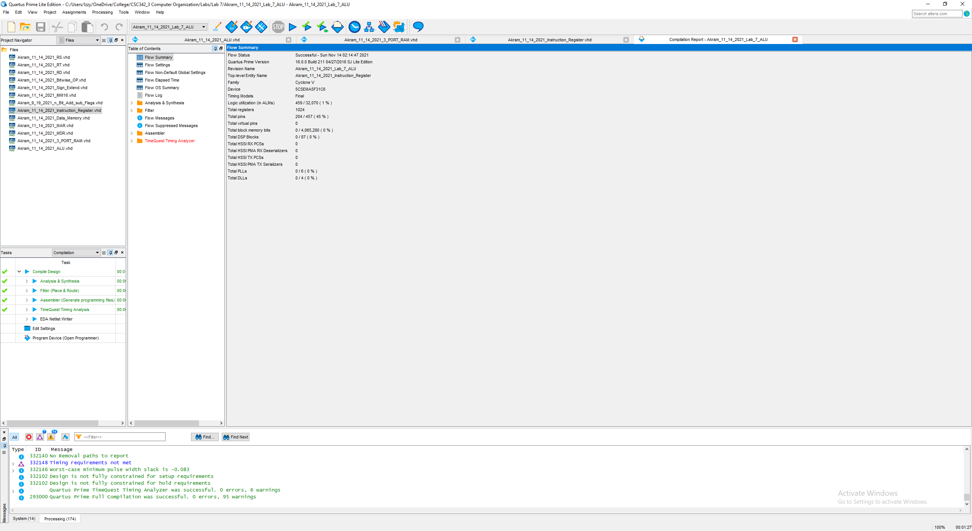

Fig 29. Compilation Report (successful)

## Data Memory

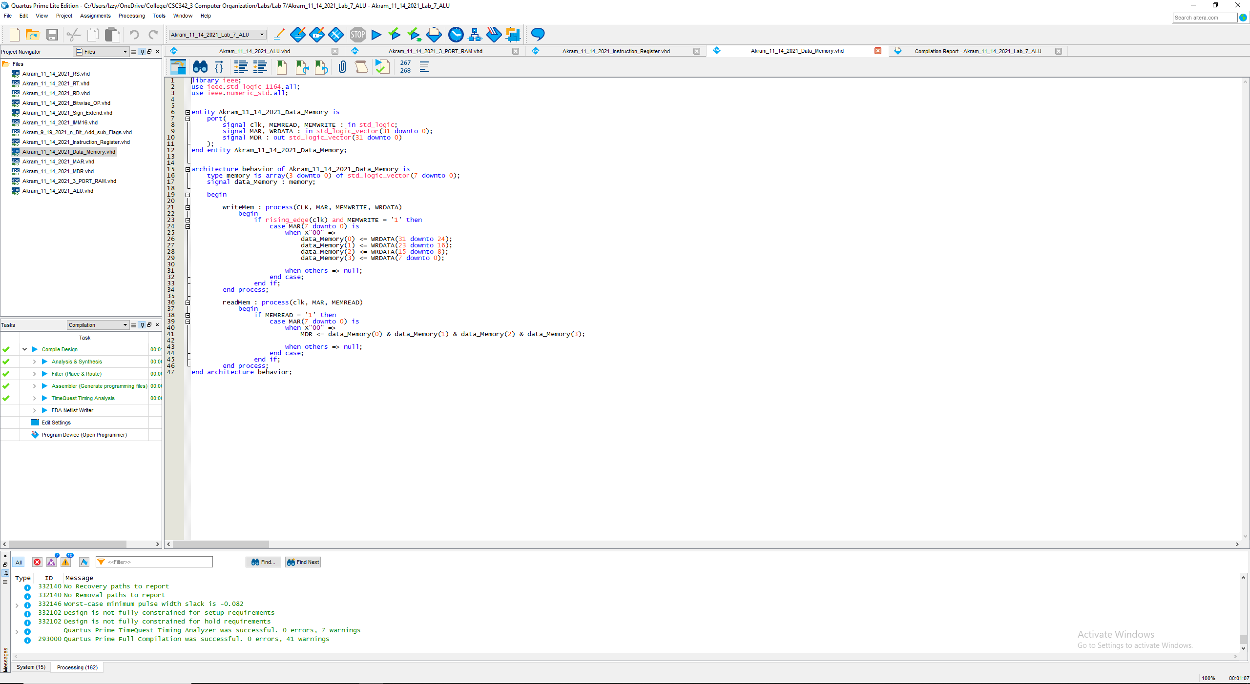

Fig 30. VHDL Code for Akram_11_14_2021_Data_Memory

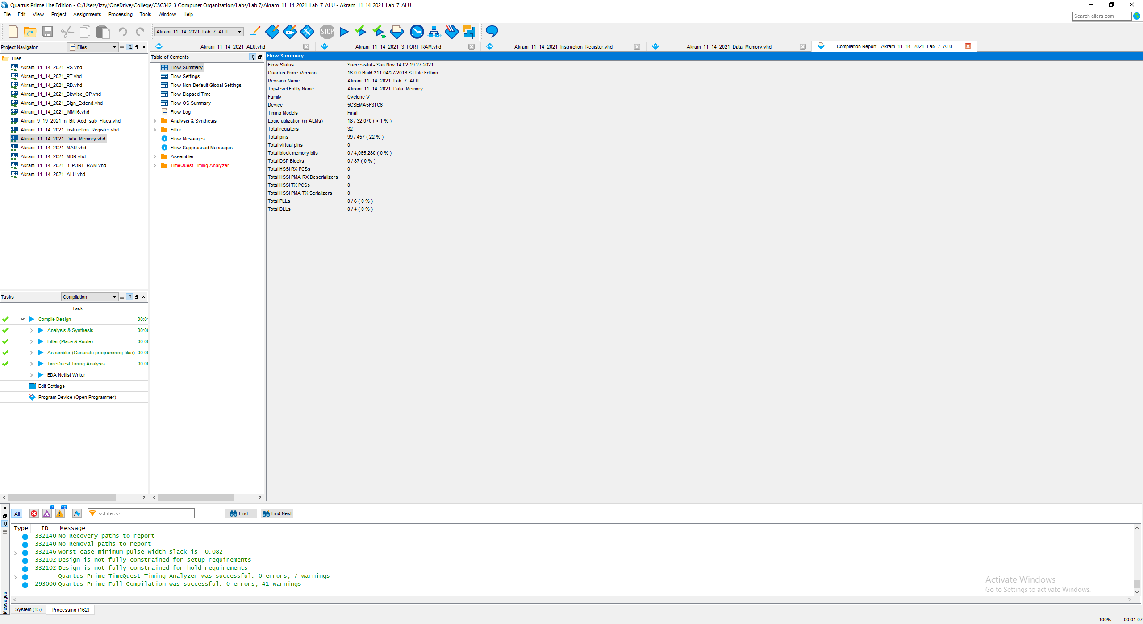

Fig 31. Compilation Report (successful)

# **Simulations**

All CLK rates are standard falling edge, op codes are included, e.g., add = 0000.

## add (000)

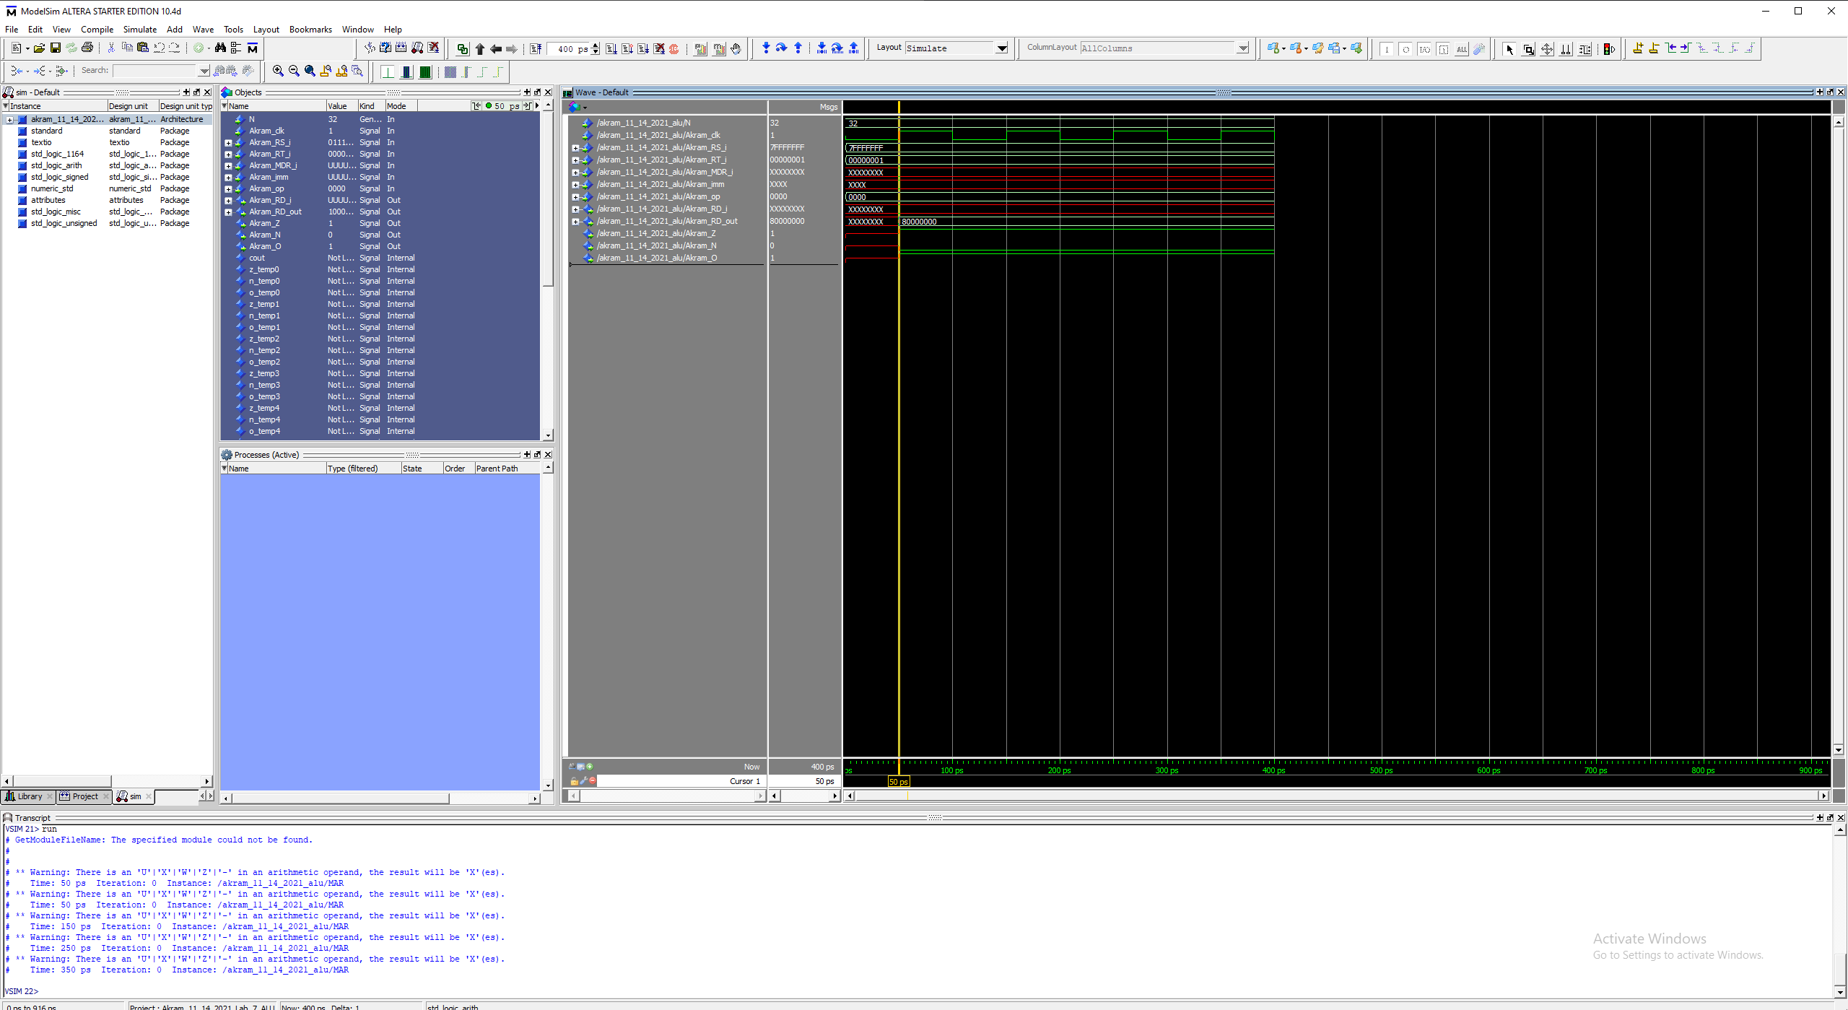

Fig 32. Add (R Format) (op code 0000)

R[rd] (0x80000000) = R[rs] (0x7FFFFFFF) + R[rt] (0x00000001)

@ 50 ps: wren lines up with the RISING EDGE of clk and our result is stored in R[rd]

Zero Flag, Overflow Flag

## addi (0001)

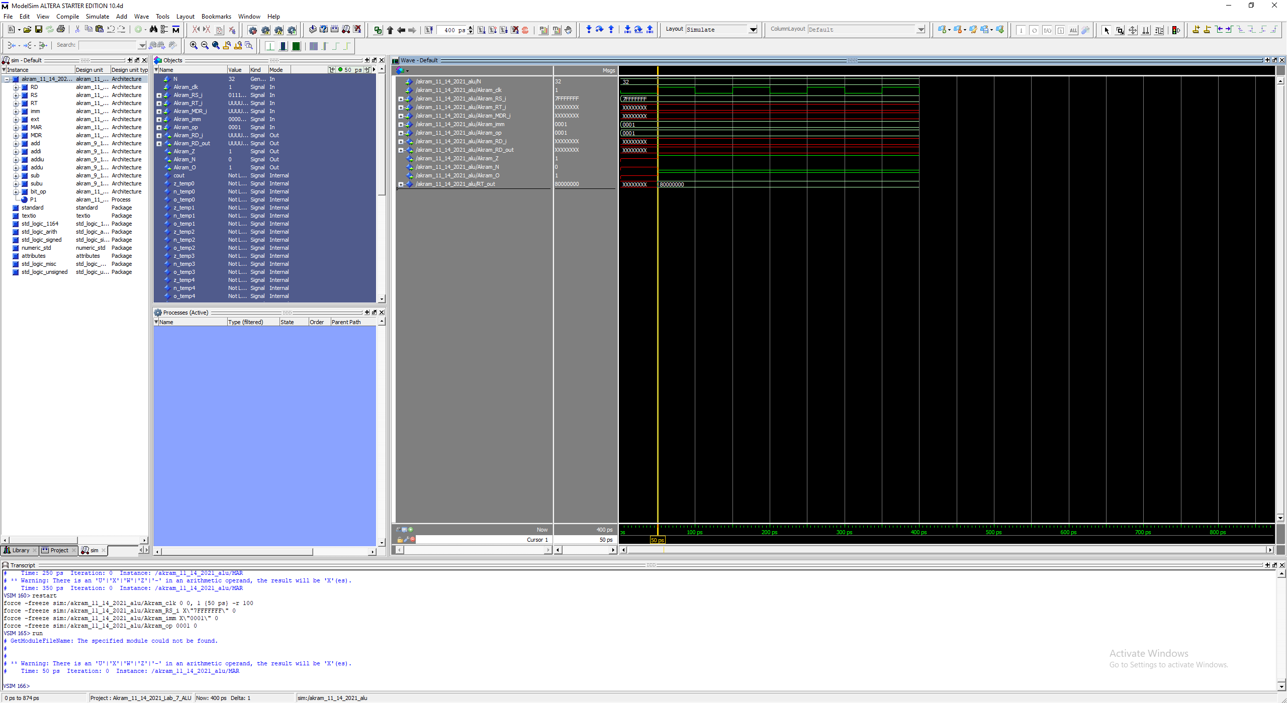

Fig 33. Addi (I Format) (op code 0001)

R[rt] (0x80000000) = R[rs] (0x7FFFFFFF) + SignExtImm (0x0001)

@ 50 ps: wren lines up with the RISING EDGE of clk and our result is stored in R[rt]

Zero Flag, Overflow Flag

## addiu (0010)

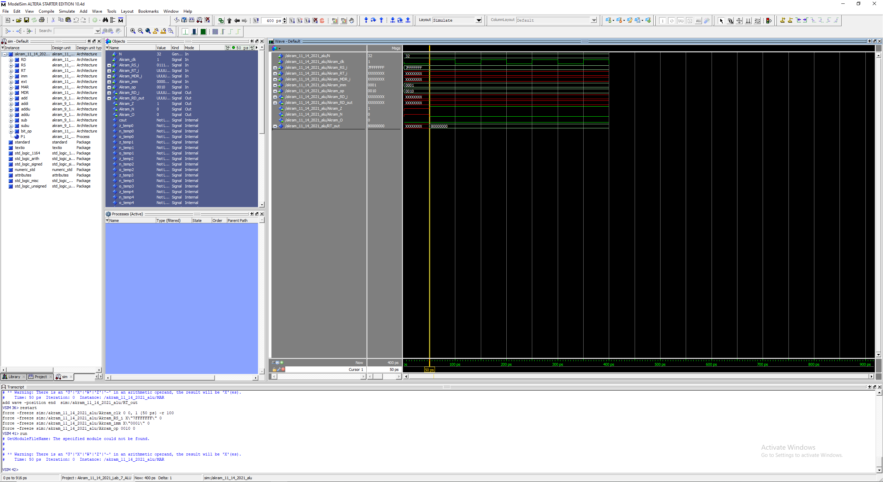

Fig 34. Addiu (I Format) (op code 0010)

R[rt] (0x80000000) = R[rs] (0x7FFFFFFF) + SignExtImm (0x0001)

@ 50 ps: wren lines up with the RISING EDGE of clk and our result is stored in R[rt]

Zero Flag

## addu (0011)

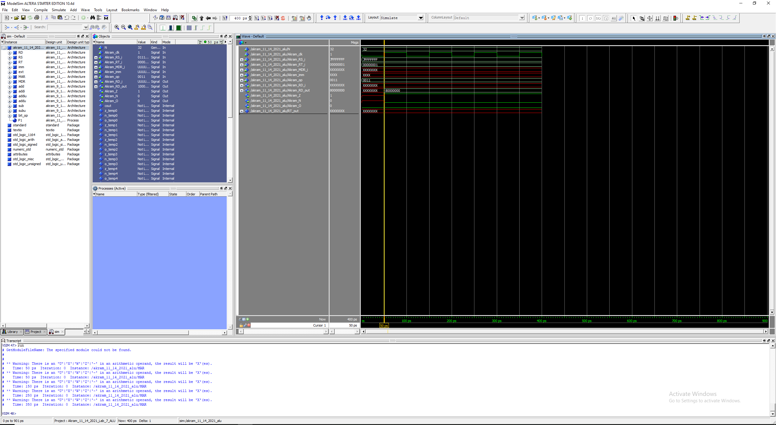

Fig 35. Addu (R Format) (op code 0011)

R[rd] (0x80000000) = R[rs] (0x7FFFFFFF) + R[rt] (0x00000001)

@ 50 ps: wren lines up with the RISING EDGE of clk and our result is stored in R[rd]

Zero Flag

## sub (0100)

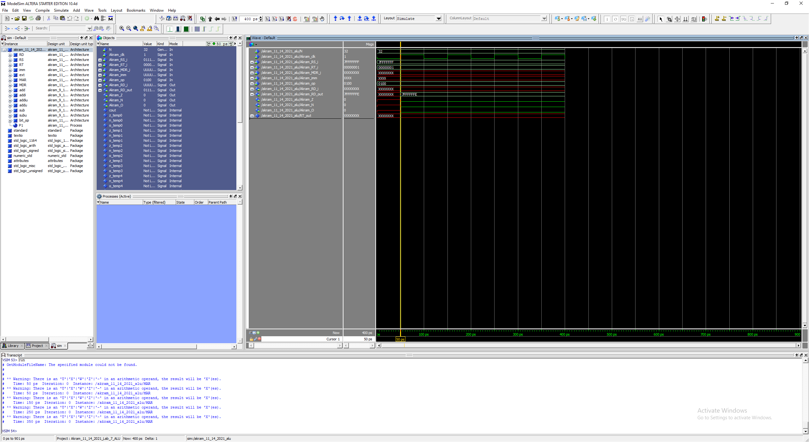

Fig 36. Sub (R Format) (op code 0100)

R[rd] (0x7FFFFFFE) = R[rs] (0x7FFFFFFF) - R[rt] (0x00000001)

@ 50 ps: wren lines up with the RISING EDGE of clk and our result is stored in R[rd]

## subu (0101)

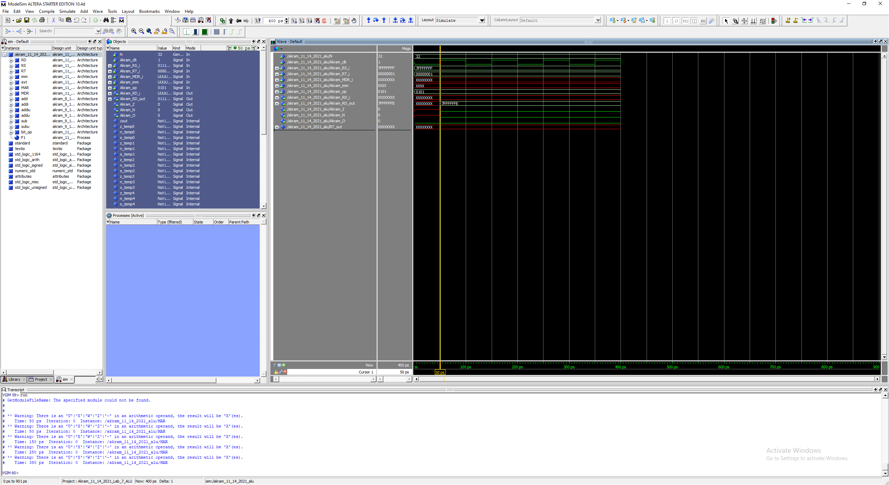

Fig 37. Subu (R Format) (op code 0101)

R[rd] (0x7FFFFFFE) = R[rs] (0x7FFFFFFF) - R[rt] (0x00000001)

@ 50 ps: wren lines up with the RISING EDGE of clk and our result is stored in R[rd]

## and (0110)

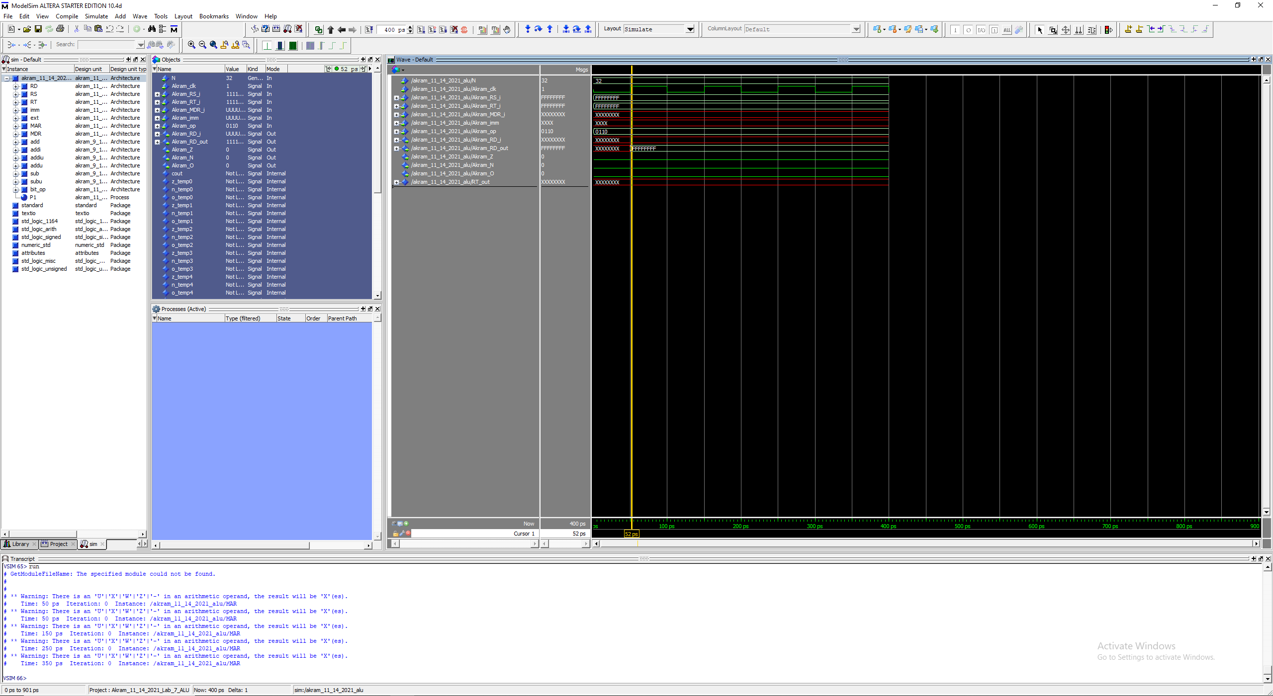

Fig 38. AND (R Format) (op code 0110)

R[rd] (0xFFFFFFFF) = R[rs] (0xFFFFFFFF) && R[rt] (0xFFFFFFFF)

@ 50 ps: wren lines up with the RISING EDGE of clk and our result is stored in R[rd]

## andi (0111)

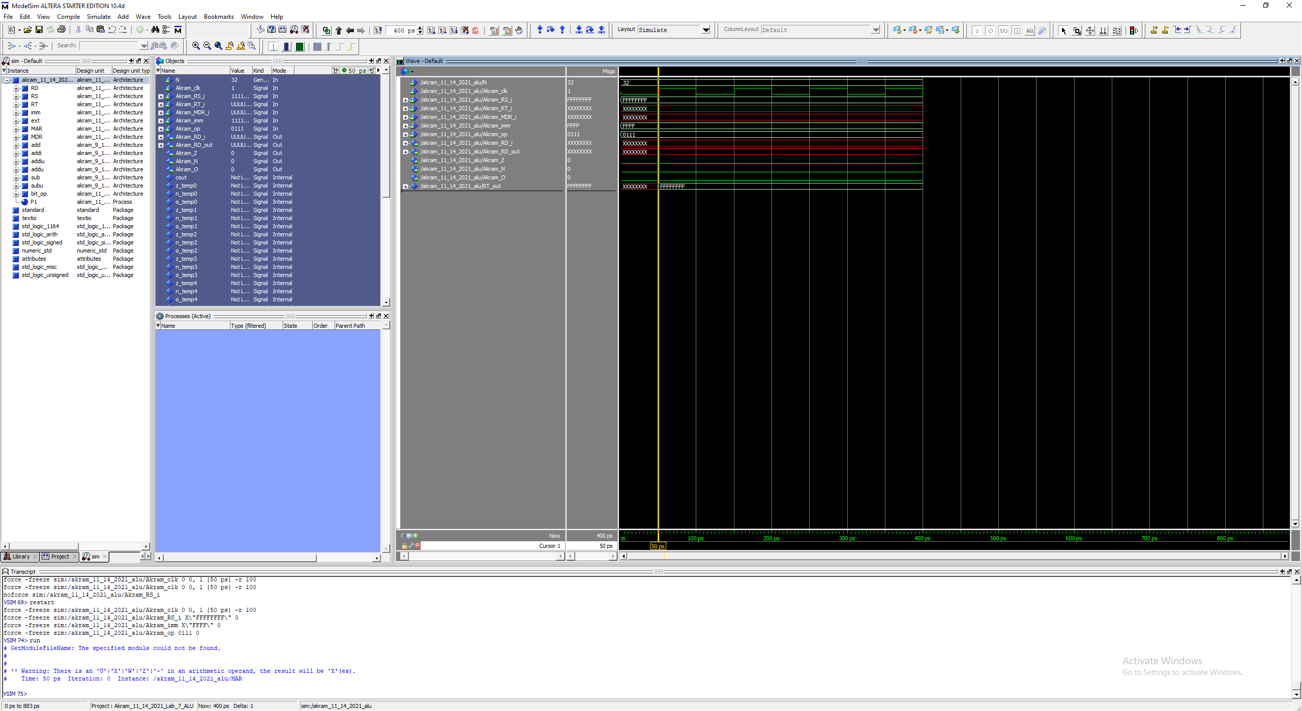

Fig 39. ANDi (I Format) (op code 0111)

R[rt] (0xFFFFFFFF) = R[rs] (0xFFFFFFFF) && ZeroExtImm (0xFFFF)

@ 50 ps: wren lines up with the RISING EDGE of clk and our result is stored in R[rt]

## nor (1000)

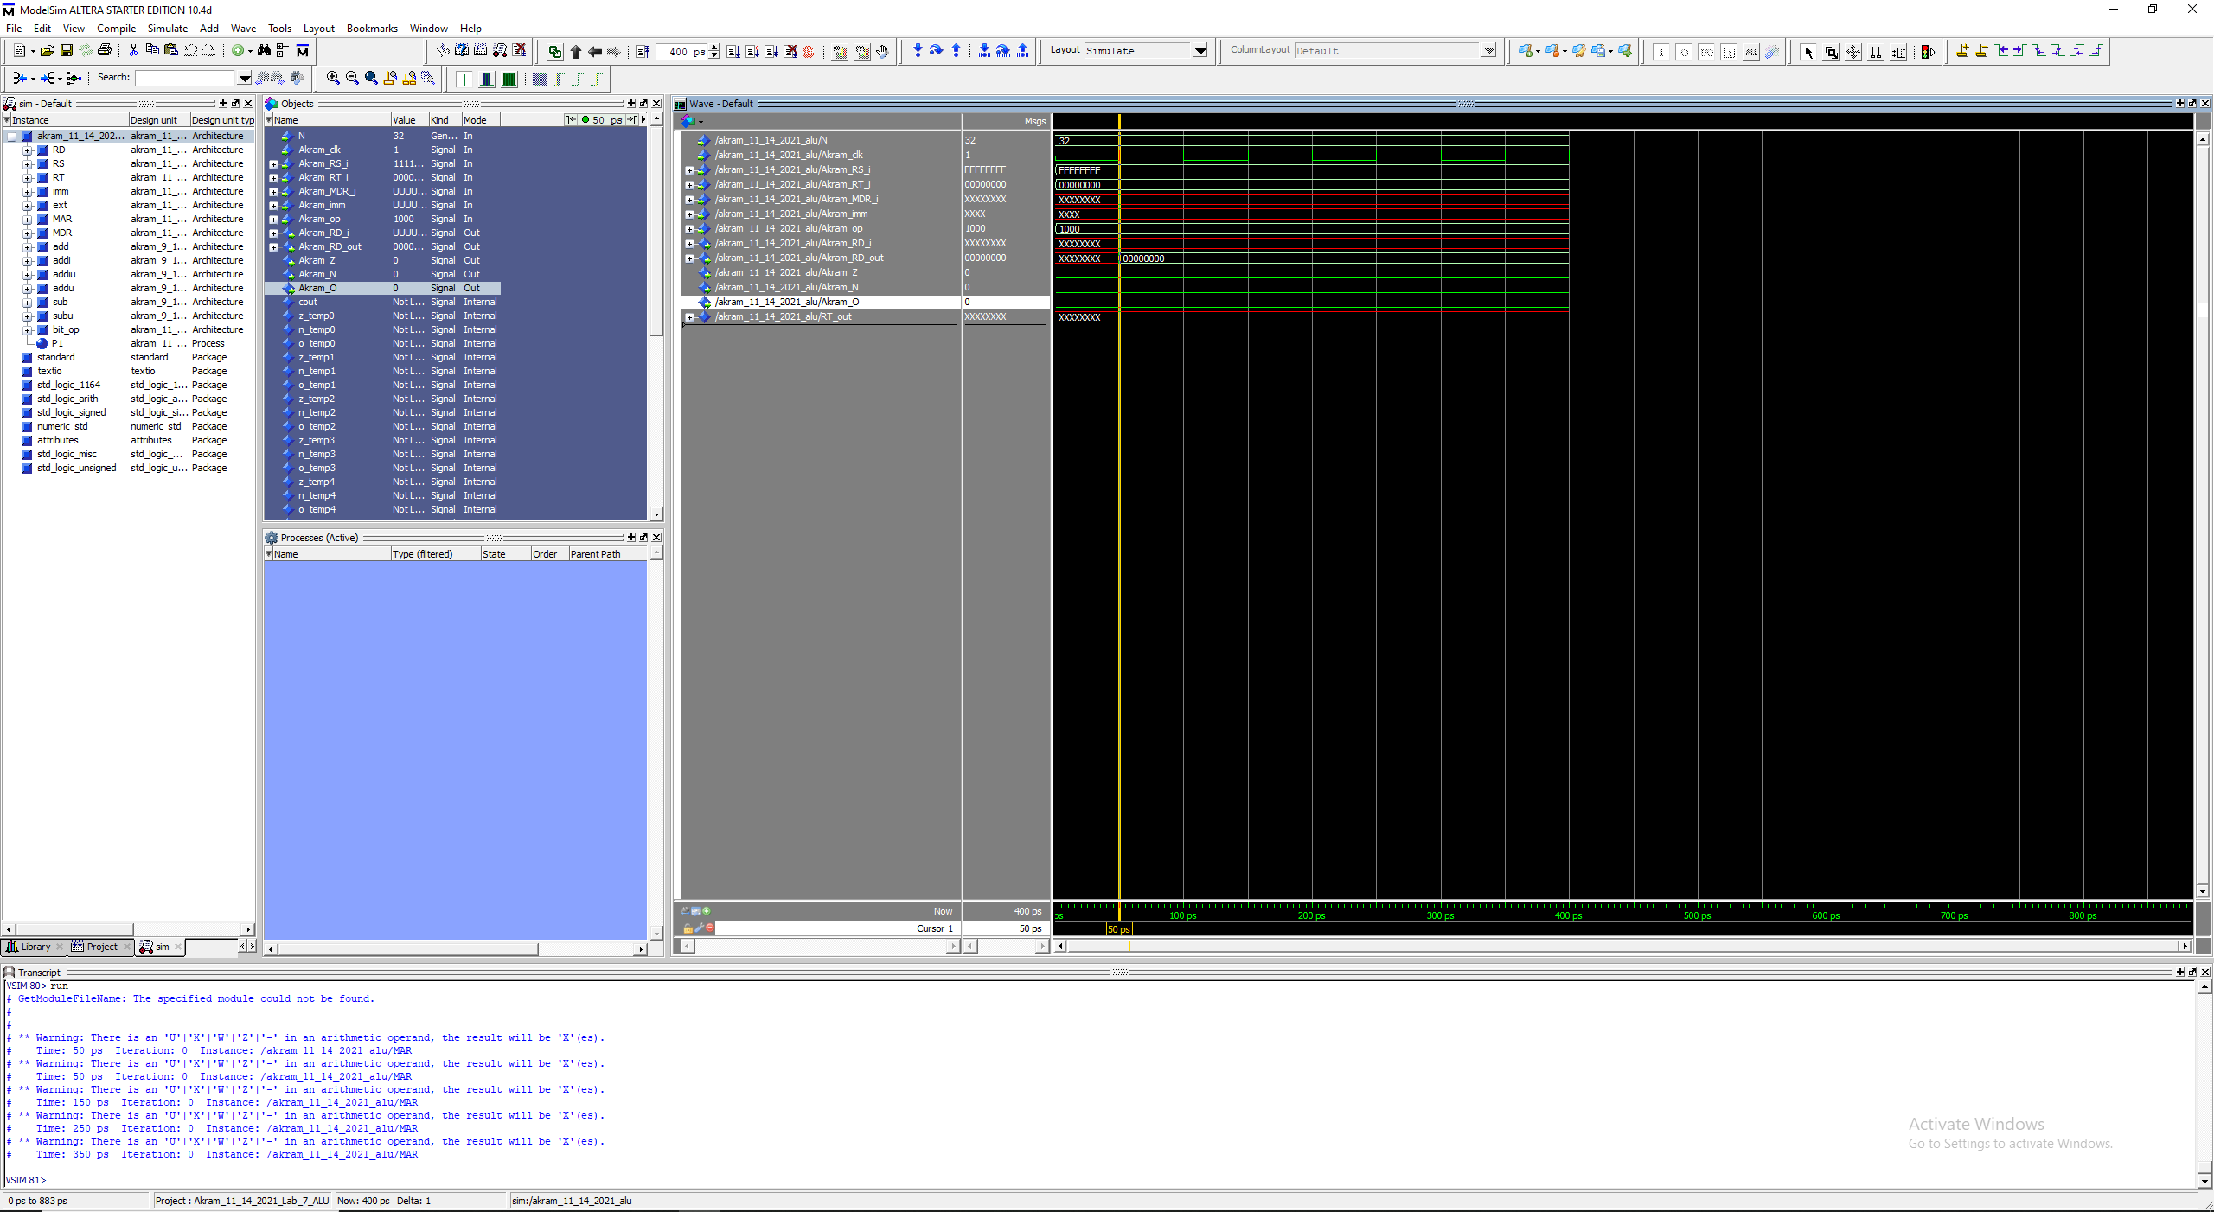

Fig 40. NOR (R Format) (op code 1000)

R[rd] (0x00000000) = ~(R[rs] (0xFFFFFFFF) | R[rt] (0x00000000))

@ 50 ps: wren lines up with the RISING EDGE of clk and our result is stored in R[rd]

## or (1001)

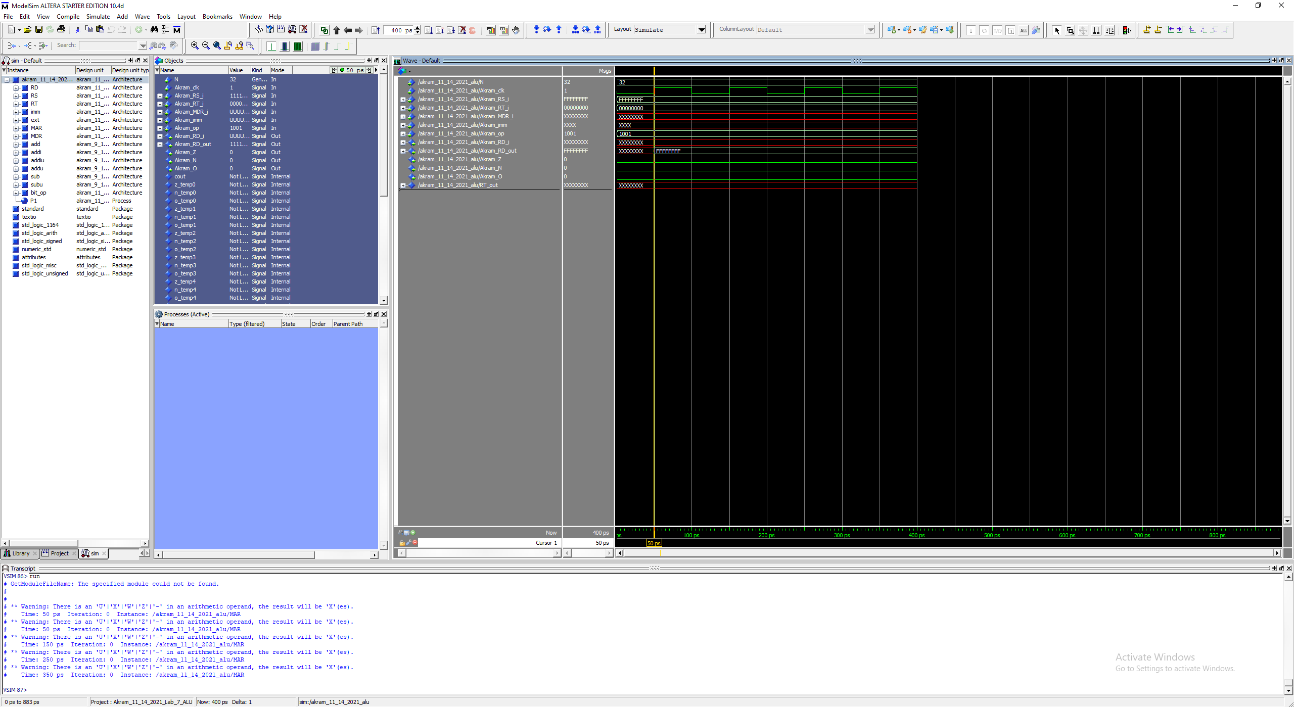

Fig 41. OR (R Format) (op code 1001)

R[rd] (0xFFFFFFFF) = R[rs] (0xFFFFFFFF) | R[rt] (0x00000000)

@ 50 ps: wren lines up with the RISING EDGE of clk and our result is stored in R[rd]

## ori (1010)

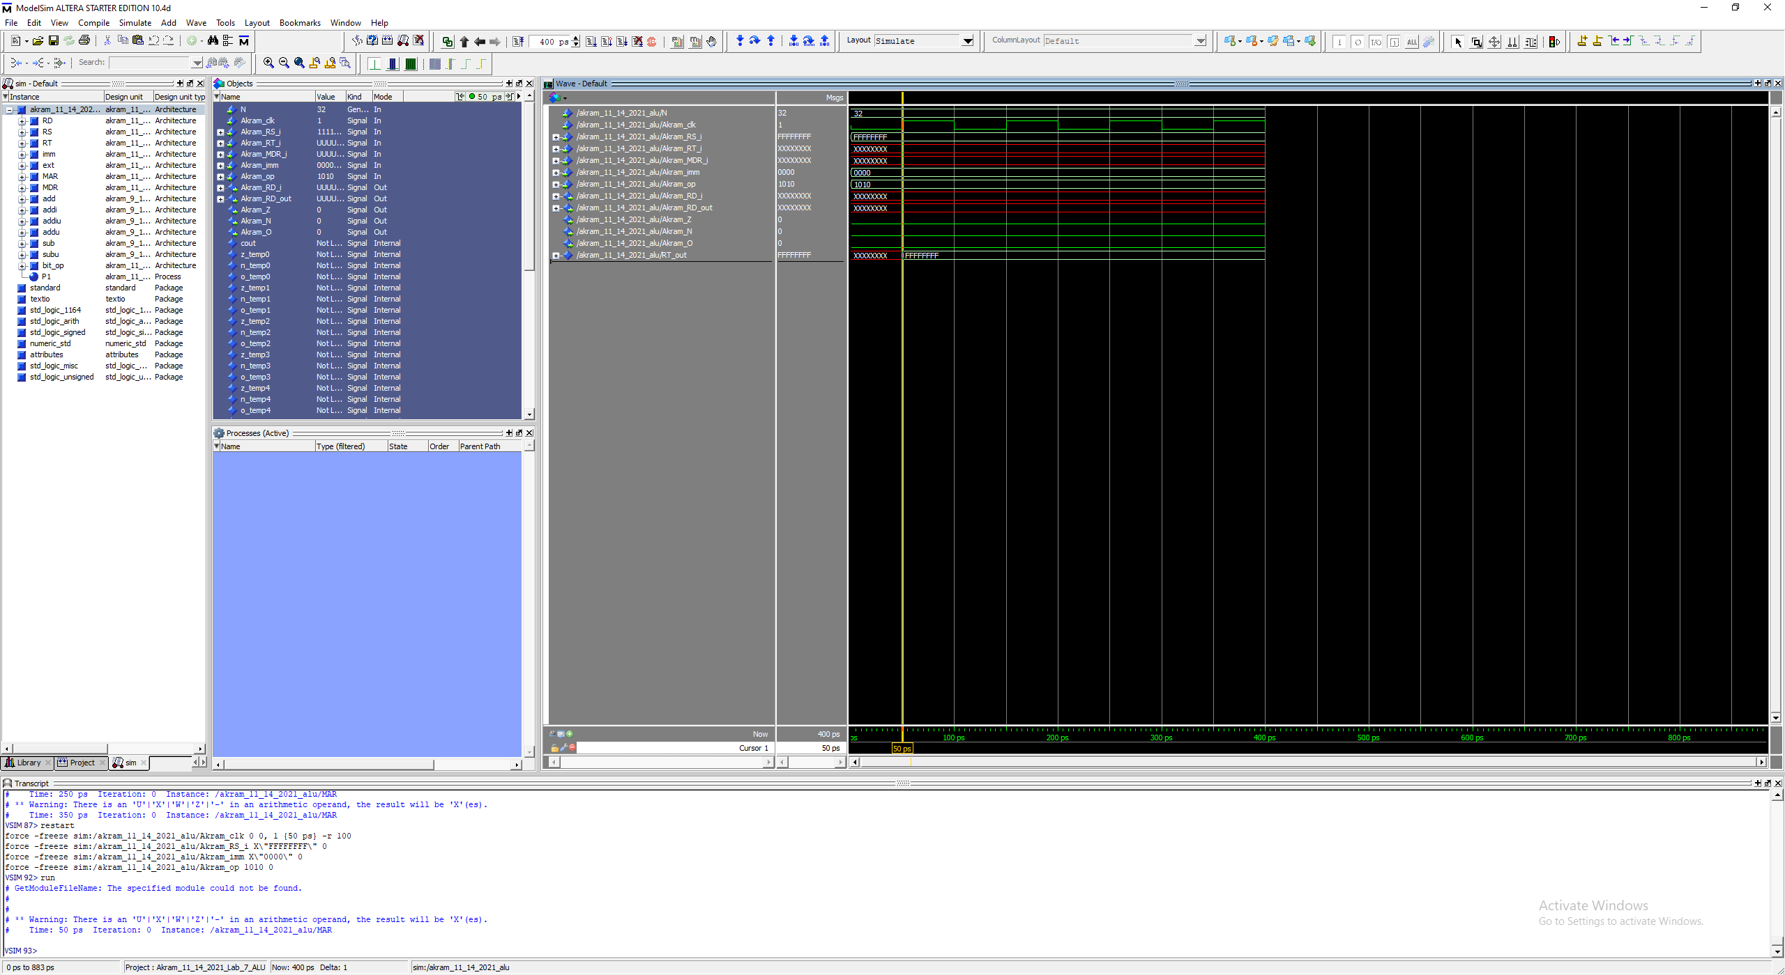

Fig 42. ORi (R Format) (op code 1010)

R[rt] (0xFFFFFFFF) = R[rs] (0xFFFFFFFF) | ZeroExtImm (0x0000)

@ 50 ps: wren lines up with the RISING EDGE of clk and our result is stored in R[rt]

## SLL (1011)

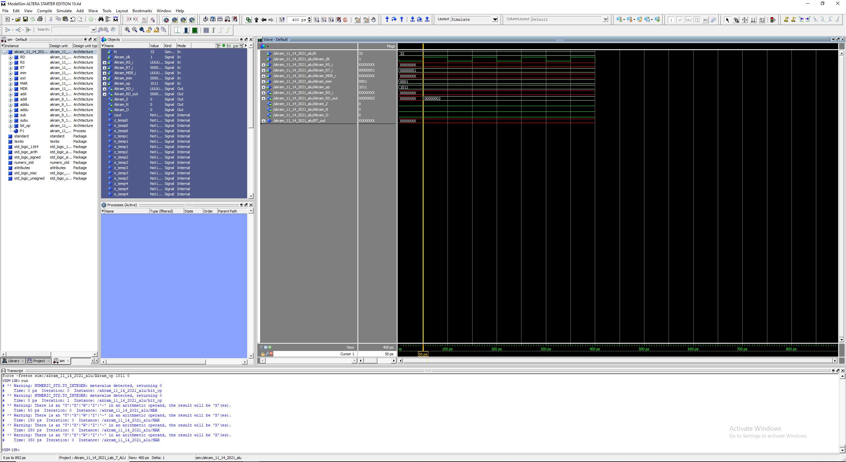

Fig 43. SLL (R Format) (op code 1011)

R[rd] (0x00000002) = R[rt] (0x00000001) << shamt (0x0001)

@ 50 ps: wren lines up with the RISING EDGE of clk and our result is stored in R[rd]

Note:

0x00000001 = 0b00000000000000000000000000000001

0x00000002 = 0b00000000000000000000000000000010 … i.e., 1 bit shifted to the left

## SRL (1011)

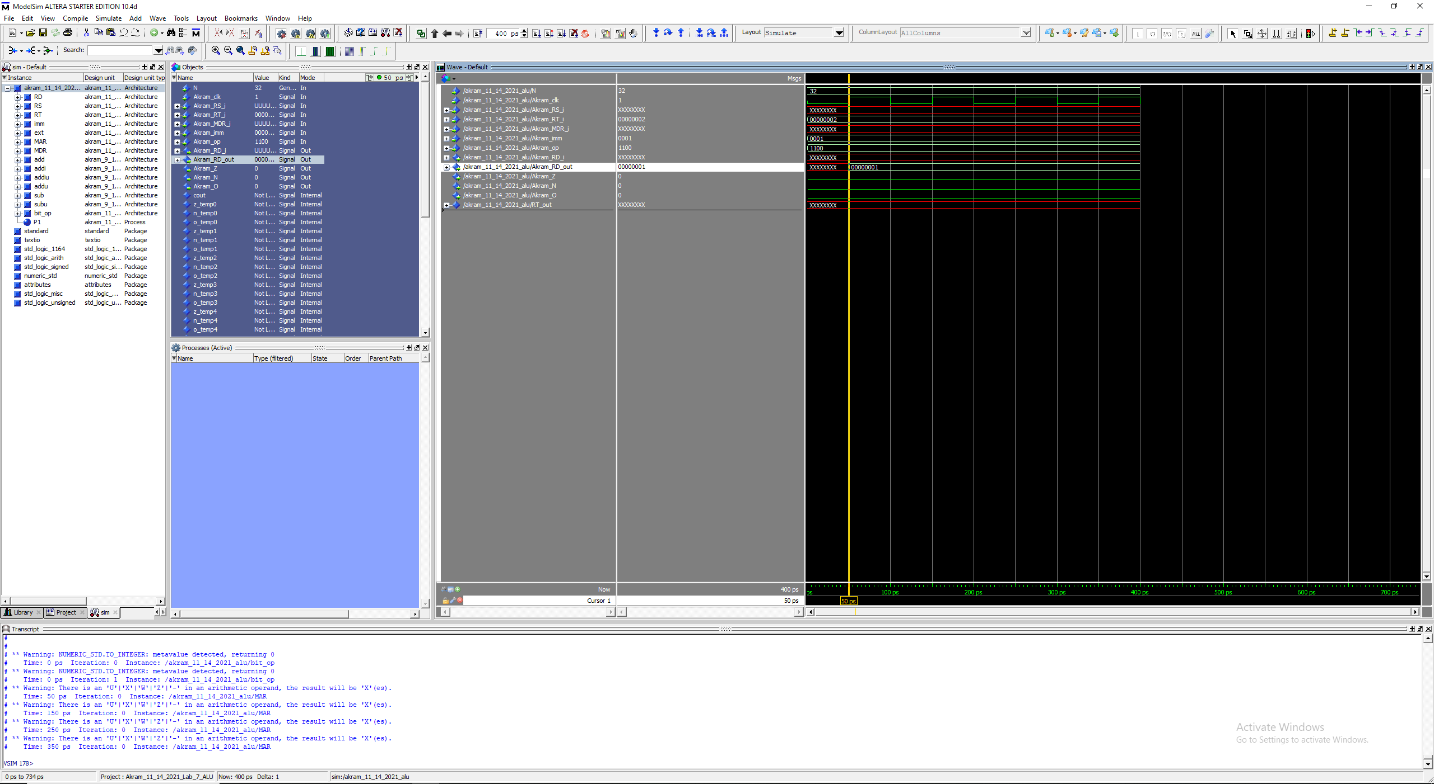

Fig 44. SRL (R Format) (op code 1011)

R[rd] (0x00000001) = R[rt] (0x00000002) >> shamt (0x0001)

@ 50 ps: wren lines up with the RISING EDGE of clk and our result is stored in R[rd]

Note:

0x00000002 = 0b00000000000000000000000000000010

0x00000001 = 0b00000000000000000000000000000001 … i.e., 1 bit shifted to the right

## SRA (1101)

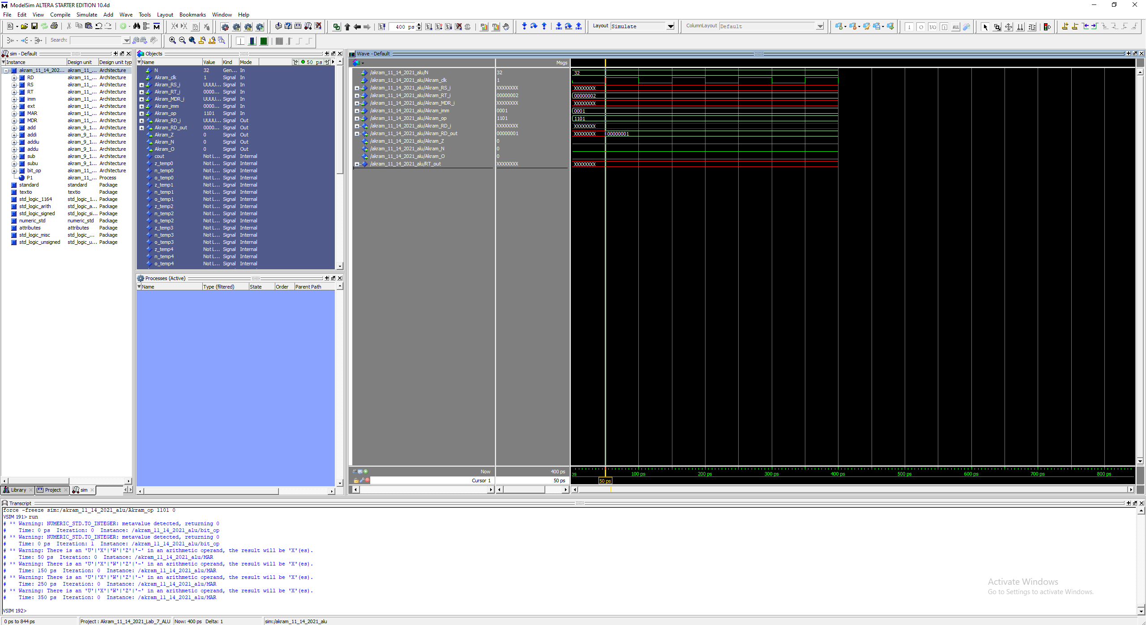

Fig 45. SRA (R Format) (op code 1101)

R[rd] (0x00000001) = R[rt] (0x00000002) >>> shamt (0x0001)

@ 50 ps: wren lines up with the RISING EDGE of clk and our result is stored in R[rd]

Note:

0x00000002 = 0b00000000000000000000000000000010

0x00000001 = 0b00000000000000000000000000000001 … i.e., 1 bit shifted to the right

## SW (1110)

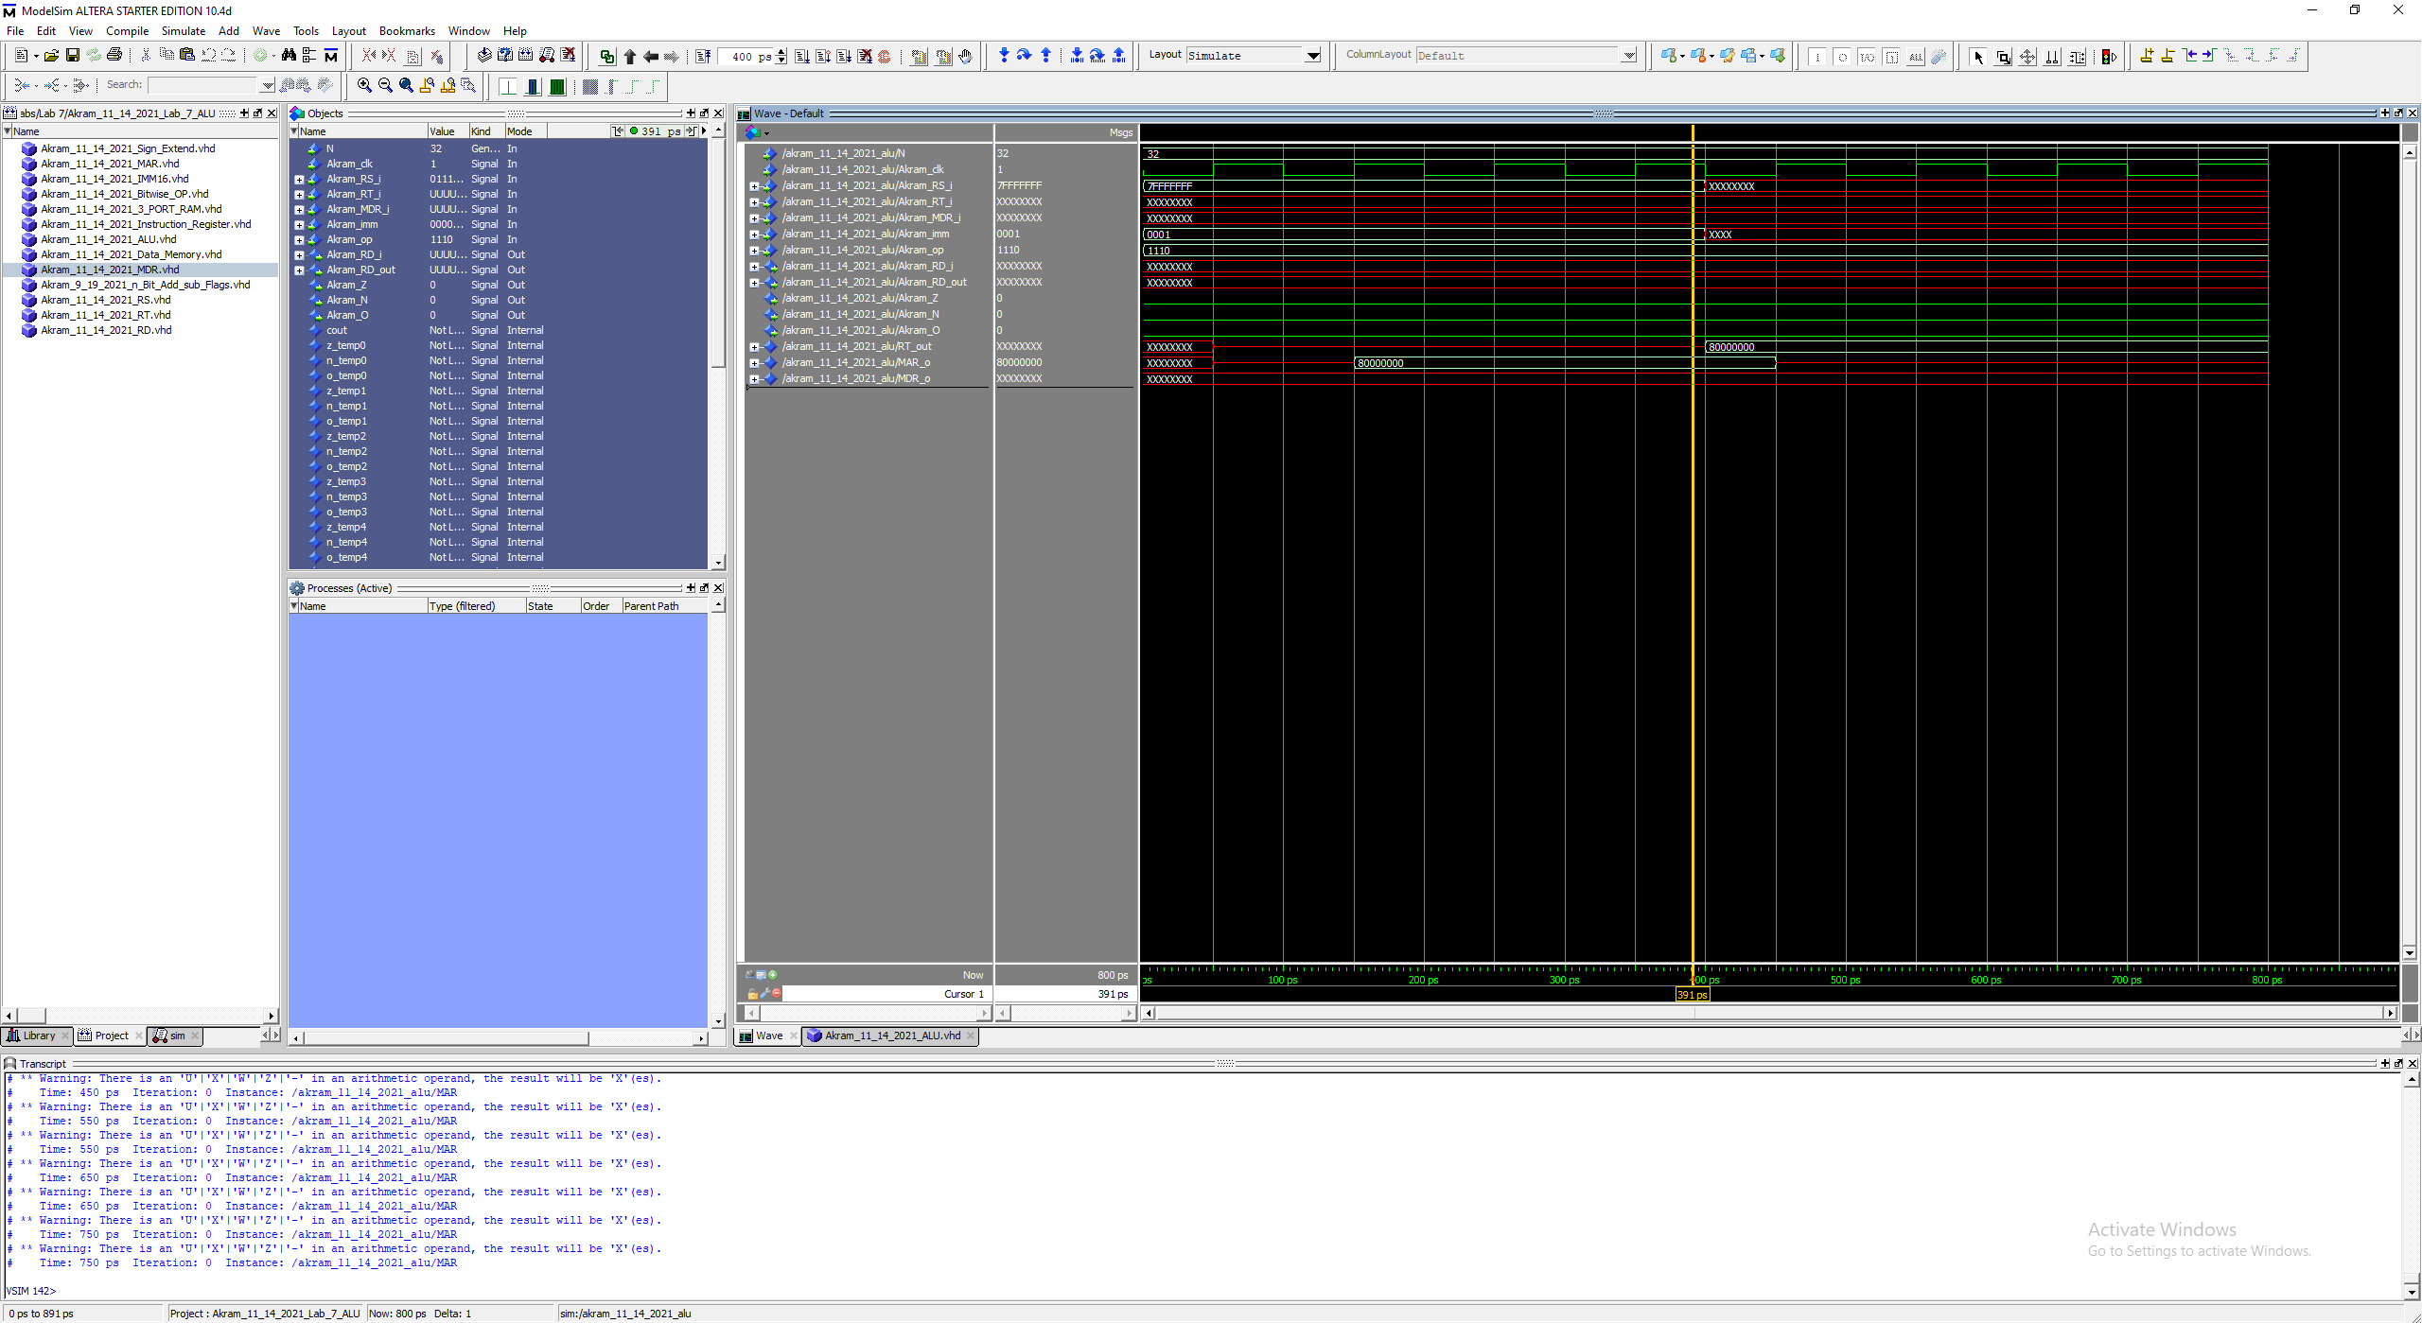

Fig 46. SW (I Format) (op code 1110)

M[R[rs] (0x7FFFFFFF) + SignExtImm (0x0001)] = R[rt] (0x80000000)

@ 150 ps: wren lines up with the RISING EDGE of clk and our result is stored in Mar_o

@ 400ps: wren lines up with the RISING EDGE of clk and our M_o is stored in RT_o … R[rt]

See next page on loading:

## LW (1110)

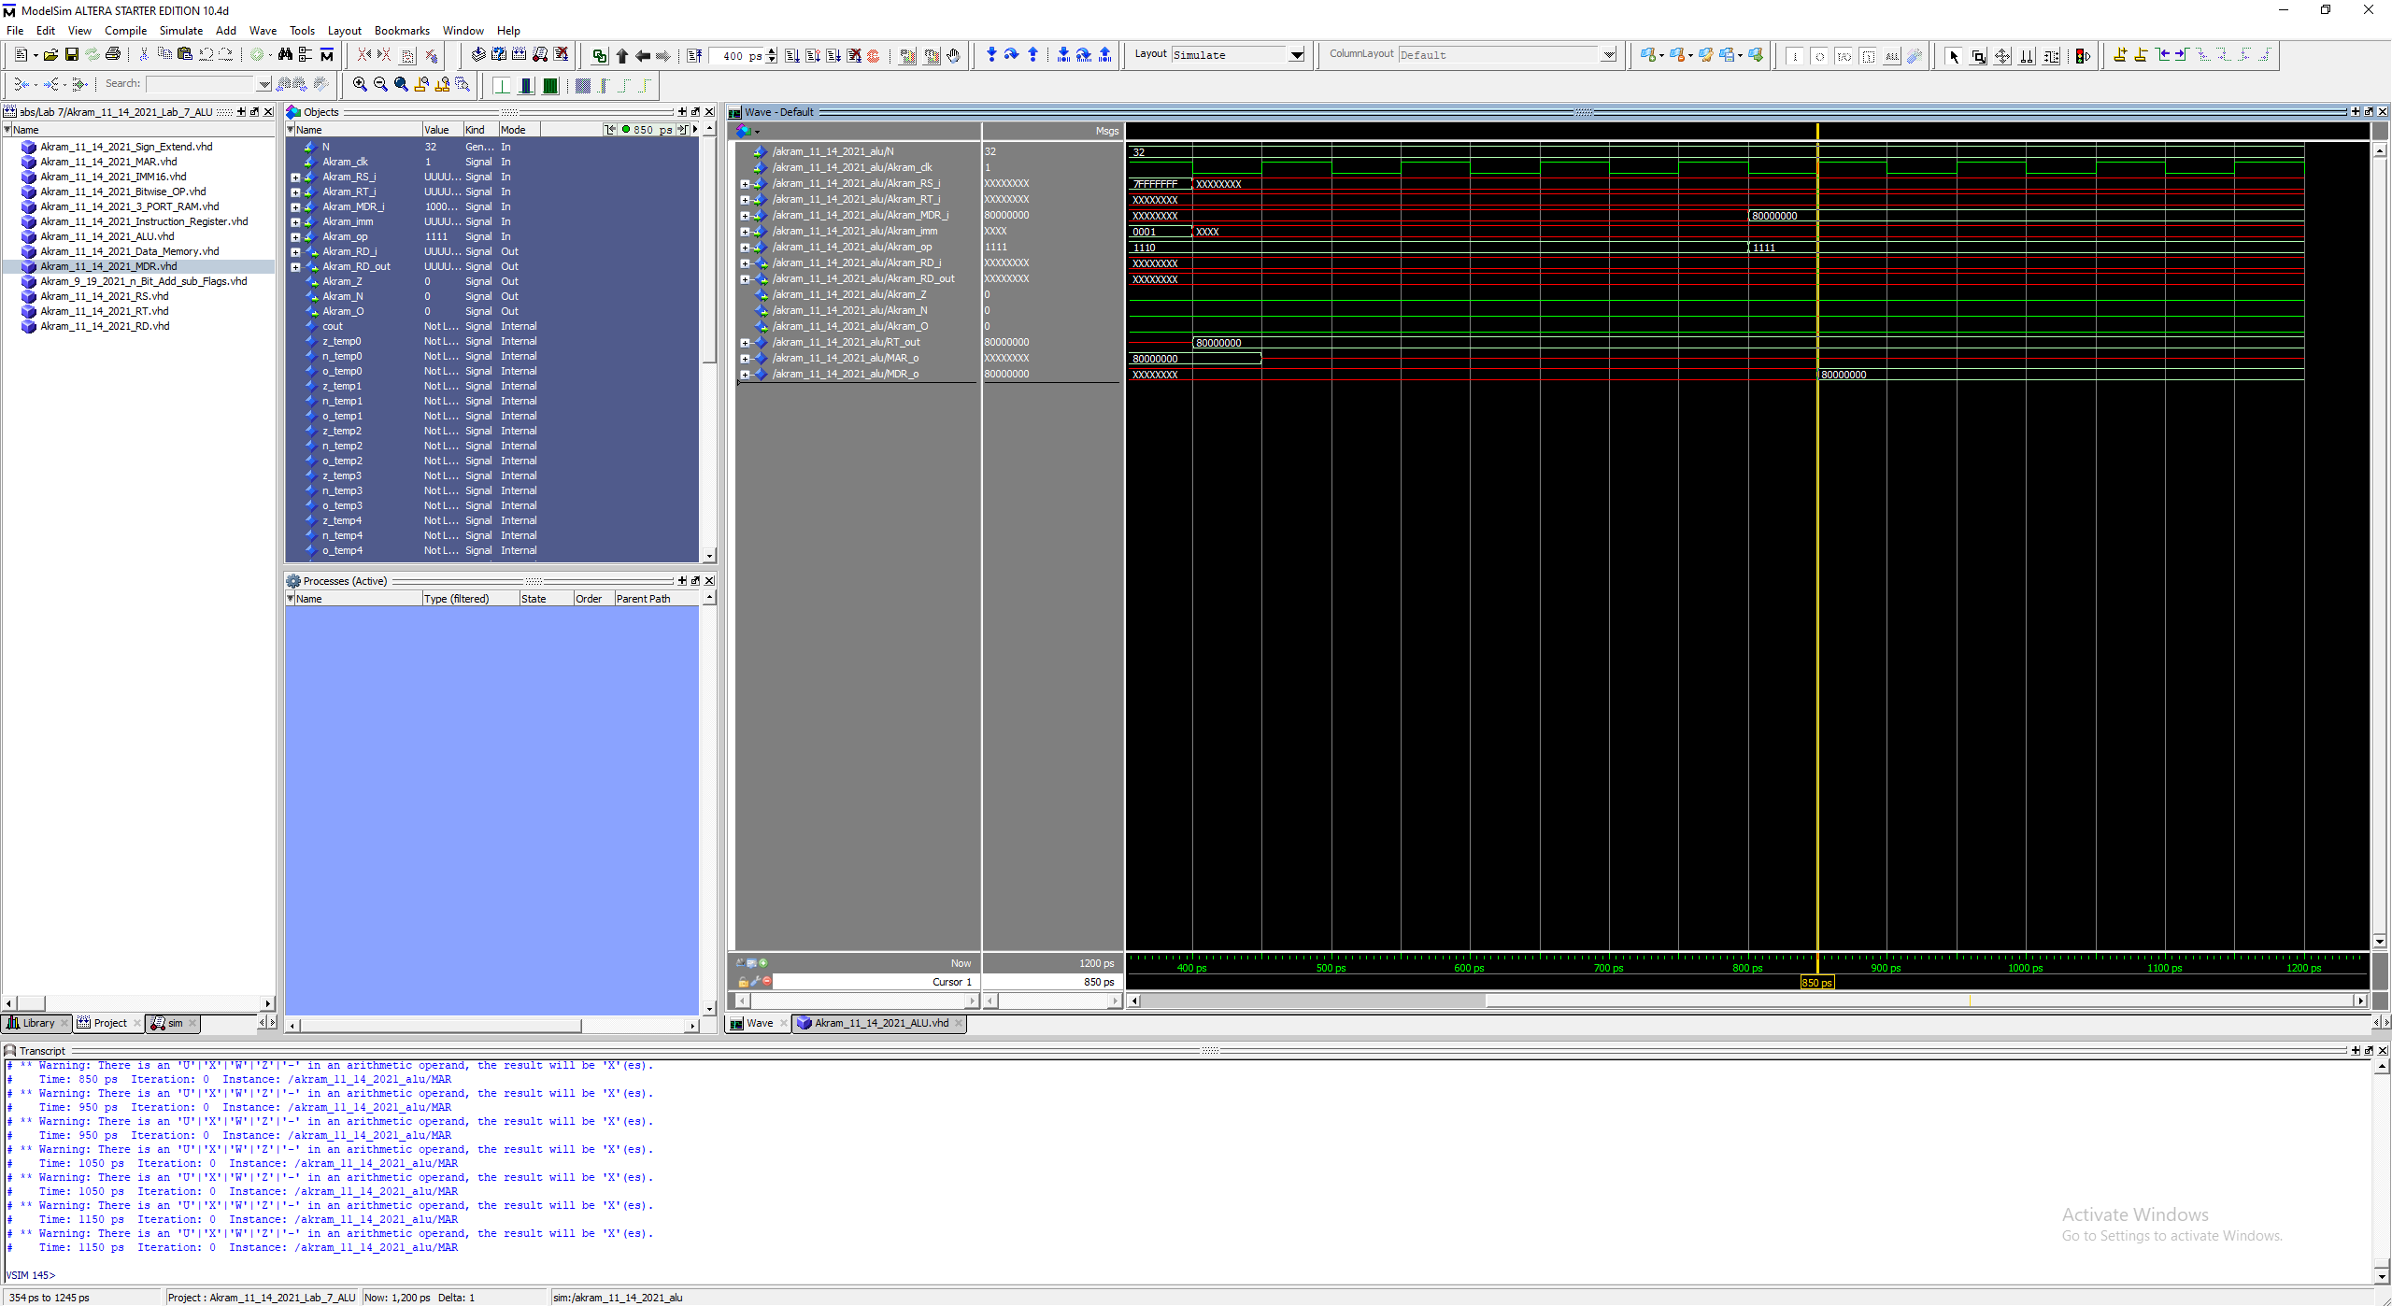

Fig 47. LW (I Format) (op code 1110)

R[rt] (0x80000000) = M[(R[rs] (0x7FFFFFFF) + SignExtImm (0x0001)]

@ 850 ps: wren lines up with the RISING EDGE of clk and our stored result in R[rt] is displayed … RT_Out

Note: Save and load word are ran back to back.

# **MIPS**

## add

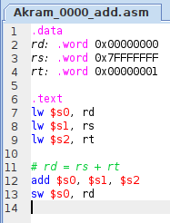

Fig 48. MIPS code for Akram_0000_add.asm

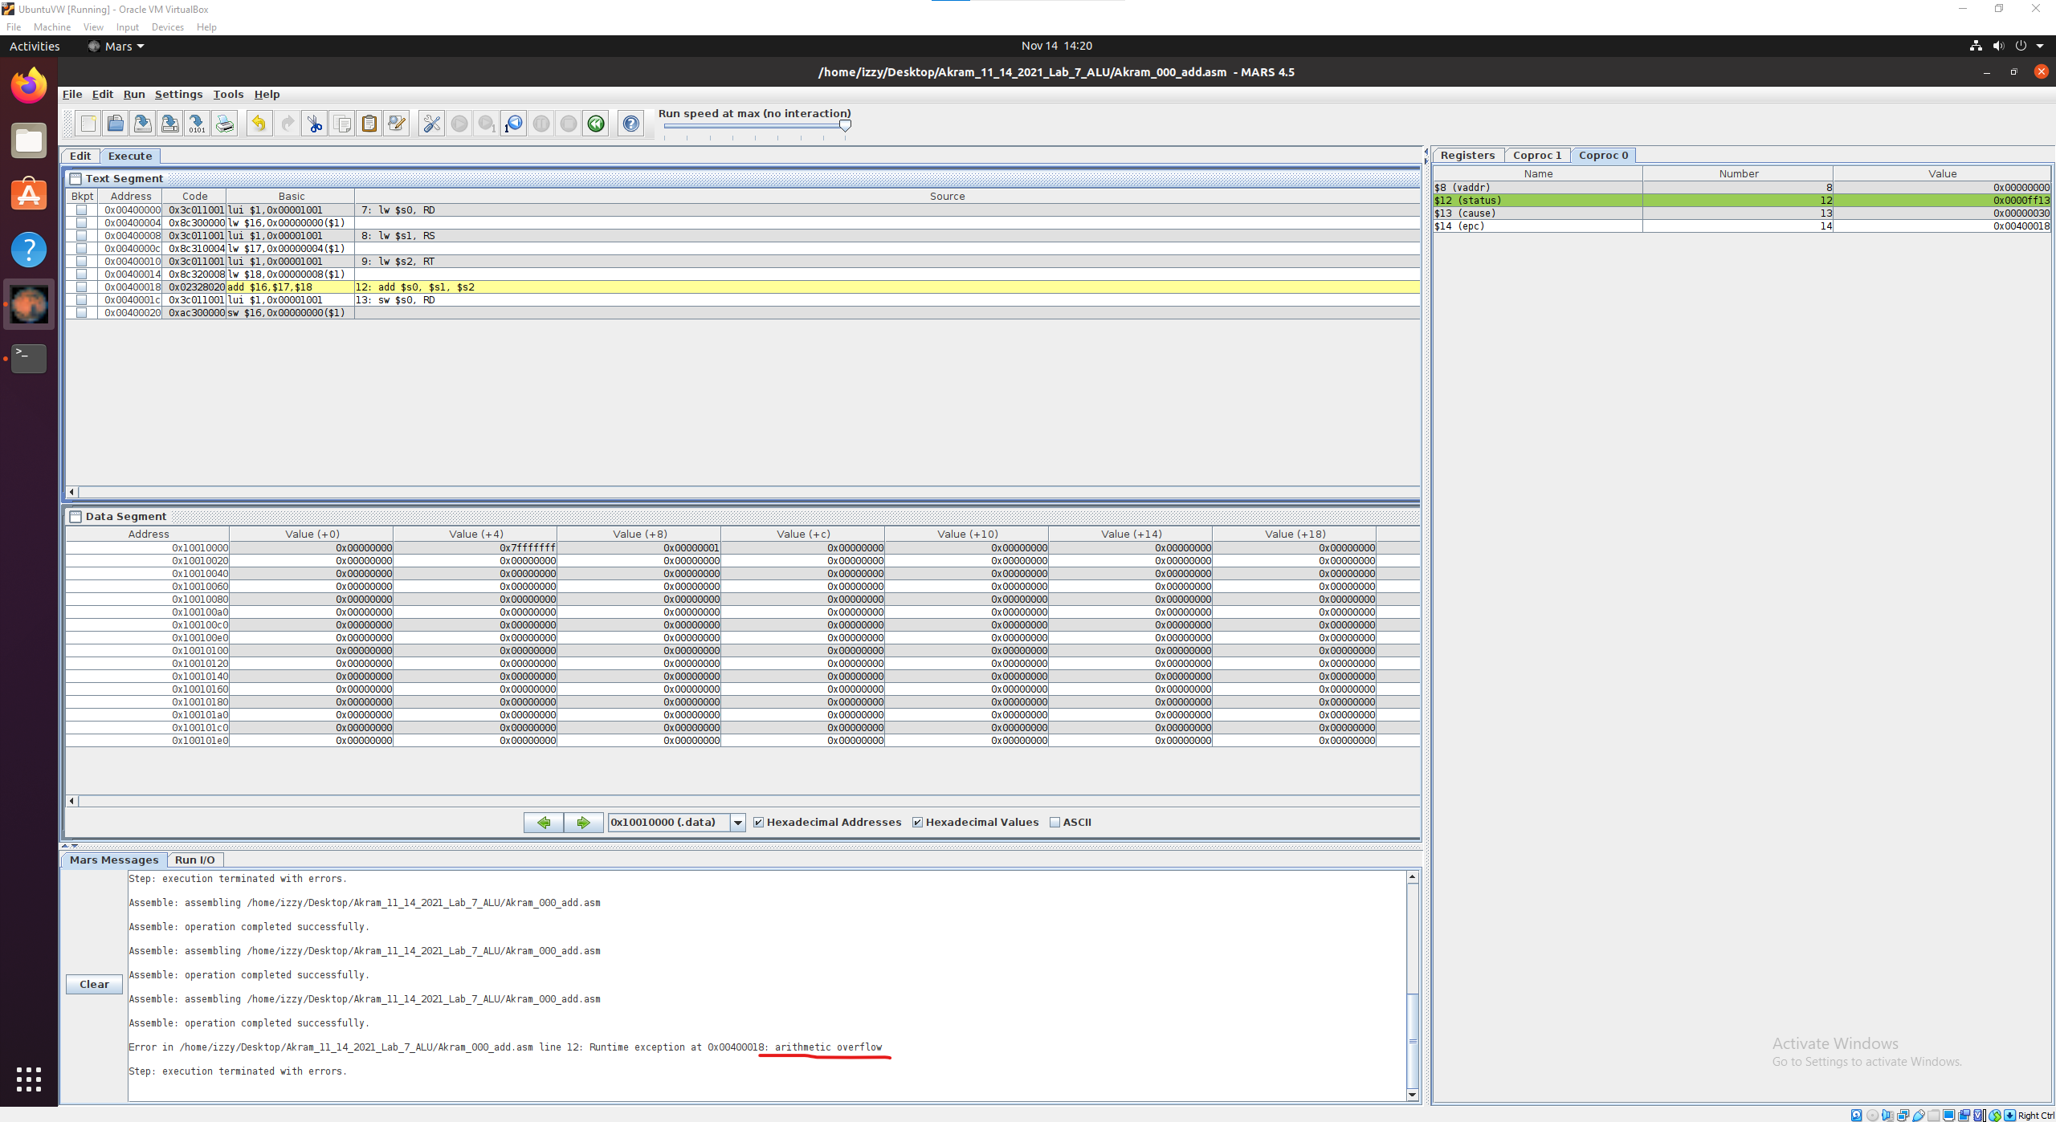

Fig 49. Execution works! Value 0x8000000 is flushed because of overflow.

Note:

Overflow detection is working. See addiu for the 0x80000000 output

## addi

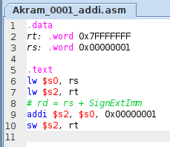

Fig 50. MIPS code for Akram_0001_addi.asm

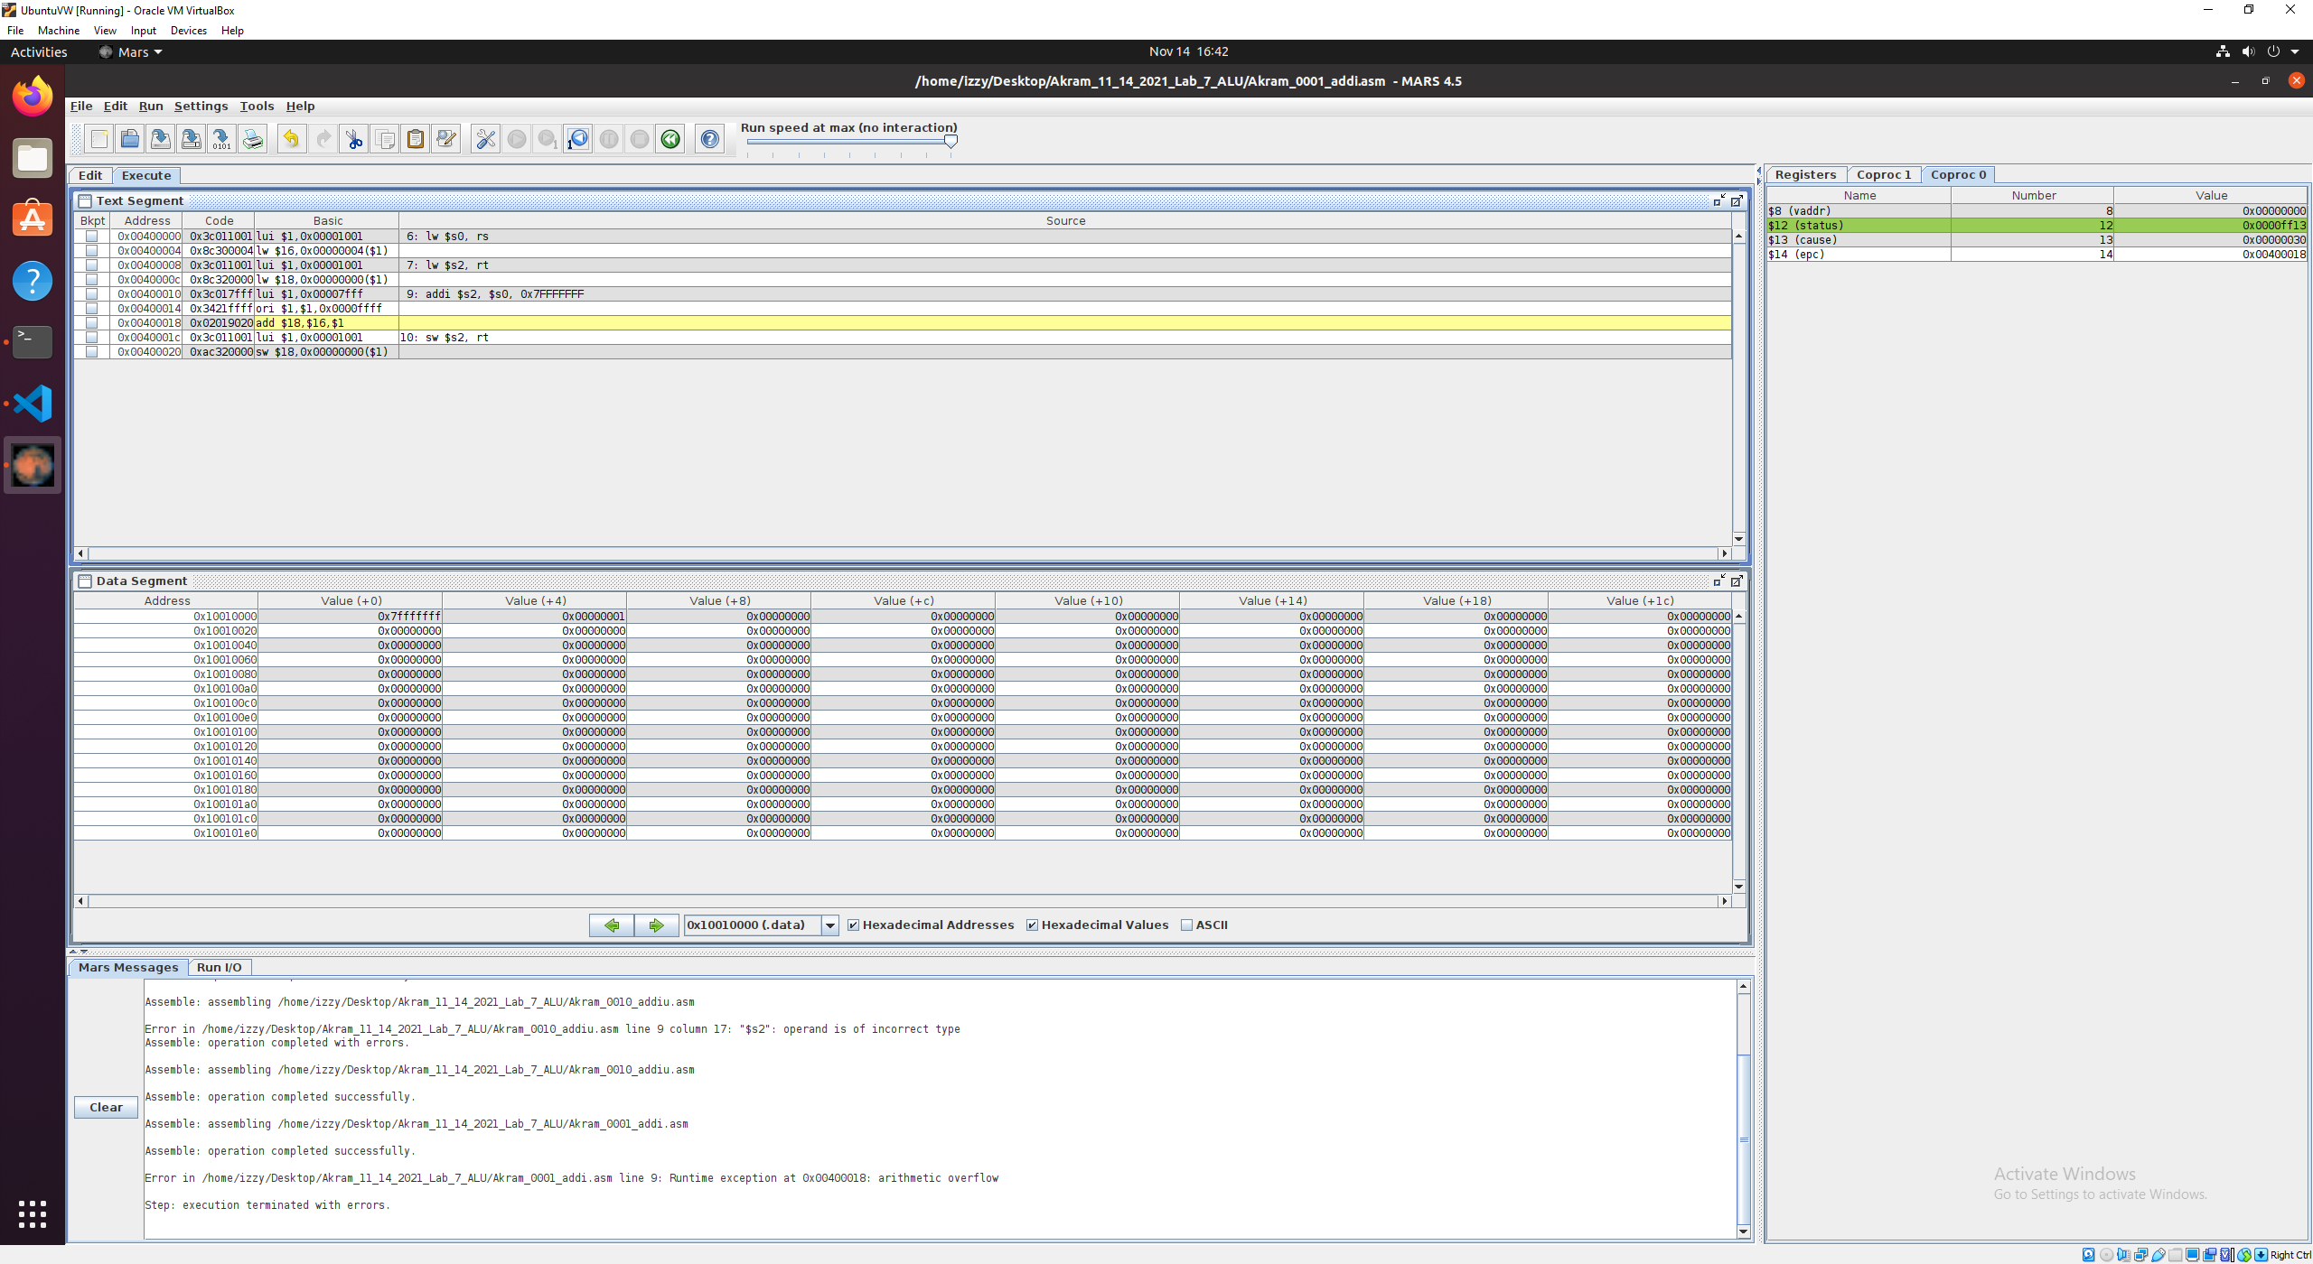

Fig 51. Execution works! Value 0x8000000 is flushed because of overflow.

Overflow detection is working.

## addiu

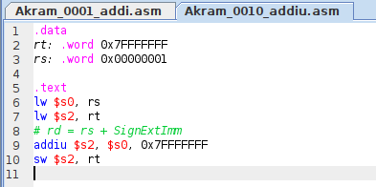

Fig X. MIPS code for Akram_0010_addiu.asm

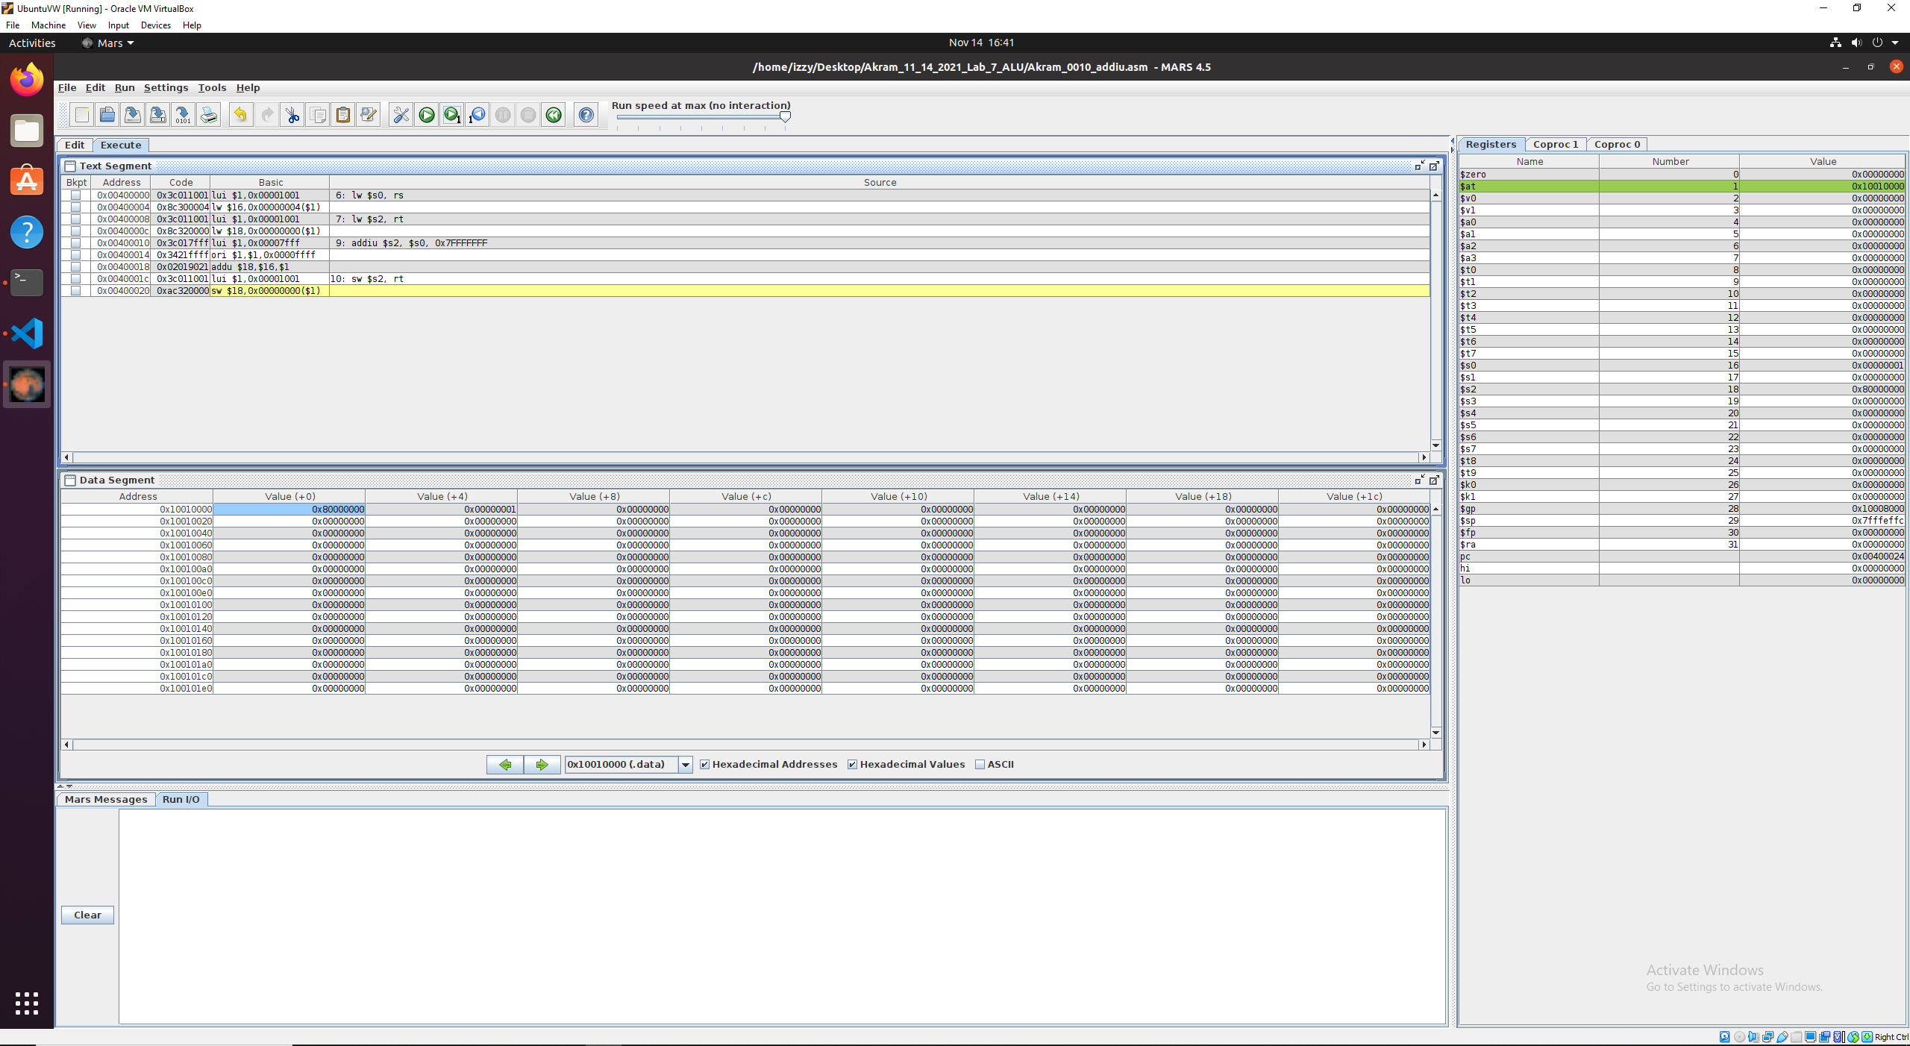

Fig 51. Execution works! Value 0x80000000 is saved into the $s2 due to the addi operation.

## addu

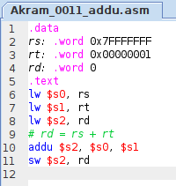

Fig X. MIPS code for Akram_0011_addiu.asm

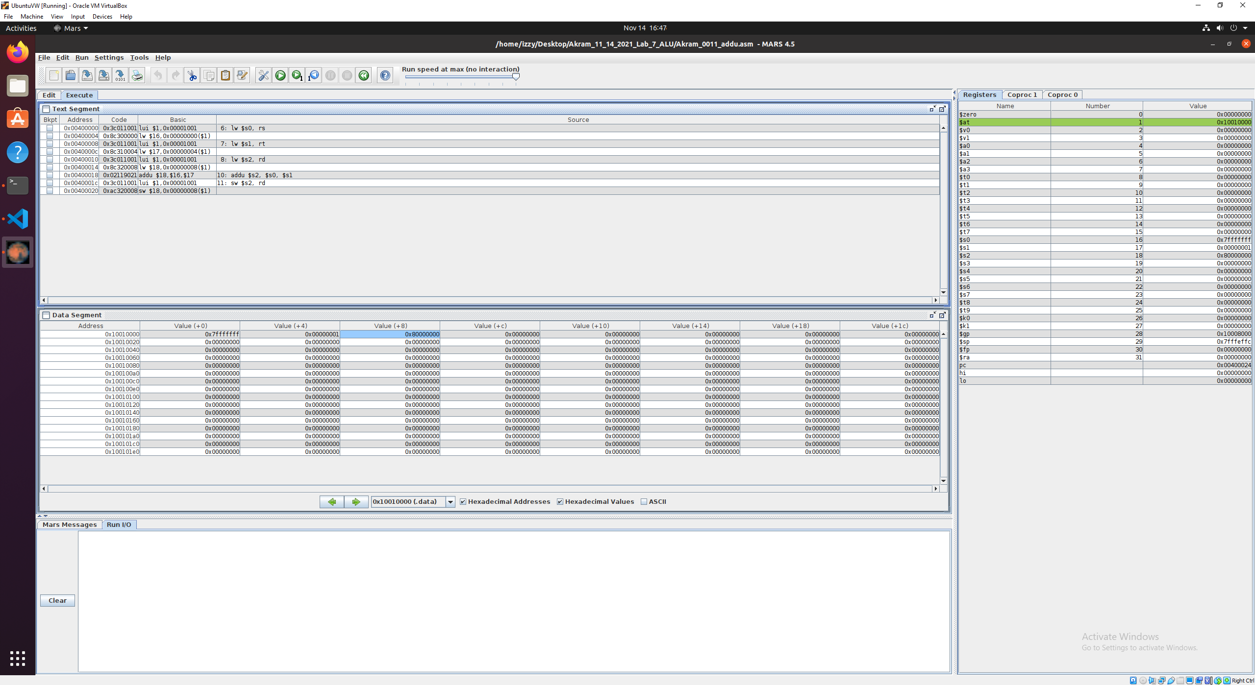

Fig 51. Execution works! Value 0x80000000 is saved into the $s2 due to the addiu operation.

## sub

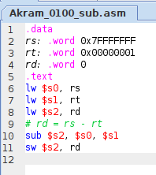

Fig X. MIPS code for Akram_0100_sub.asm

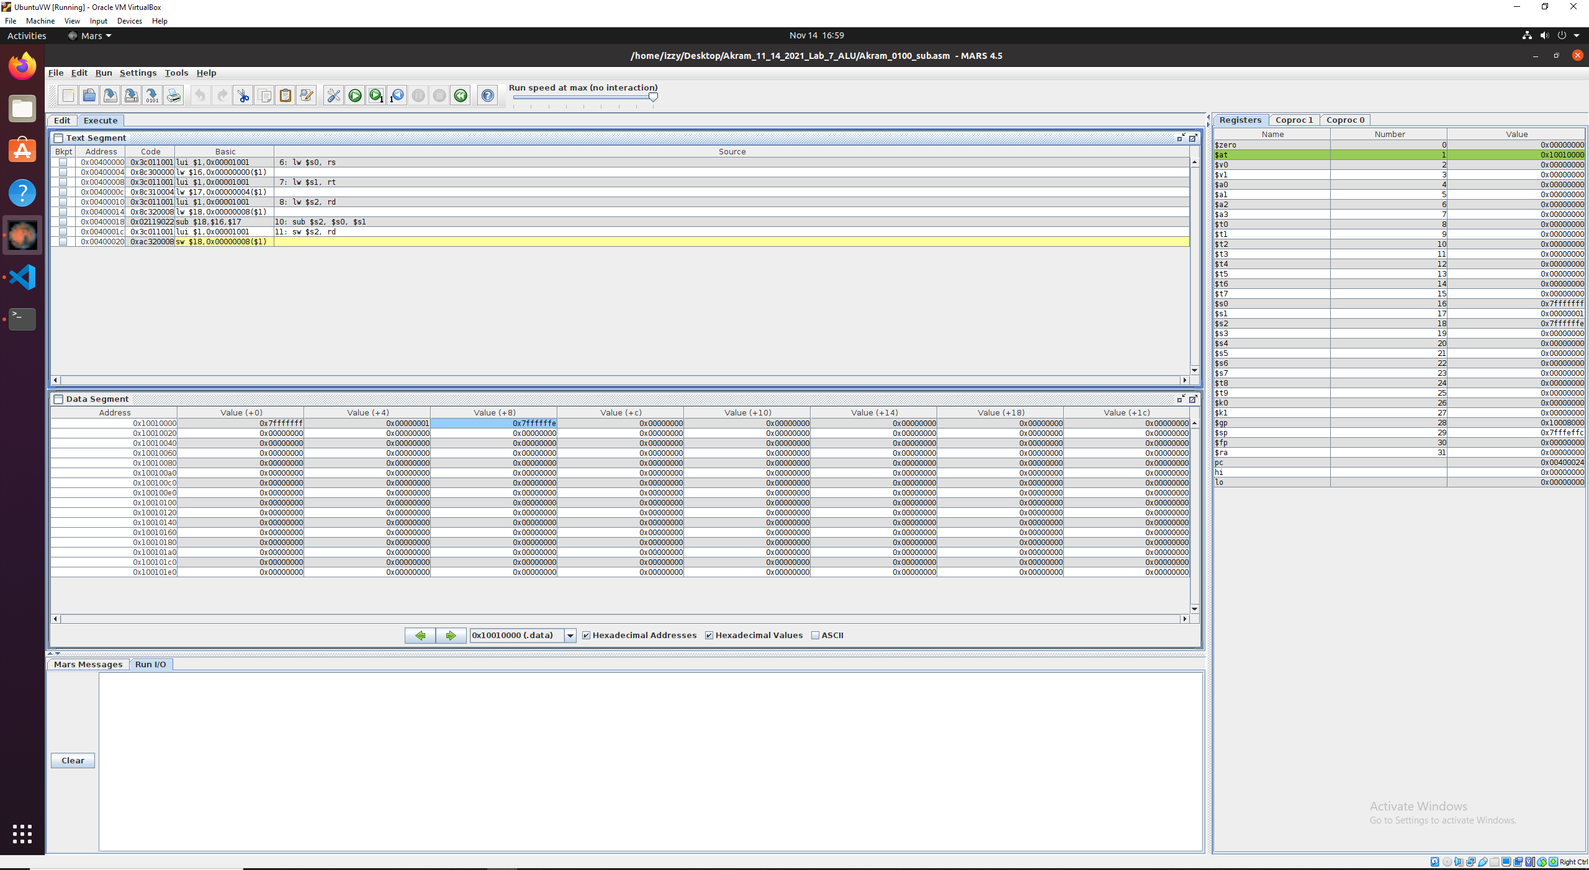

Fig 51. Execution works! Value 0x7FFFFFF8 is saved into the $s2 due to the sub operation.

## subu

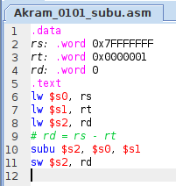

Fig X. MIPS code for Akram_0101_subu.asm

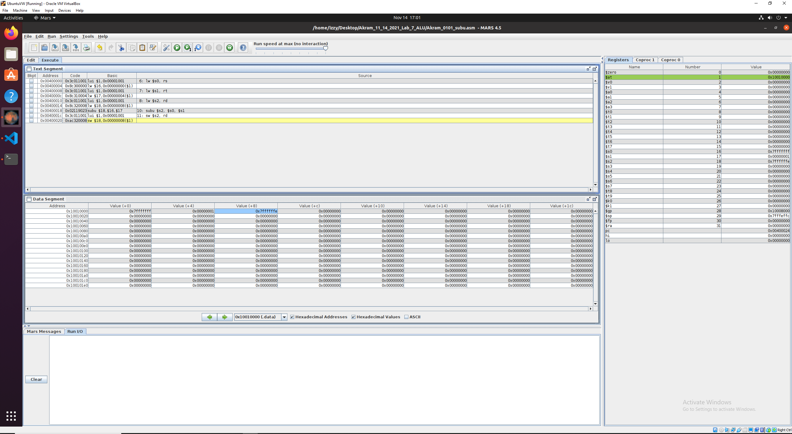

Fig 51. Execution works! Value 0x7FFFFFF8 is saved into the $s2 due to the sub operation.

## and

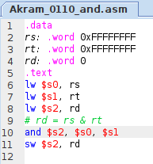

Fig X. MIPS code for Akram_0110_and.asm

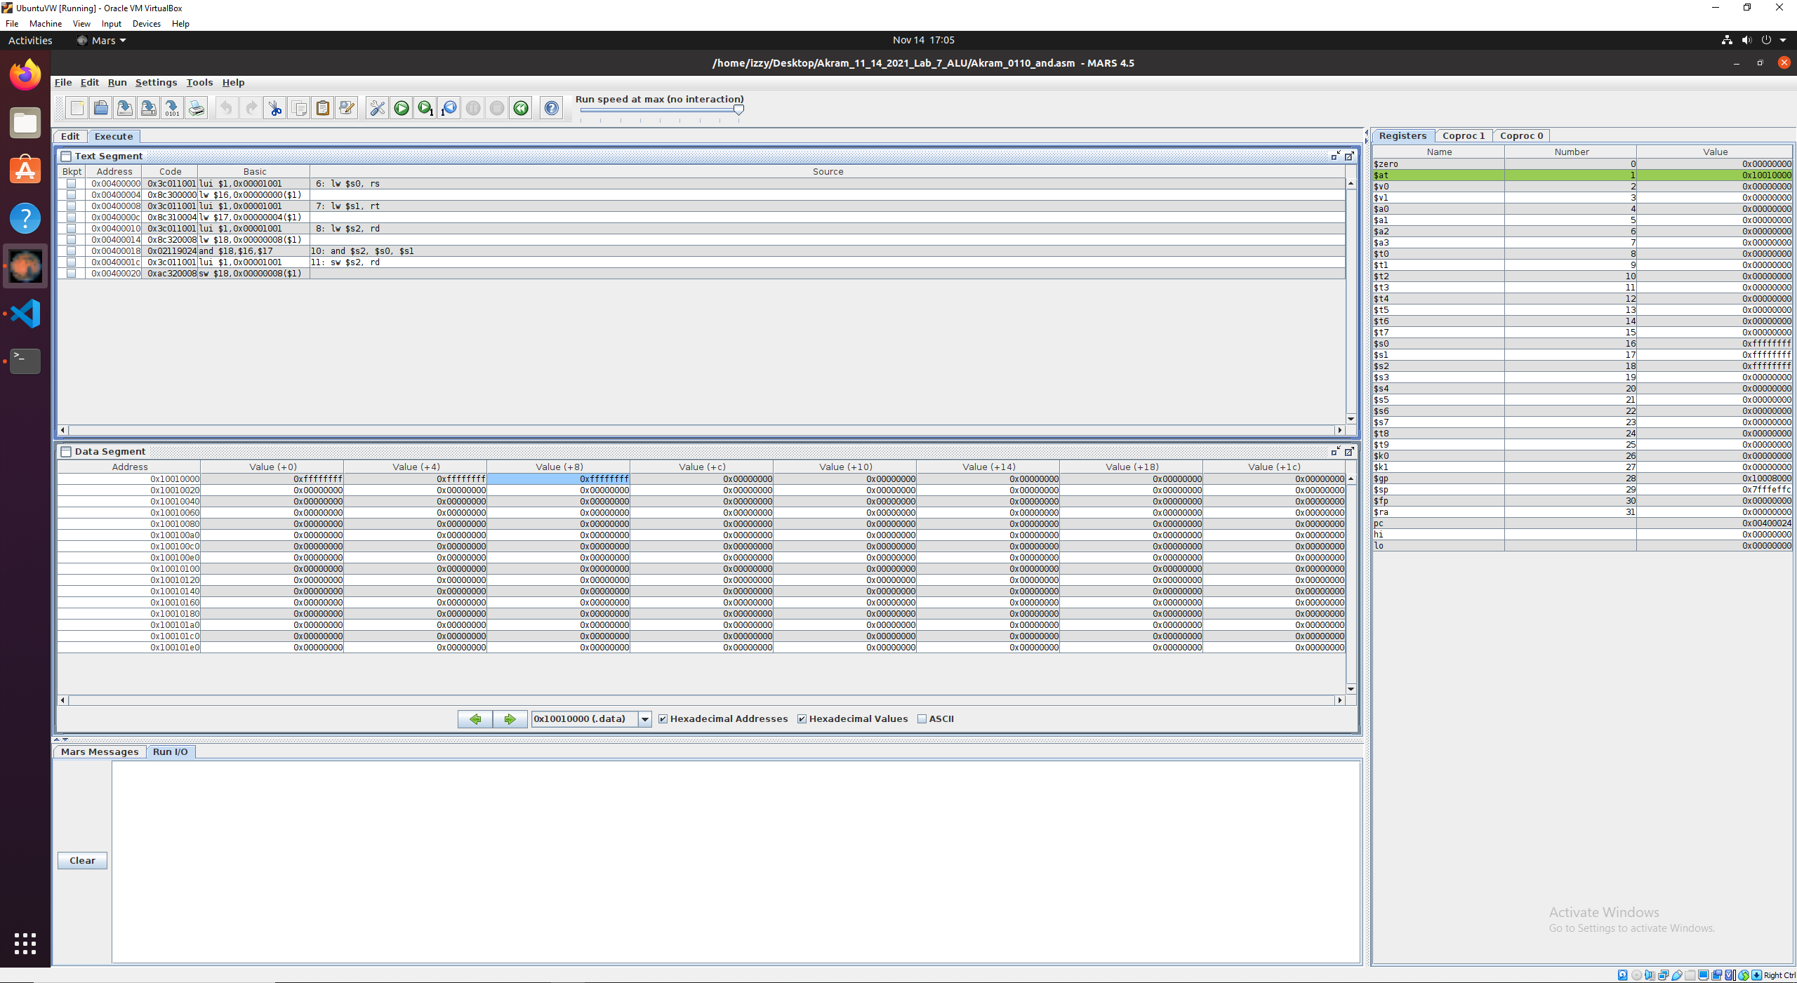

Fig 51. Execution works! Value 0xFFFFFFFF is saved into the $s2 due to the and operation.

## andi

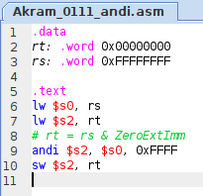

Fig X. MIPS code for Akram_0111_andi.asm

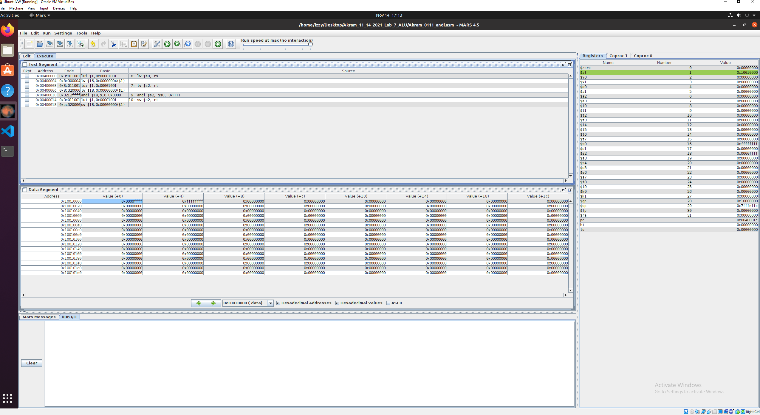

Fig 51. Execution works! Value 0x0000FFFF is saved into the $s2 due to the andi operation.

## nor

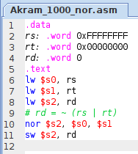

Fig X. MIPS code for Akram_1000_nor.asm

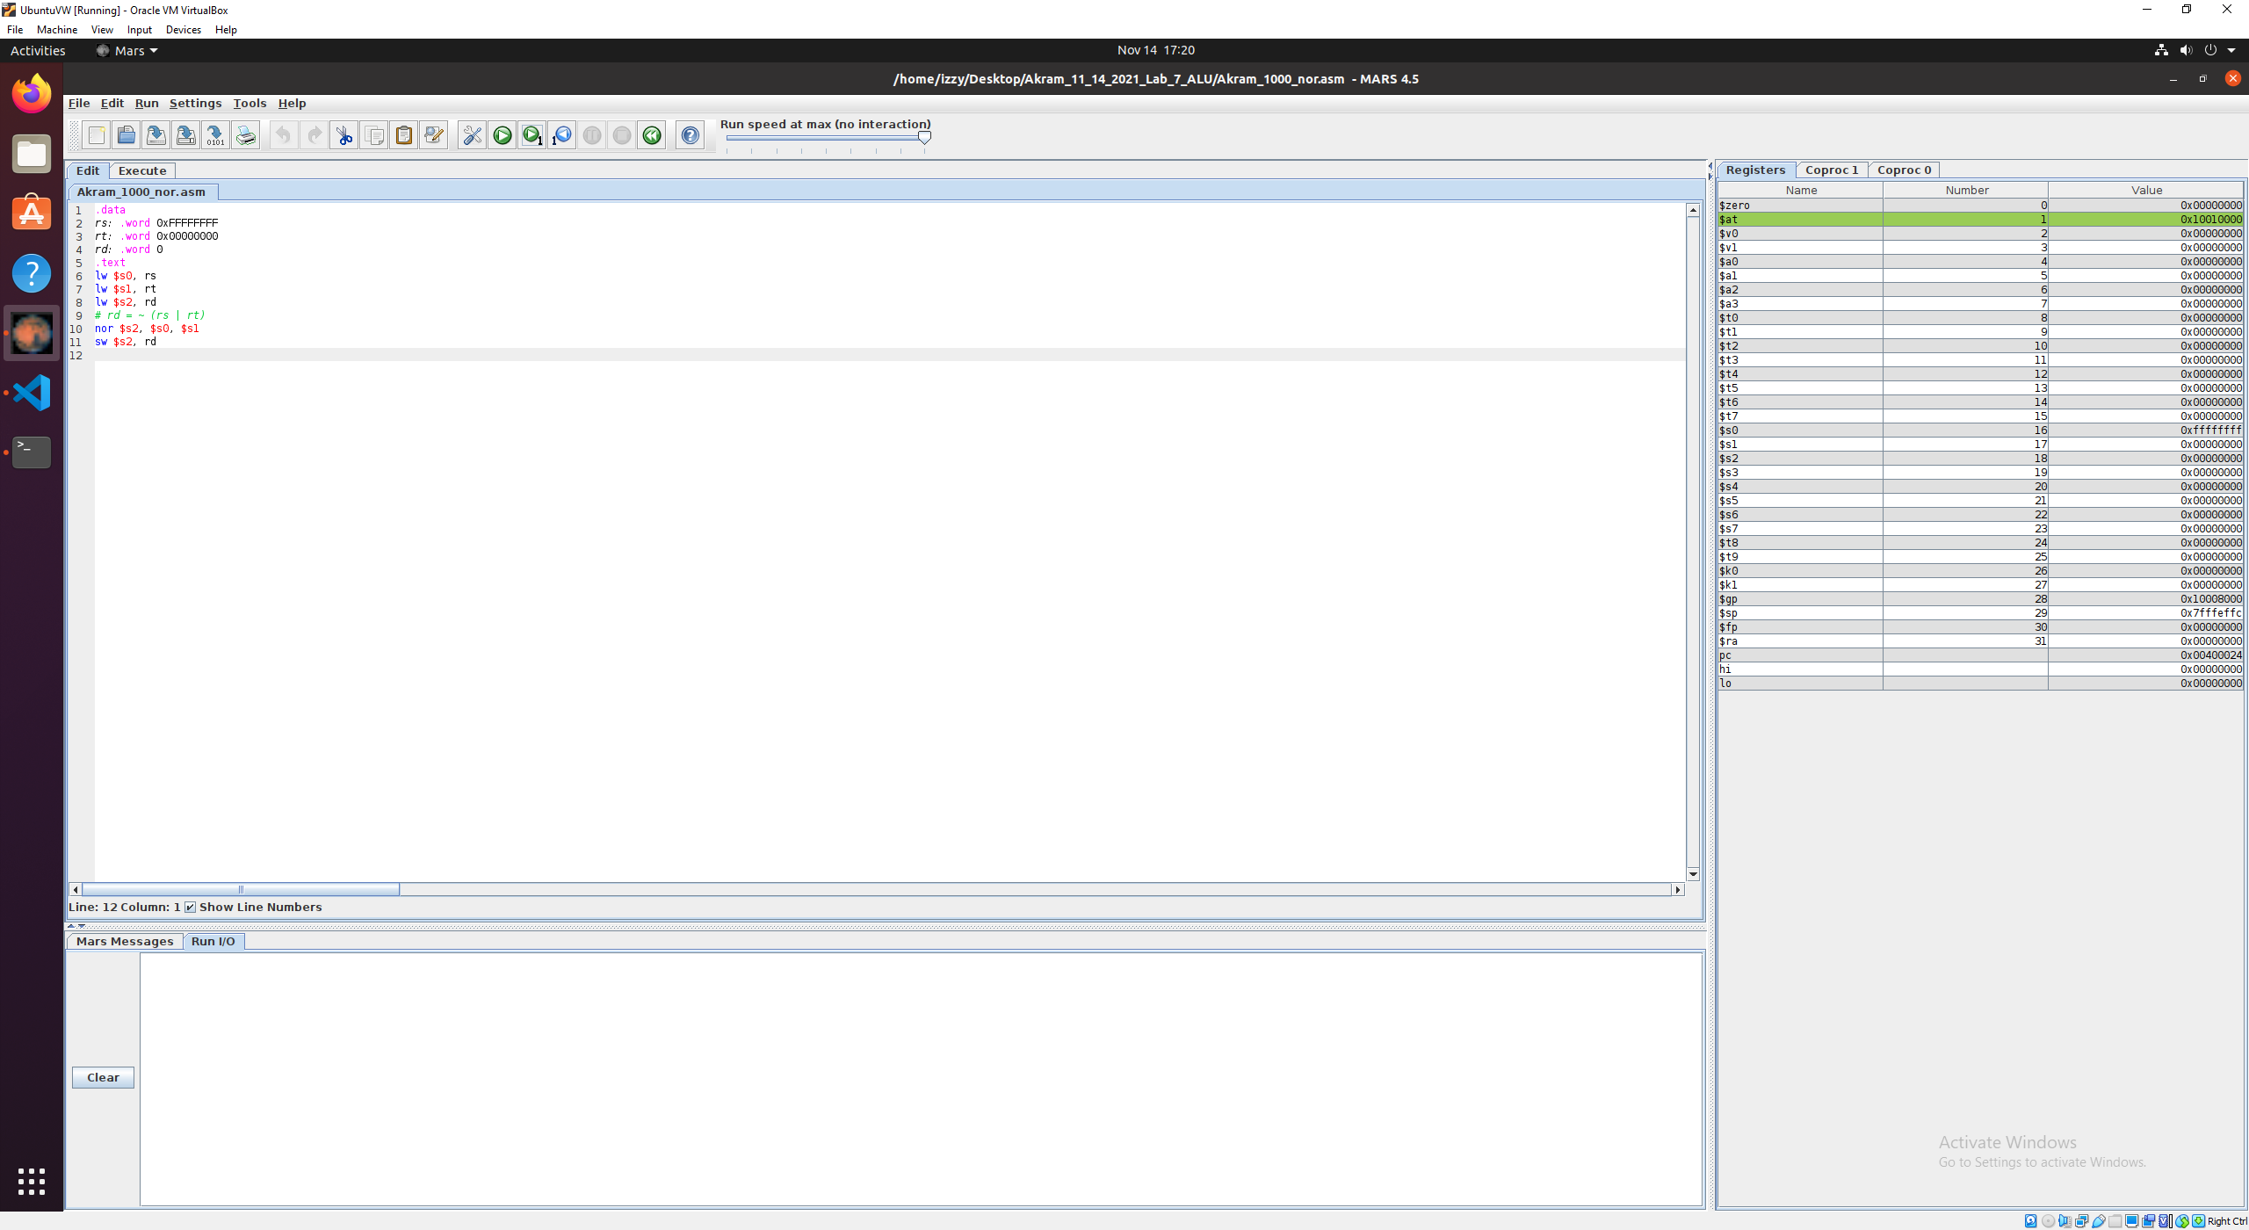

Fig 51. Execution works! Value 0x00000000 is saved into the $s2 due to the nor operation.

## or

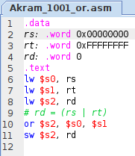

Fig X. MIPS code for Akram_1001_or.asm

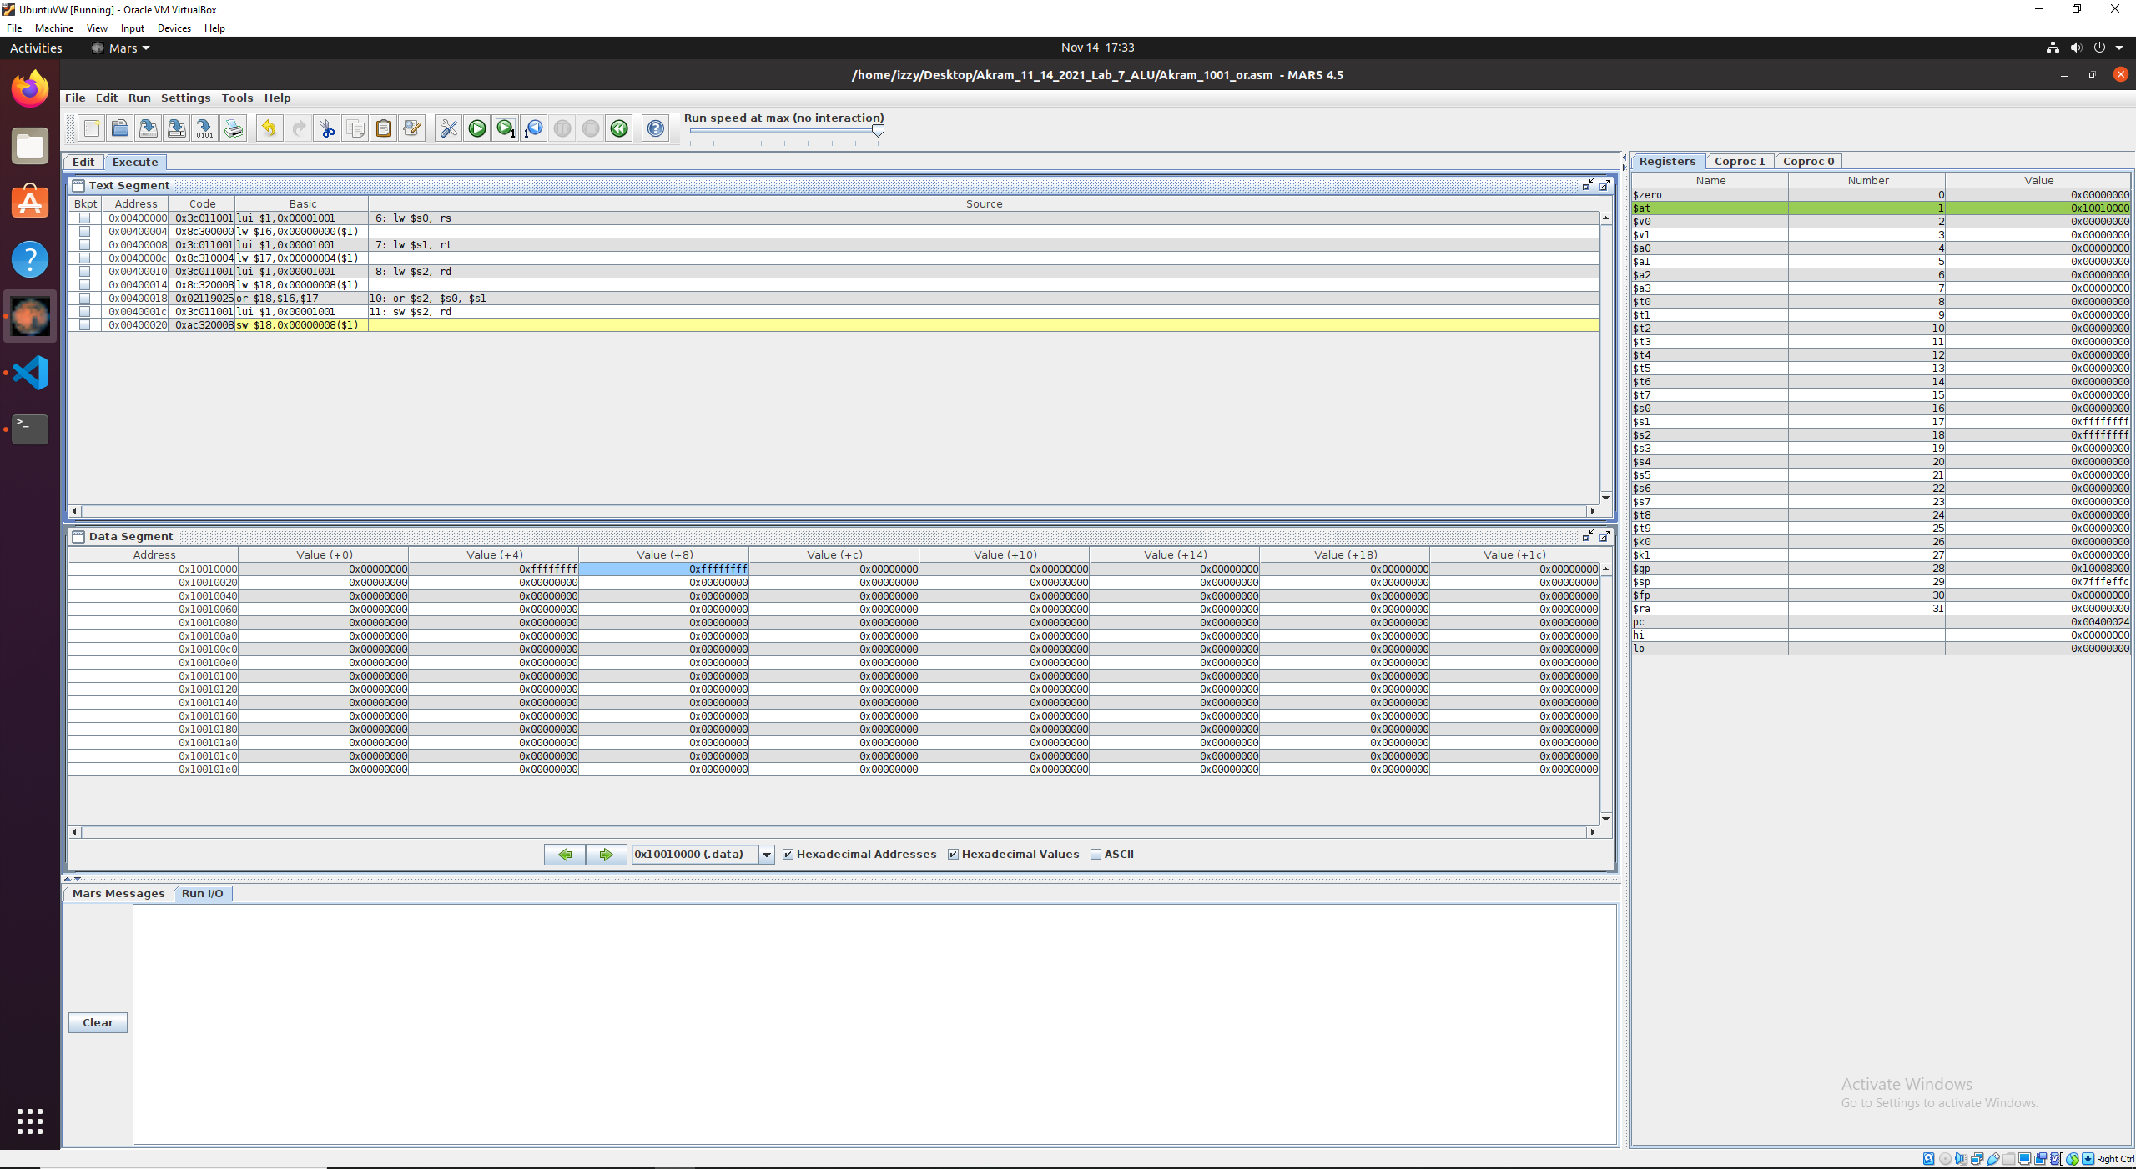

Fig 51. Execution works! Value 0xFFFFFFFF is saved into the $s2 due to the or operation.

## ori

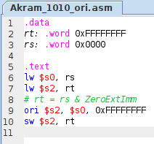

Fig X. MIPS code for Akram_1010_ori.asm

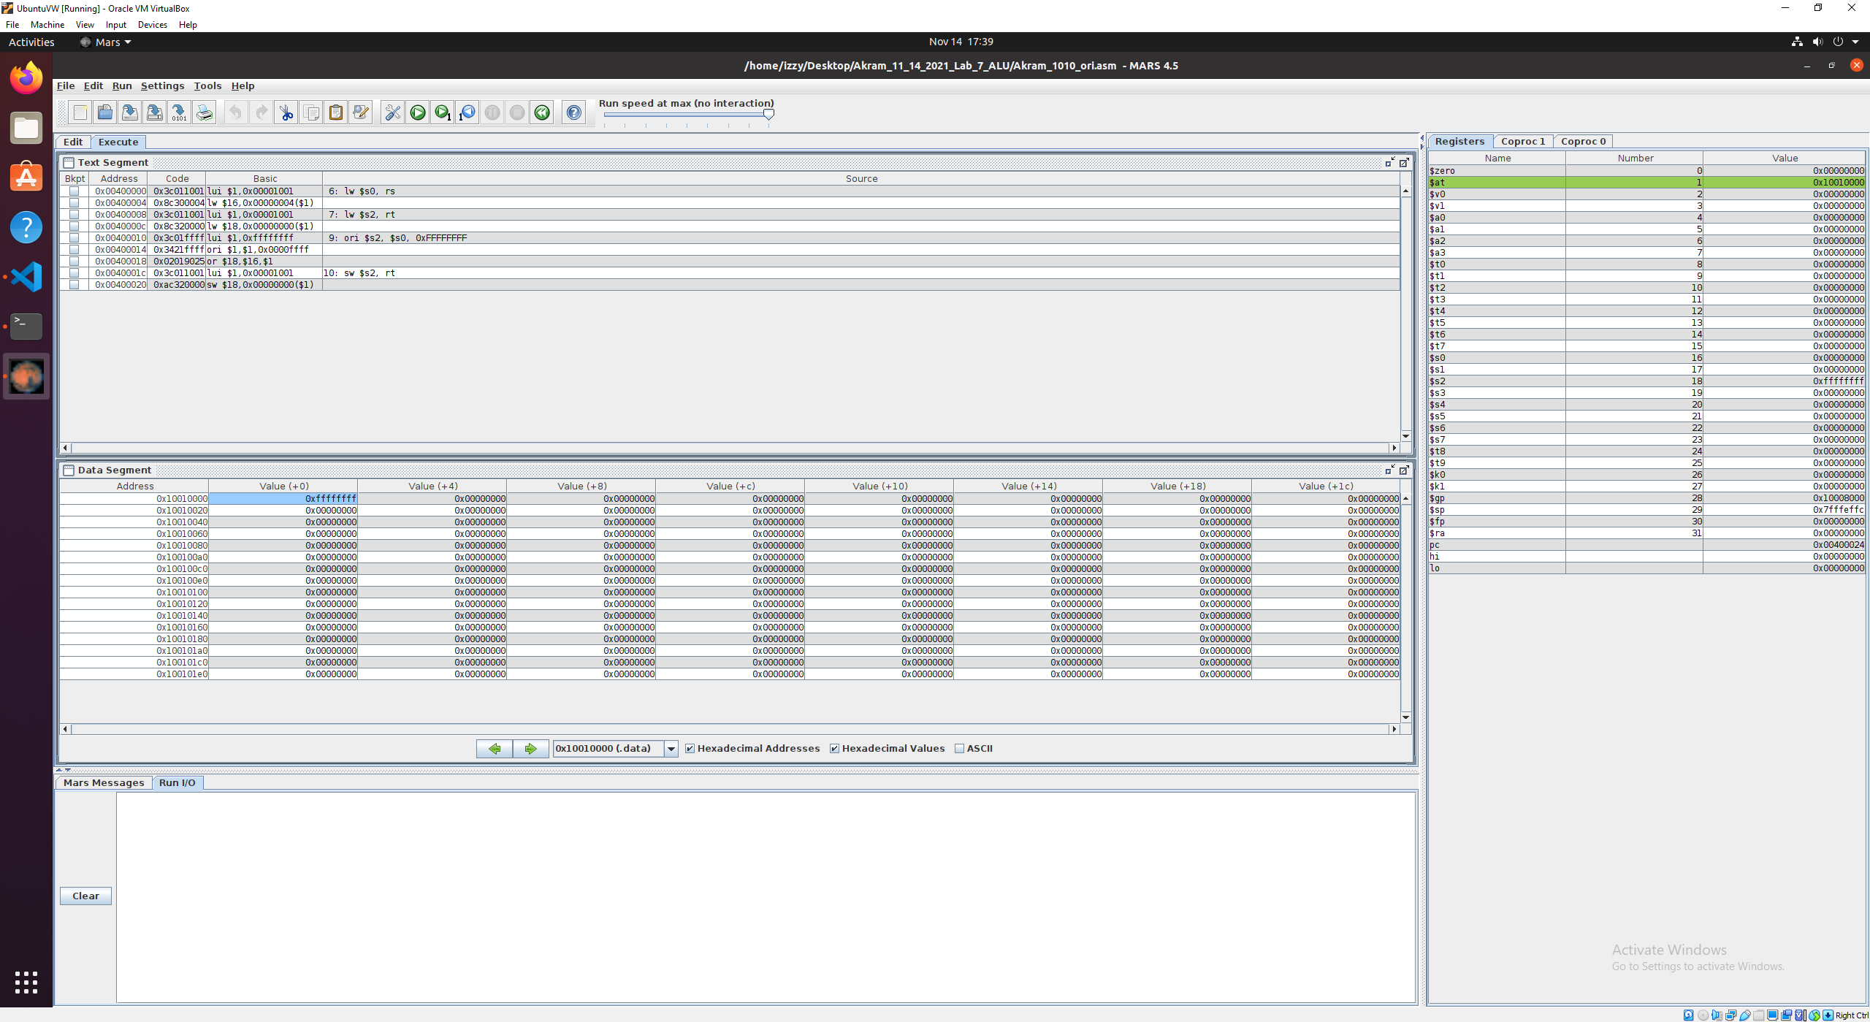

Fig 51. Execution works! Value 0xFFFFFFFF is saved into the $s2 due to the ori operation.

## sll

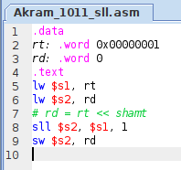

Fig X. MIPS code for Akram_1011_sll.asm

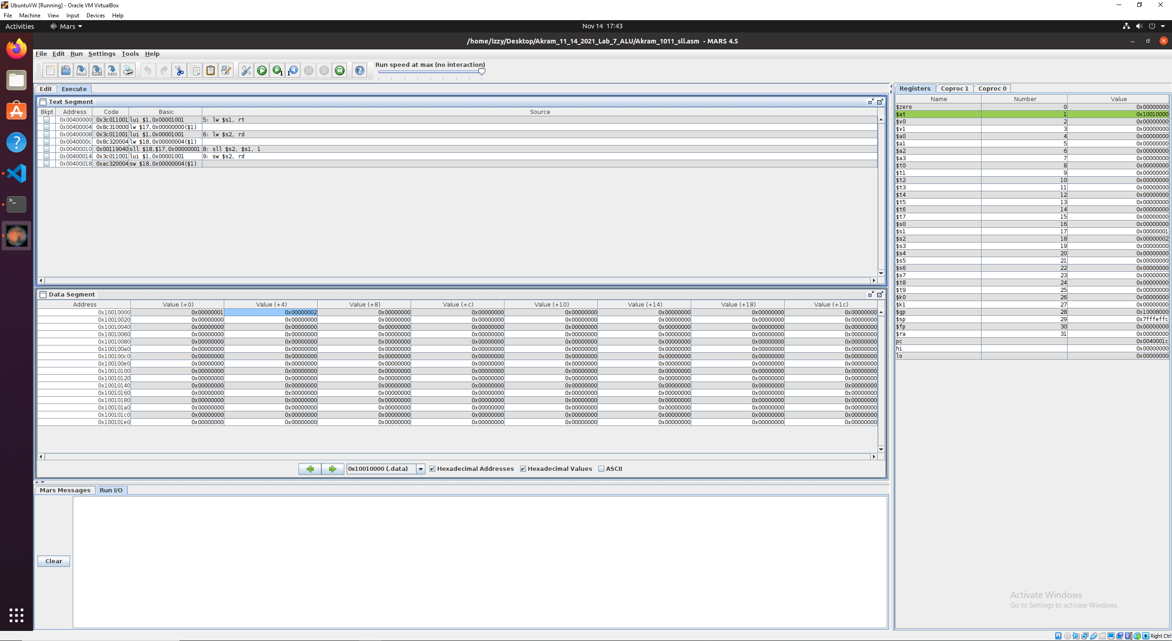

Fig 51. Execution works! Value 0x00000002 is saved into the $s2 due to the sll operation.

Note:

0x00000001 = 0b00000000000000000000000000000001

0x00000002 = 0b00000000000000000000000000000010 … i.e., 1 bit shifted to the left

## srl

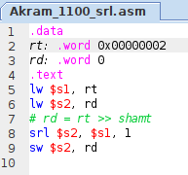

Fig X. MIPS code for Akram_1100_srl.asm

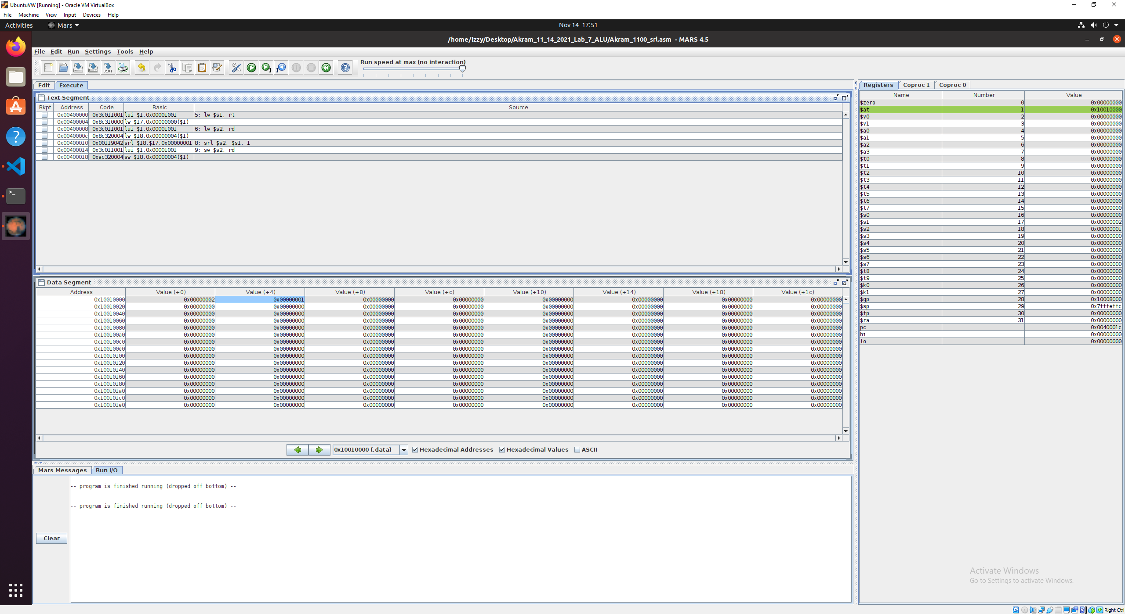

Fig 51. Execution works! Value 0x00000001 is saved into the $s2 due to the srl operation.

Note:

0x00000002 = 0b00000000000000000000000000000010

0x00000001 = 0b00000000000000000000000000000001 … i.e., 1 bit shifted to the right

## sra

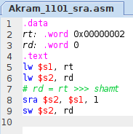

Fig X. MIPS code for Akram_1101_sra.asm

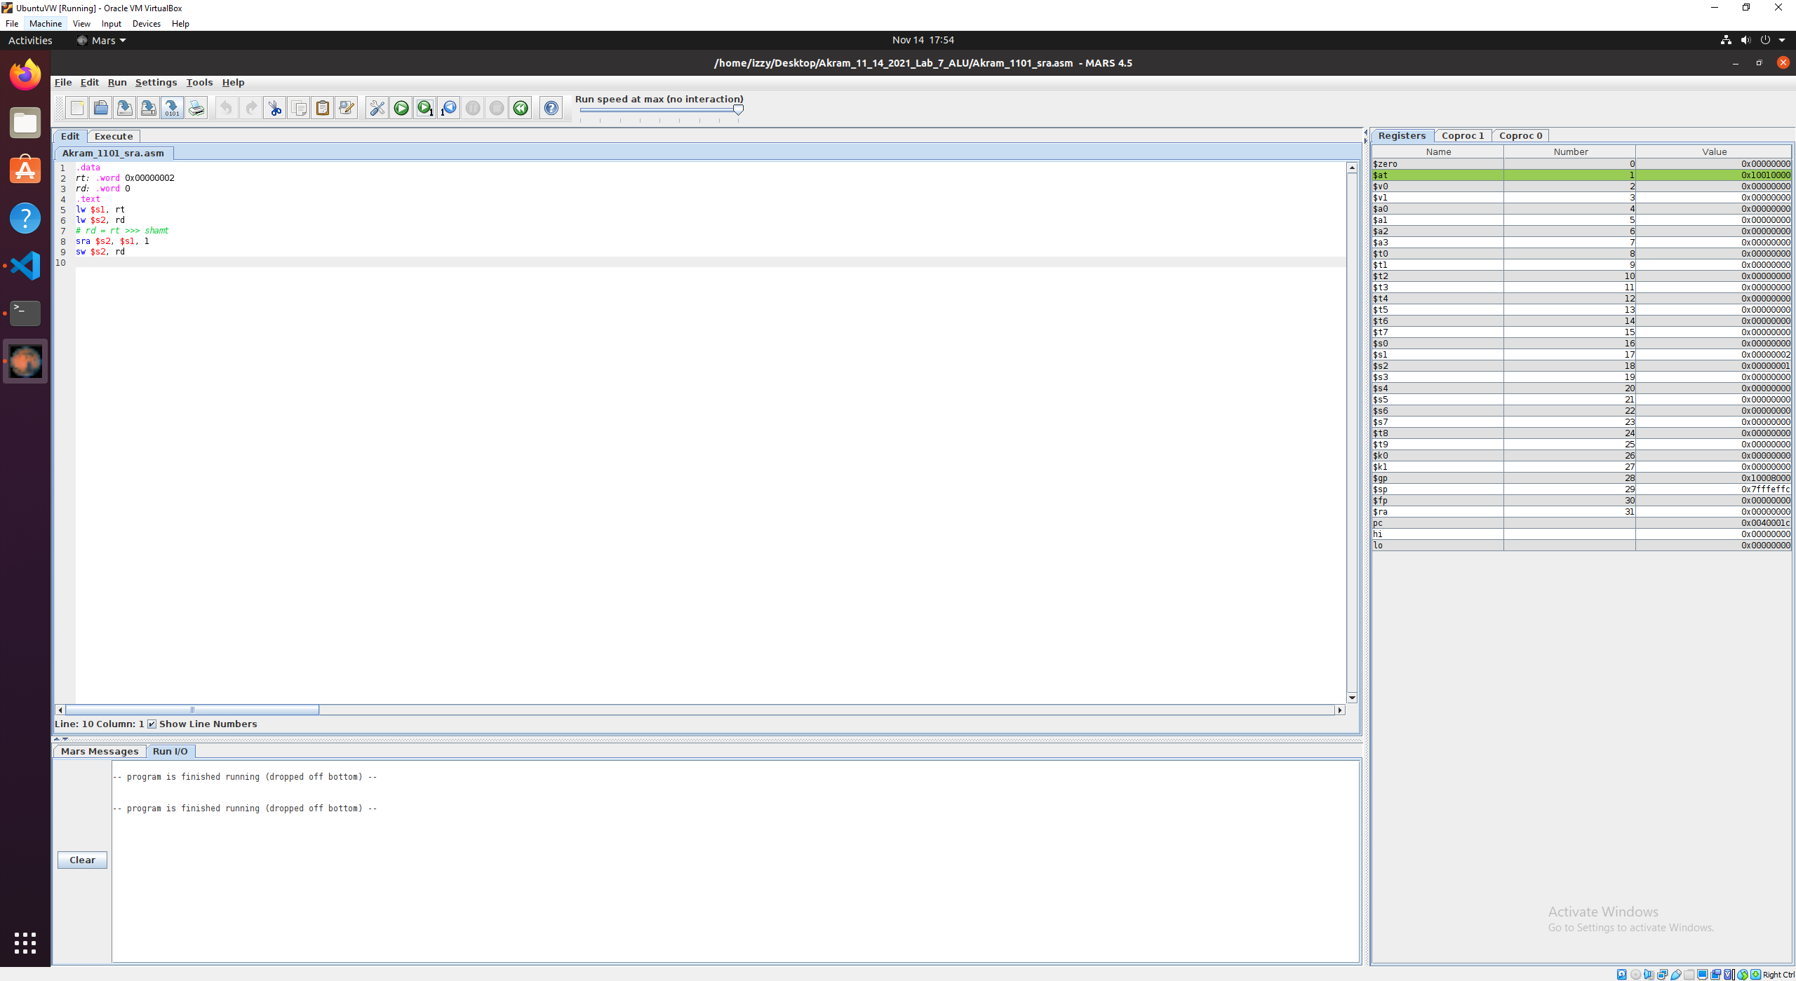

Fig 51. Execution works! Value 0x00000001 is saved into the $s2 due to the sra operation.

Note:

0x00000002 = 0b00000000000000000000000000000010

0x00000001 = 0b00000000000000000000000000000001 … i.e., 1 bit shifted to the right

# Conclusion

* The ALU is a major component of the overall Single-Cycle CPU
  + Converts 32-bit input into binary instructions that details a component’s function
  + Stores 32-bit values into read registers
  + Performs arithmetic operations
  + Writes the results into a write register
  + We used 3-port RAM for this version of our ALU
  + MIPS instruction showcase that our VHDL code is correct
* We implemented in VHDL; MIPS Instructions shown in the table (green pages).
* We verified correctness in ModelSim Simulation using waveforms for several select cases.
* We compared the execution of instructions I have designed with corresponding MIPS instructions in MARS environment.

This ALU lab performs addition and subtraction and stores values into the register, this lab is a portion of the single-cycle CPU. This lab and all the previous labs will lead us to a single-cycle CPU.